The Footwork Fix
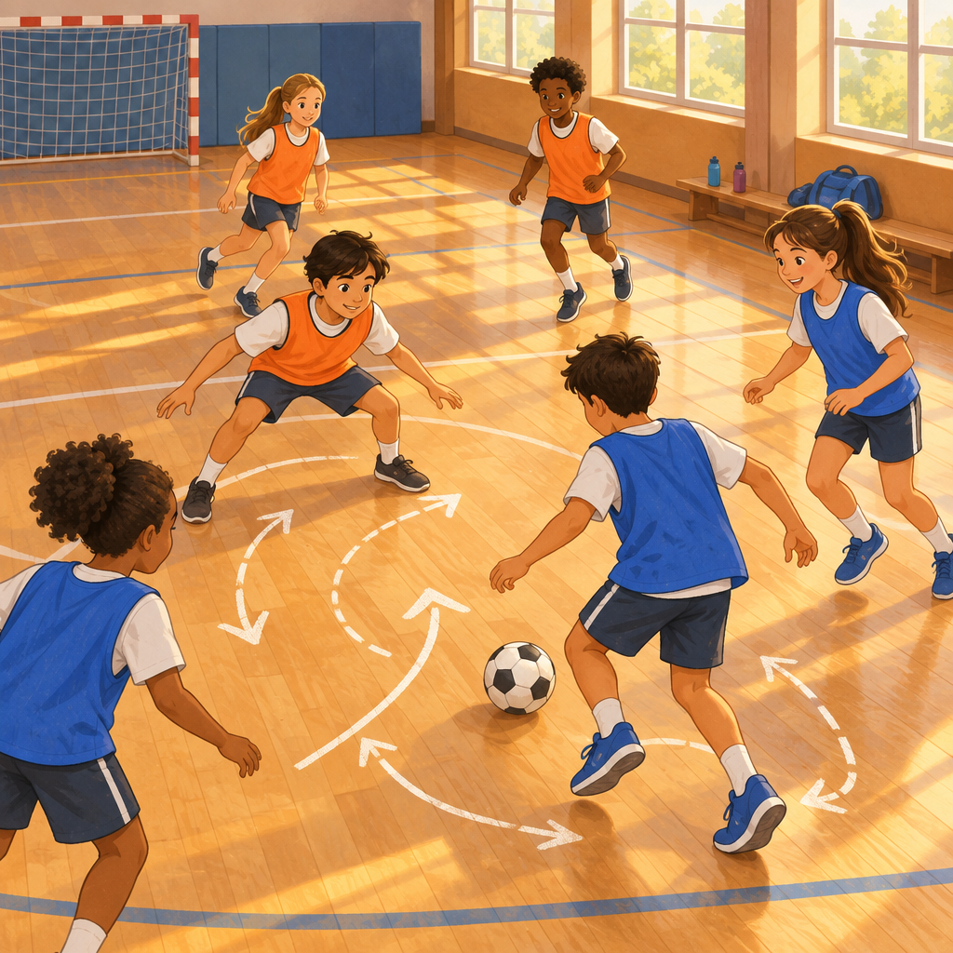
Maya adapted and applied movement patterns in the gym. "You never pass, Devon!" "You never call for it!" he shot back. Coach Sam walked over. "Before you fix the game, fix your feet. Show me your defensive shuffle." Maya bent her knees, arms wide, sliding side to side. Devon copied her. "Same pattern you use in tag and in badminton," Coach Sam said. "Now, about that pass. What actually happened?" Maya breathed out. "I was open. I got frustrated." "I didn't see you," Devon admitted. "I was watching the ball too hard." "Okay. Next time, call my name?" "Deal." They reset, shuffled into position, and Devon threaded a pass right to her. Maya scored, grinning. "Feet and words. Both matter." "Both matter," Devon.

Words to know
- defensive shuffle: a controlled sideways movement pattern used to stay balanced and ready in many sports
- movement pattern: a repeated way of moving that shows up across different activities and can be practiced and improved
- conflict resolution: steps like listening, understanding, and proposing solutions that help people work out disagreements
Curriculum link: Outcome, Outcome, Knowledge, Understanding, Knowledge, Skills, Knowledge, Understanding, Skills, Understanding
Listen to the narration

AILI audio story · en · claude-sonnet-5 · 2026-09-17

