The Particle Model of Matter
Central concept: Particle Model of Matter

Connections
- Particle Model of Matter (includes) -> Basic Ideas
- Basic Ideas (describes) -> Solids
- Basic Ideas (describes) -> Liquids
- Basic Ideas (describes) -> Gases
- Particle Model of Matter (involves) -> Attractive Forces
- Attractive Forces (strongest in) -> Solids
- Attractive Forces (weakest in) -> Gases
- Particle Model of Matter (explains) -> Physical Properties
- Physical Properties (includes) -> Mass
- Physical Properties (includes) -> Volume
- Physical Properties (includes) -> Density
- Physical Properties (includes) -> Compressibility
- Mass (compares to volume) -> Density
- Volume (compares to mass) -> Density
- Particle Model of Matter (investigated by) -> Investigation Skills
- Investigation Skills (measures) -> Mass
- Investigation Skills (measures) -> Volume
- Investigation Skills (compares) -> Density

Notes
- Particle Model of Matter: Explains the behaviour of particles in matter. Understanding, PDF p.1
- Basic Ideas: All matter is made of small particles that are always moving and have spaces between them. Knowledge, PDF p.1
- Solids: Particles are close together and vibrate in place. Knowledge, Resource
- Liquids: Particles have spaces and can slide past each other. Knowledge, Resource
- Gases: Particles have large spaces and move in all directions. Knowledge, Resource
- Attractive Forces: Strongest in solids, weakest in gases.
- Physical Properties: Include state, mass, volume, density, and compressibility. Knowledge, Understanding
- Mass: Amount of matter, measured in grams and kilograms. Knowledge, Skills
- Volume: Amount of space matter takes up, measured in millilitres and litres. Knowledge, Skills
- Density: Compares mass to volume; objects that are less dense than a fluid will float.
- Compressibility: Ability of a liquid or gas to reduce in volume under pressure. Knowledge, Skills
- Investigation Skills: Represent solids, liquids, and gases using the particle model of matter; relate particle movement and arrangement to the state of matter.
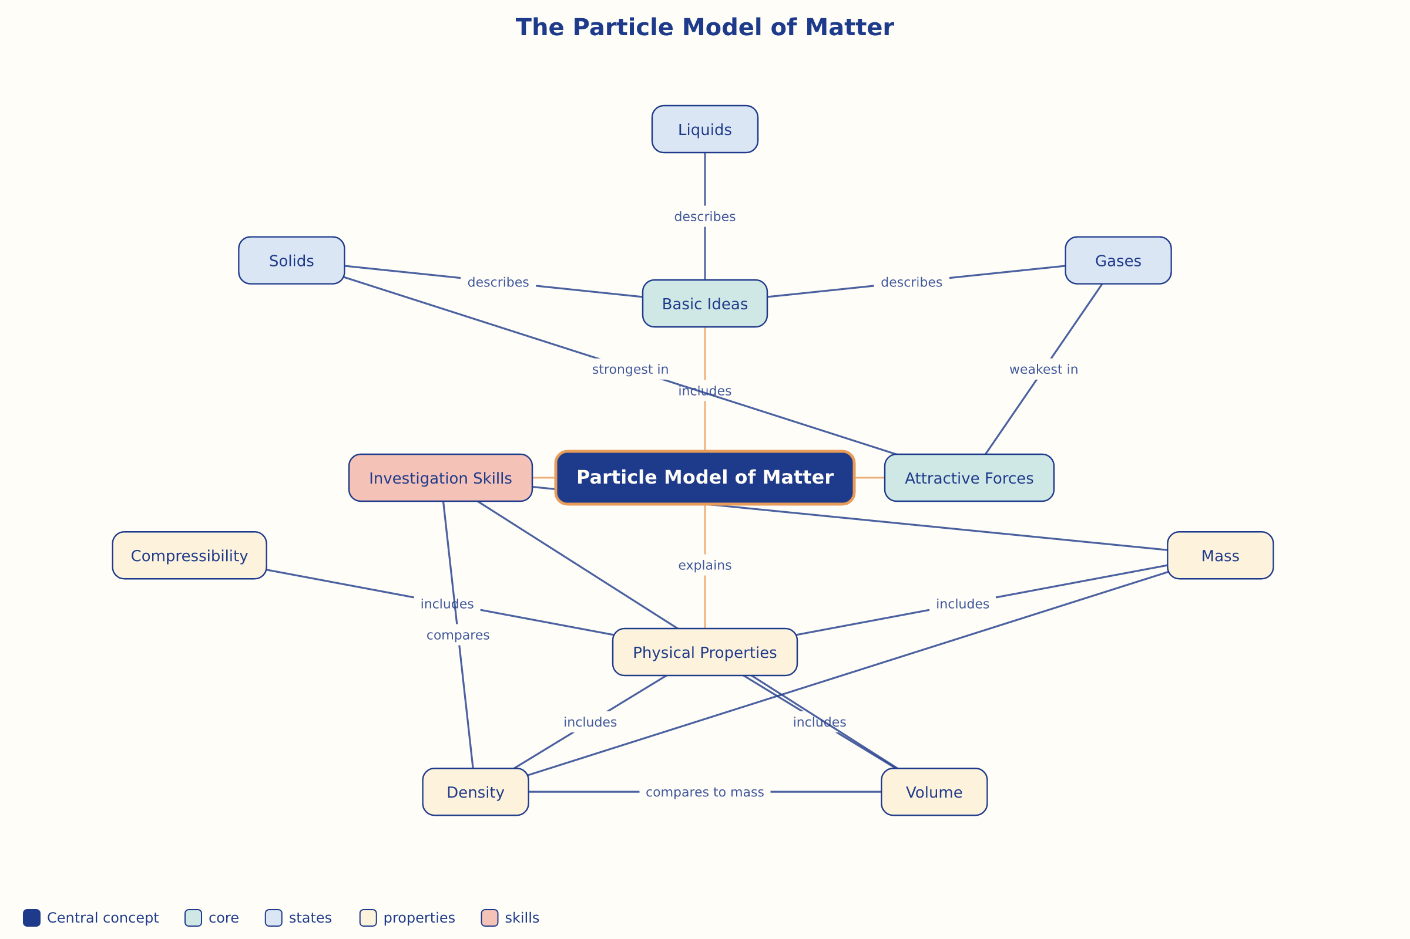

AILI word map · en · claude-sonnet-5 · 2026-09-17

