Addition and Subtraction Within 100
Central concept: Addition and Subtraction Within 100

Connections
- Addition and Subtraction Within 100 (uses) -> Number Facts
- Addition and Subtraction Within 100 (uses) -> Two-Digit Strategies
- Addition and Subtraction Within 100 (involves) -> Compose Sums
- Addition and Subtraction Within 100 (applies to) -> Real-World Problems
- Number Facts (builds) -> Make Tens
- Two-Digit Strategies (includes) -> Make Tens
- Compose Sums (shows) -> Order Doesn't Matter
- Compose Sums (uses) -> Visualize 100
- Real-World Problems (measures) -> Quantity and Length
- Real-World Problems (finds) -> Missing Numbers
- Sums to 100 (checks with) -> Inverse Operations
- Addition and Subtraction Within 100 (includes) -> Sums to 100

Notes
- Addition and Subtraction Within 100: Grade 2 students investigate how addition and subtraction work with numbers up to 100. Outcome
- Number Facts: Familiar addition and subtraction facts with addends to 10 help students solve larger problems. Knowledge, Knowledge
- Two-Digit Strategies: Making multiples of ten and using doubles are key strategies for two-digit addition and subtraction. Knowledge, Knowledge
- Make Tens: Breaking numbers into tens helps solve addition and subtraction problems efficiently. Skills, Skills
- Compose Sums: A sum can be made in many different ways, including with more than two addends. Understanding, Understanding
- Order Doesn't Matter: When adding more than two numbers, the order does not change the sum. Knowledge, Knowledge
- Real-World Problems: Addition and subtraction represent quantities and lengths in real situations. Understanding, Understanding
- Inverse Operations: Addition and subtraction are opposites; use one to check the other. Skills
- Missing Numbers: Find unknown quantities in addition and subtraction sentences within 100. Skills
- Visualize 100: See 100 as groups of 10 in different ways to understand place value. Skills, Skills
- Sums to 100: Add numbers so the total is 100 or less; subtract from numbers up to 100. Skills
- Quantity and Length: Use addition and subtraction to work with objects you can count or distances you can measure. Skills
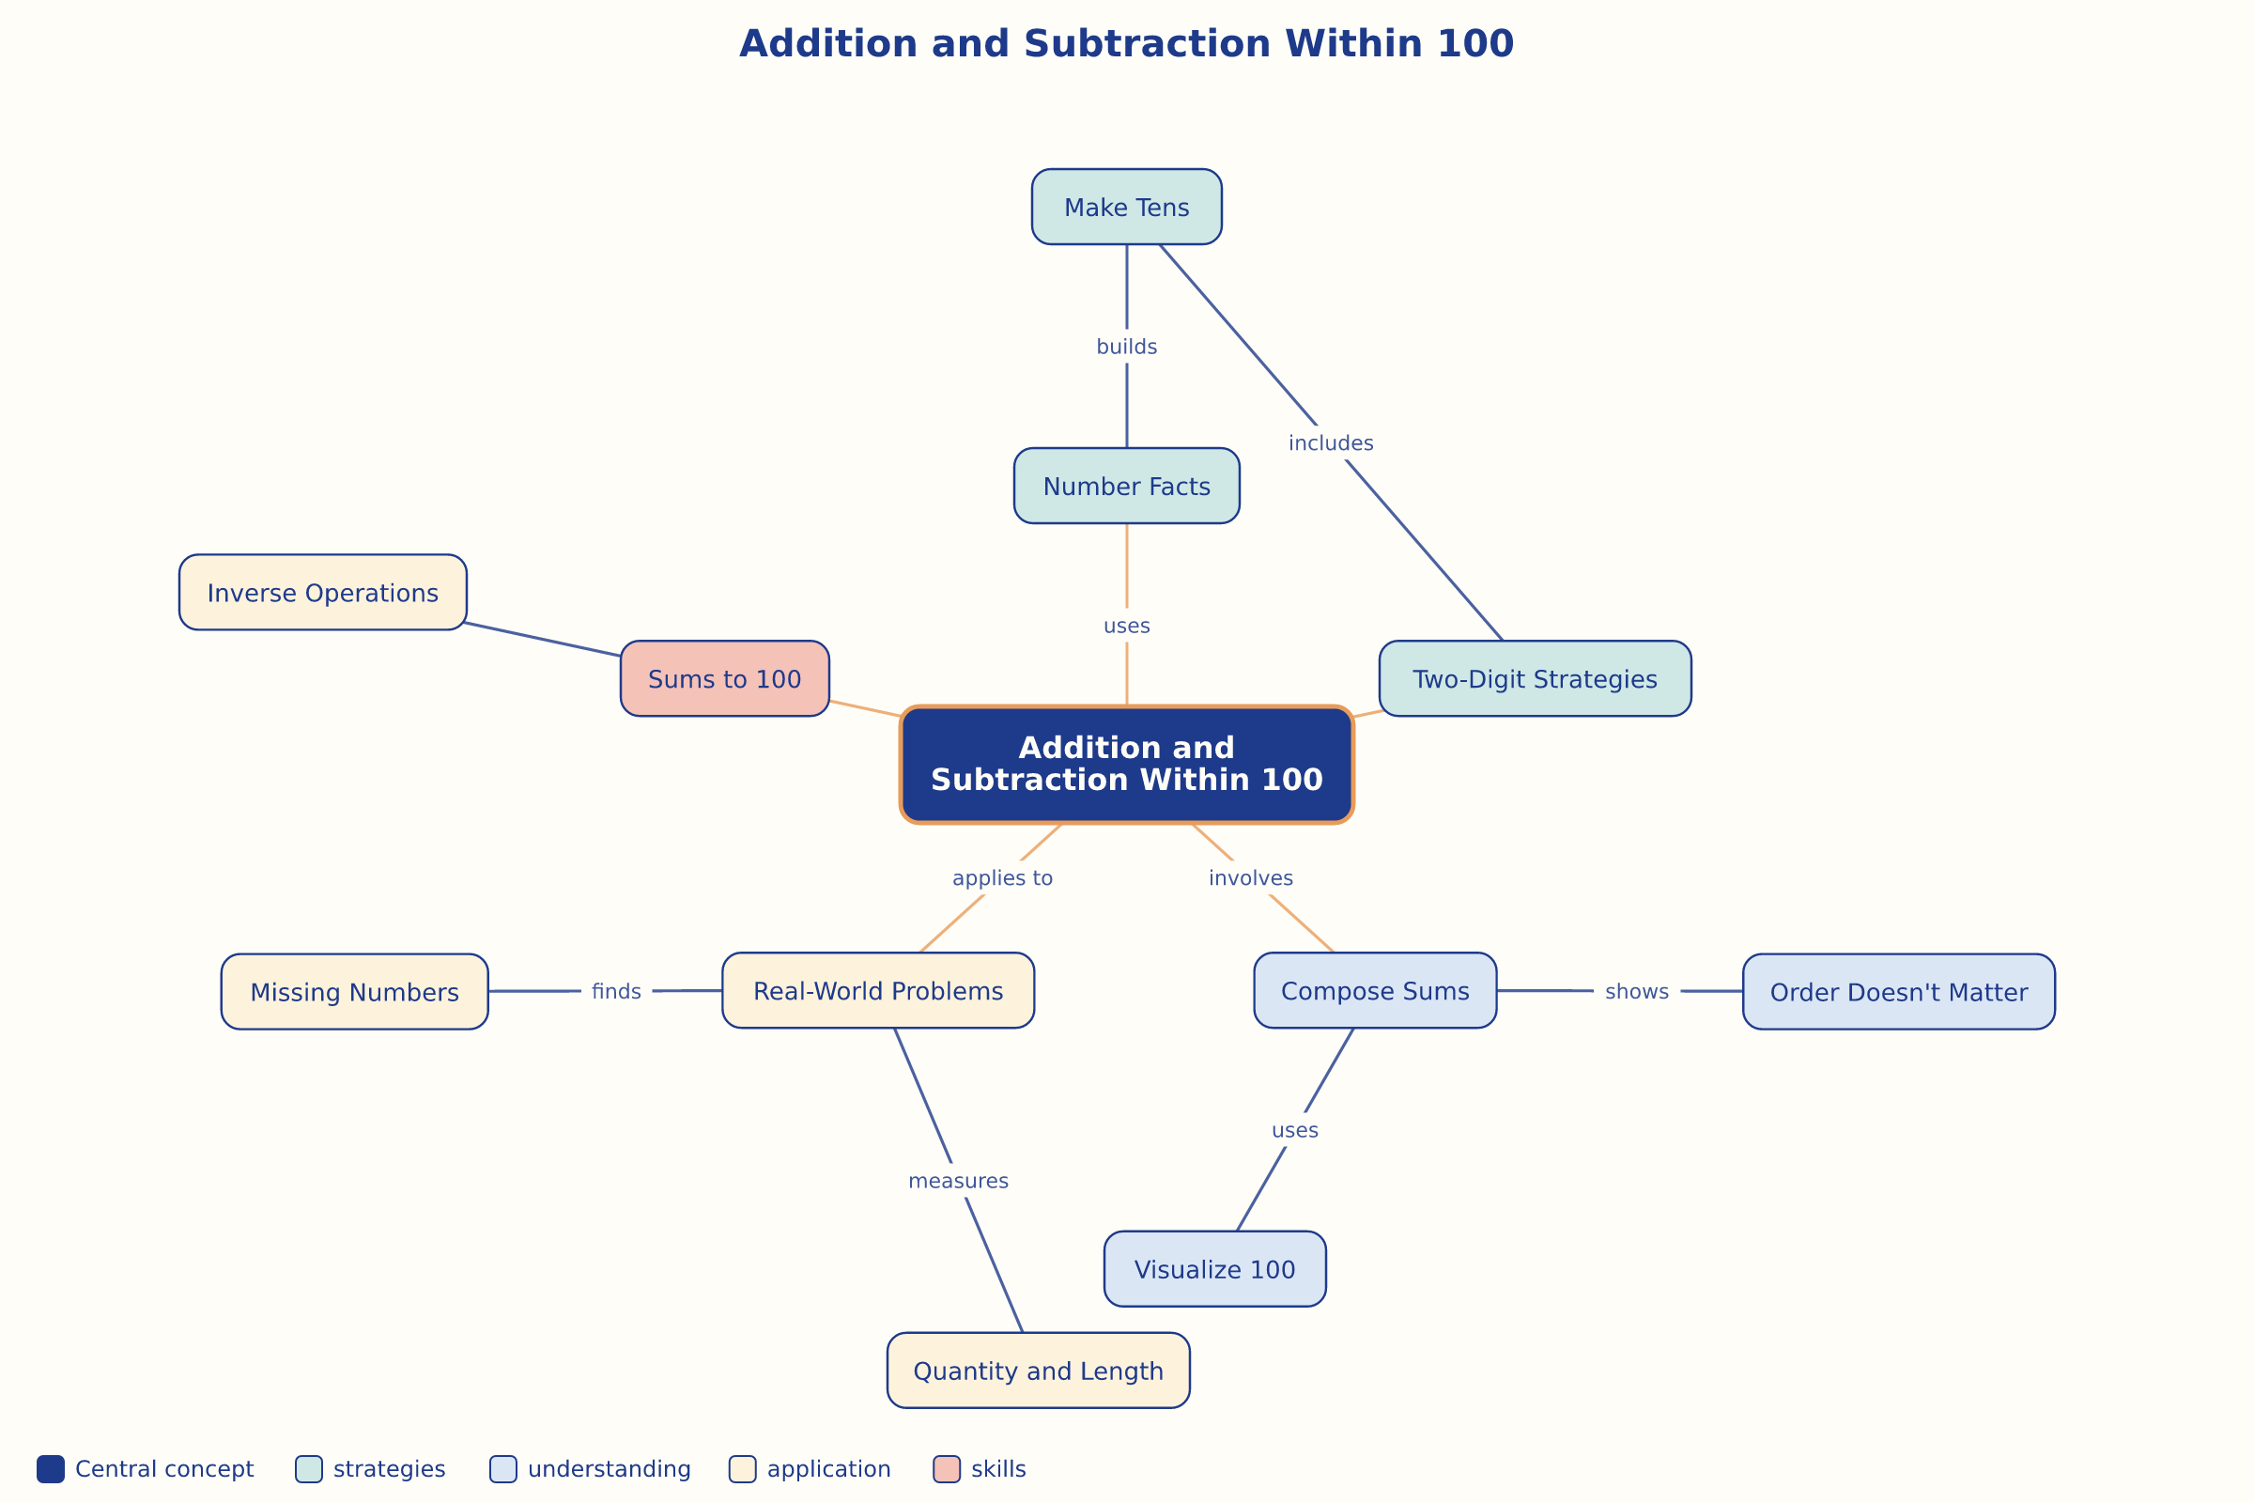

AILI word map · en · claude-haiku-4-5-20251001 · 2026-09-17

