The Nervous System: Structure and Function
Students identify principal nervous system structures and explain how neurons transmit signals to regulate body systems.
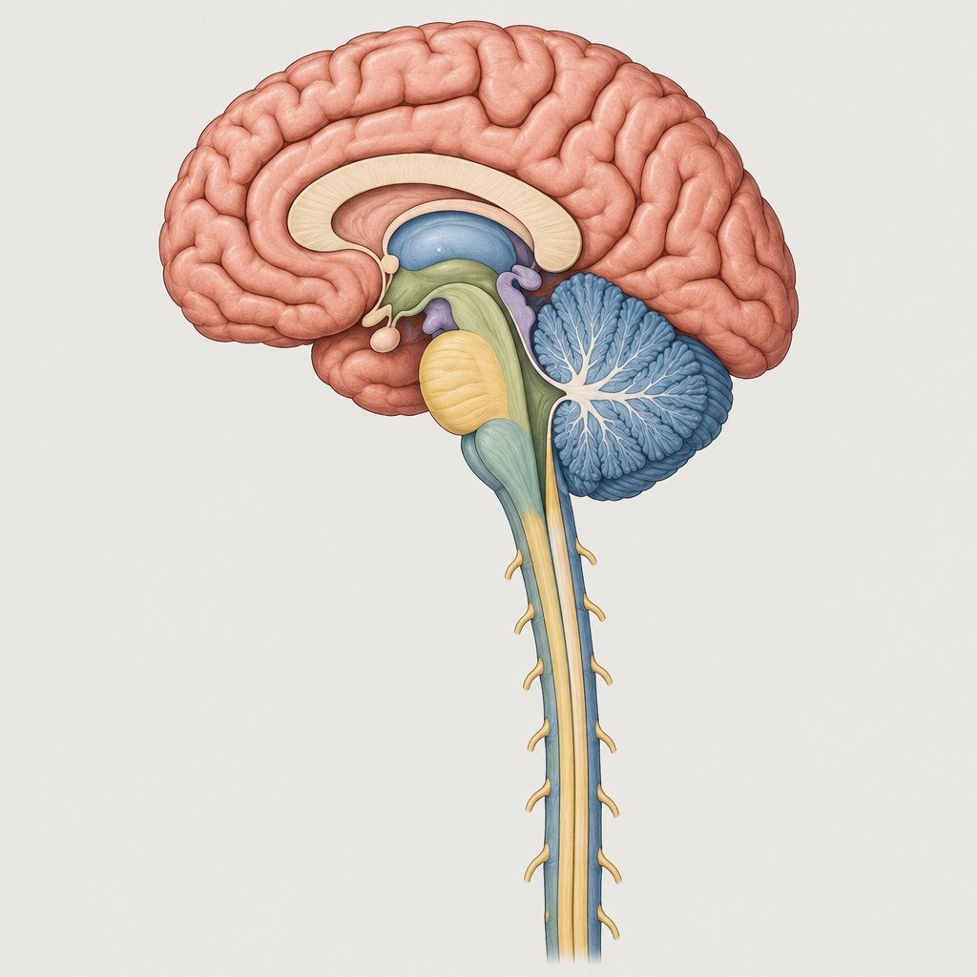

Learning intentions
We are learning to identify the structures of the central and peripheral nervous systems and explain how neurons transmit signals across synapses to regulate voluntary and involuntary body functions.

Success criteria
I can:
- Label the major structures of the brain, spinal cord, and peripheral nervous system
- Explain the function of each principal structure in regulating somatic and autonomic responses
- Describe the structure of a neuron and the sequence of events in action potential formation
- Explain synaptic transmission and the role of neurotransmitters
- Distinguish between the sympathetic and parasympathetic nervous systems and their opposing effects

Curriculum alignment
Students identify principal structures of the central and peripheral nervous systems and explain their functions in regulating voluntary and involuntary systems (Outcome, Outcome). Students describe neuron structure, myelin sheath function, action potential formation, and synaptic transmission involving norepinephrine, acetylcholine, and cholinesterase (Outcome, Outcome). Students explain how the nervous system controls physiological processes (Topic). The lesson draws on the unit's focus on homeostasis and equilibrium (Topic).

Materials
- Diagram handout: labelled brain structures (cerebral hemispheres, lobes, cerebellum, pons, medulla oblongata, hypothalamus, spinal cord)
- Diagram handout: neuron structure (soma, dendrites, axon, axon terminal, myelin sheath)
- Diagram handout: synapse with presynaptic and postsynaptic membranes
- Whiteboard or projector for displaying structures during direct instruction
- Index cards with sympathetic and parasympathetic effects (prepared in advance)
- Student worksheet: matching and short-answer questions on neuron structure and function

Lesson sequence

1. Hook (5 minutes)
Begin with a scenario. Tell students: "You touch a hot stove. Your hand pulls back before you feel pain. You don't think about it. What structures in your nervous system made that happen, and how fast did the signal travel?"
Ask students to turn to a partner and predict: What do they think happens between the moment of contact and the moment the hand moves? Take two or three responses. Do not correct; acknowledge the ideas and tell them the lesson will explain the actual pathway and speed.

2. Direct instruction: Neuron structure and action potential (10 minutes)
Display the neuron diagram. Point to each part and name it: soma (cell body), nucleus, dendrites, axon, axon terminal, synaptic vesicles. Explain the function of each. The soma contains the nucleus and most organelles. Dendrites receive signals from other neurons. The axon transmits signals away from the soma. The axon terminal releases neurotransmitters.
Explain the myelin sheath. It is a fatty coating around the axon that speeds up action potential transmission. Ask: Why would speed matter? (Faster response to danger or sensory input.)
Now explain action potential formation in plain sequence:
- At rest, the neuron has a resting potential of about −70 millivolts (negative inside).
- When a stimulus reaches the dendrite, sodium ions flow into the soma, making the inside less negative.
- If the stimulus is strong enough, the threshold is reached (about −55 millivolts).
- Once threshold is reached, voltage-gated sodium channels open. Sodium rushes in. The membrane potential becomes positive (depolarization).
- At the peak, sodium channels close and potassium channels open. Potassium flows out. The membrane potential becomes negative again (repolarization).
- This cycle repeats along the axon, moving the action potential from the soma toward the axon terminal.
State the all-or-none principle: If the stimulus reaches threshold, an action potential fires at full strength. If it does not reach threshold, no action potential fires. There is no partial response.
Explain intensity of response: A stronger stimulus does not produce a larger action potential (it is all-or-none). Instead, a stronger stimulus causes more neurons to fire, or the same neuron to fire more frequently. This is how the nervous system encodes strong sensations.

3. Direct instruction: Synaptic transmission (8 minutes)
Display the synapse diagram. Label the presynaptic neuron (the one sending the signal), the synaptic cleft (the gap), and the postsynaptic neuron (the one receiving the signal).
Explain the sequence:
- The action potential reaches the axon terminal of the presynaptic neuron.
- Calcium channels open. Calcium ions flow in.
- Synaptic vesicles containing neurotransmitter molecules fuse with the presynaptic membrane and release their contents into the synaptic cleft.
- Neurotransmitter molecules diffuse across the cleft and bind to receptors on the postsynaptic membrane.
- If the neurotransmitter is excitatory (like acetylcholine in many cases), it opens sodium channels on the postsynaptic membrane, making the postsynaptic neuron more likely to fire.
- The neurotransmitter is then broken down or reabsorbed to end the signal.
Name the neurotransmitters in the curriculum: acetylcholine, norepinephrine, and cholinesterase (which breaks down acetylcholine). Ask: Why is it important to break down the neurotransmitter? (So the signal does not continue indefinitely; the postsynaptic neuron must be able to "reset.")

4. Direct instruction: Central and peripheral nervous systems (8 minutes)
Display the brain and spinal cord diagram. Explain that the central nervous system (CNS) consists of the brain and spinal cord. The peripheral nervous system (PNS) consists of all nerves outside the CNS.
Name the principal brain structures and their functions:
- Cerebral hemispheres: conscious thought, voluntary movement, sensory processing, memory, emotion
- Cerebral lobes: frontal lobe (motor control and decision-making), parietal lobe (sensory processing), temporal lobe (hearing and memory), occipital lobe (vision)
- Cerebellum: coordination and balance
- Pons: relays signals between the cerebellum and other brain regions
- Medulla oblongata: controls involuntary functions like breathing and heart rate
- Hypothalamus: regulates body temperature, hunger, thirst, and hormones; maintains homeostasis
- Spinal cord: transmits signals between the brain and the rest of the body; coordinates reflex responses
Explain the peripheral nervous system. It has two divisions: the somatic nervous system (controls voluntary skeletal muscles) and the autonomic nervous system (controls involuntary functions like heart rate, digestion, and blood vessel constriction).
The autonomic nervous system has two branches with opposing effects:
- Sympathetic nervous system: prepares the body for "fight or flight" (increases heart rate, dilates pupils, decreases digestion)
- Parasympathetic nervous system: promotes "rest and digest" (decreases heart rate, constricts pupils, increases digestion)
Ask: Why is it useful for the body to have two opposing systems? (Allows fine control; the body can shift between alertness and rest depending on the situation.)

5. Guided practice (6 minutes)
Distribute the matching worksheet. Work through the first three items together as a class. For example:
"Match the structure to its function.
- Medulla oblongata, (a) controls voluntary movement and conscious thought
- Cerebellum, (b) controls heart rate and breathing
- Cerebral hemispheres, (c) coordinates balance and movement"
Ask a student to read item 1 aloud and explain their choice. (Answer: 1-b.) Ask why. (The medulla controls involuntary vital functions.) Repeat for items 2 and 3.
Then ask students to complete the remaining items in pairs. Circulate and listen for correct use of terminology. After 3 minutes, review the answers as a class.

6. Independent practice and consolidation (3 minutes)
Display this short-answer prompt on the board:
"A person touches a hot surface and pulls their hand away. Describe the path of the nerve signal from the sensory receptor in the skin to the spinal cord and back to the muscle, naming at least three structures involved and explaining what happens at a synapse."
Students write their answer individually. Collect the responses as an exit ticket. Do not grade; use the responses to identify gaps before the next lesson.

Differentiation
Extension: Ask students to explain why myelinated axons transmit action potentials faster than unmyelinated axons. (In myelinated axons, the action potential "jumps" between gaps in the myelin sheath, a process called saltatory conduction, covering distance more quickly.) Have them research a disorder of myelin, such as multiple sclerosis, and explain how damage to myelin affects nerve transmission.
Support: Provide a partially labelled diagram of the brain and spinal cord. Students fill in the missing labels using a word bank. Pair students with a peer mentor during guided practice. Simplify the short-answer prompt: "Name three structures in the nervous system and explain what one of them does."

Assessment
Formative check during guided practice (minute 11): Observe student responses during the matching activity. Look for:
- Correct pairing of structures to functions
- Use of accurate terminology (medulla, cerebellum, cerebral hemispheres)
- Ability to explain the reason for their choice
If a student pairs the medulla with "coordination and balance" (a cerebellum function), clarify that the medulla controls vital involuntary functions like breathing and heart rate, while the cerebellum handles coordination. If a student struggles to articulate why, ask a guiding question: "What happens to your breathing and heart rate when you are in danger?" (They speed up, controlled by the medulla.)
Review the exit-ticket responses before the next lesson. If more than half the class cannot describe synaptic transmission or name the structures involved in a reflex pathway, revisit those concepts in the opening 5 minutes of the next lesson using a different example (e.g., the pupillary reflex or patellar reflex).

AILI rapid lesson · en · claude-haiku-4-5-20251001 · 2026-09-17

