Histories and Stories of Ways of Life in Canada
Central concept: Canada's Formation

Connections
- Canada's Formation (uses) -> Time and Place
- Canada's Formation (uses) -> Systems
- Canada's Formation (supports) -> Citizenship
- Time and Place (explores) -> Political Boundaries
- Time and Place (examines) -> Perspectives and Events
- Systems (includes) -> Government Structure
- Systems (includes) -> Democracy
- Colonial Influence (shapes) -> Political Boundaries
- Fur Trade (supports) -> Colonial Influence
- Government Structure (shaped by) -> Historical Influences
- Democracy (enables) -> Civic Participation
- Citizenship (includes) -> Civic Participation

Notes
- Canada's Formation: The dynamic process of how Canada became a country through political, economic, and historical influences Topic, Guiding question, Outcome
- Time and Place: Exploring relationships between people, place, and time to understand perspectives and events Topic
- Systems: Evaluating processes and structures of organizations to understand decision making Topic, Topic
- Citizenship: Understanding local, national, and global issues to empower action toward an inclusive society Topic
- Political Boundaries: Changes in Canada's borders and territorial divisions over time Outcome
- Colonial Influence: How colonies shaped the development and formation of Canada as a country Guiding question, Outcome
- Fur Trade: Economic opportunity that influenced the establishment and development of Canada Guiding question, Outcome
- Government Structure: How the federal government of Canada is organized and functions Guiding question, Outcome
- Historical Influences: Past events and decisions that shaped Canada's government Outcome
- Democracy: Principles of democratic government in Canada Guiding question, Outcome
- Civic Participation: Ways citizens engage in democratic societies and support inclusive communities Guiding question, Outcome
- Perspectives and Events: Different viewpoints and significant occurrences that help us understand Canada's story Topic, Outcome
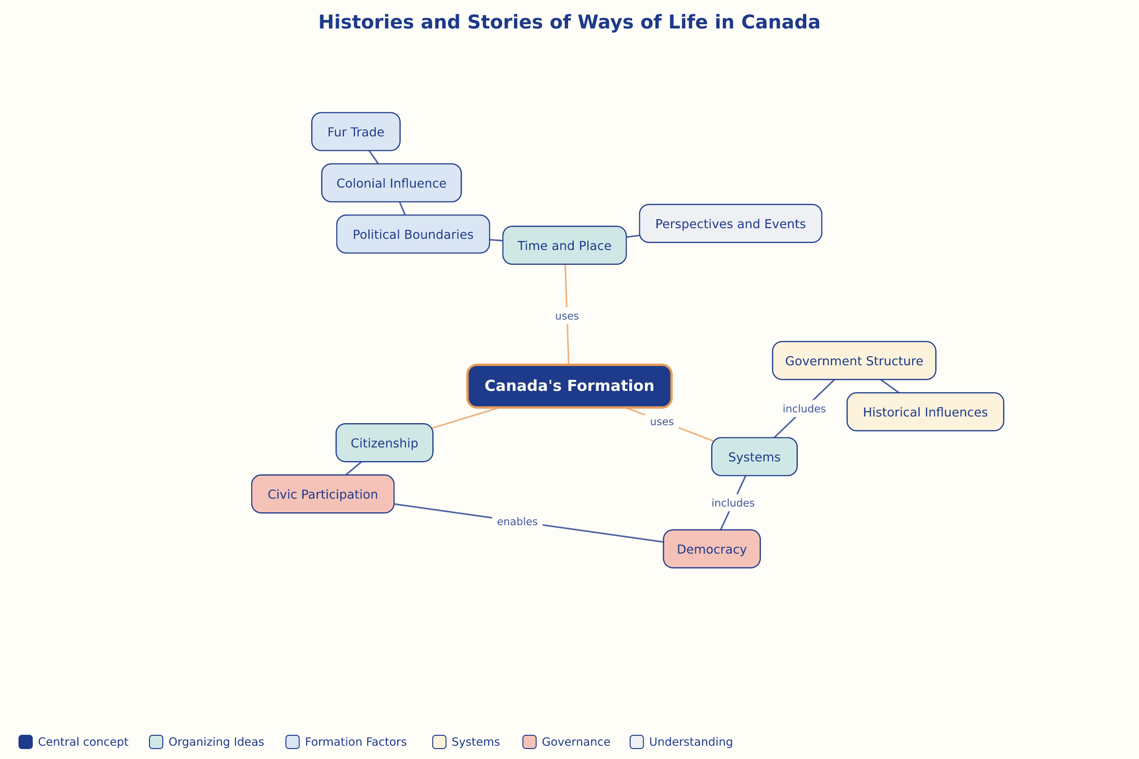

AILI word map · en · claude-haiku-4-5-20251001 · 2026-09-17

