Movement Skills and Healthy Relationships (Grade 6)
Central concept: Physical Literacy

Connections
- Physical Literacy (develops through) -> Movement Patterns
- Physical Literacy (supported by) -> Conflict Resolution
- Movement Patterns (applied in) -> Controlled Activities
- Movement Patterns (applied in) -> Dynamic Activities
- Movement Patterns (improves) -> Skill Proficiency
- Movement Patterns (enables) -> Creative Movement
- Movement Patterns (includes) -> First Nations, Métis, Inuit Activities
- Controlled Activities (supports) -> Skill Proficiency
- Dynamic Activities (supports) -> Skill Proficiency
- Conflict Resolution (supports) -> Engagement in Physical Activity
- Conflict Resolution (supports) -> Engagement in Physical Activity
- Conflict Resolution (supports) -> Engagement in Physical Activity
- Cooperative and Competitive Situations (influences) -> Conflict Resolution

Notes
- Physical Literacy: Development through movement and active living supporting well-being Outcome, Outcome
- Movement Patterns: Movements that enable the body to respond to stimuli; can be customized and transferred across activities Knowledge, Knowledge
- Controlled Activities: Structured, individual, or partnered activities allowing repeated practice of movement skills Knowledge
- Dynamic Activities: Fluid and changing activities requiring immediate decision making and skill refinement Knowledge
- Skill Proficiency: Accuracy, speed, and competence developed through adapting movement patterns Skills
- Creative Movement: Using objects, tempo, rhythm, and adaptation to develop movement combinations and sequences Knowledge, Understanding
- Conflict Resolution: Practices to manage disagreements and support engagement in physical activity Outcome, Knowledge
- Team Effectiveness: Influenced by ability to manage conflict and collaborate toward shared goals Understanding
- Managing Emotions: Acknowledging feelings as part of conflict resolution practice Knowledge
- Listening and Understanding: Clarifying facts and listening to understand others' perspectives in conflict Knowledge
- Cooperative and Competitive Situations: Different contexts that influence how individuals experience and resolve conflict Knowledge, Understanding
- First Nations, Métis, Inuit Activities: Unique and diverse movement patterns providing opportunities to develop and enhance skill Knowledge
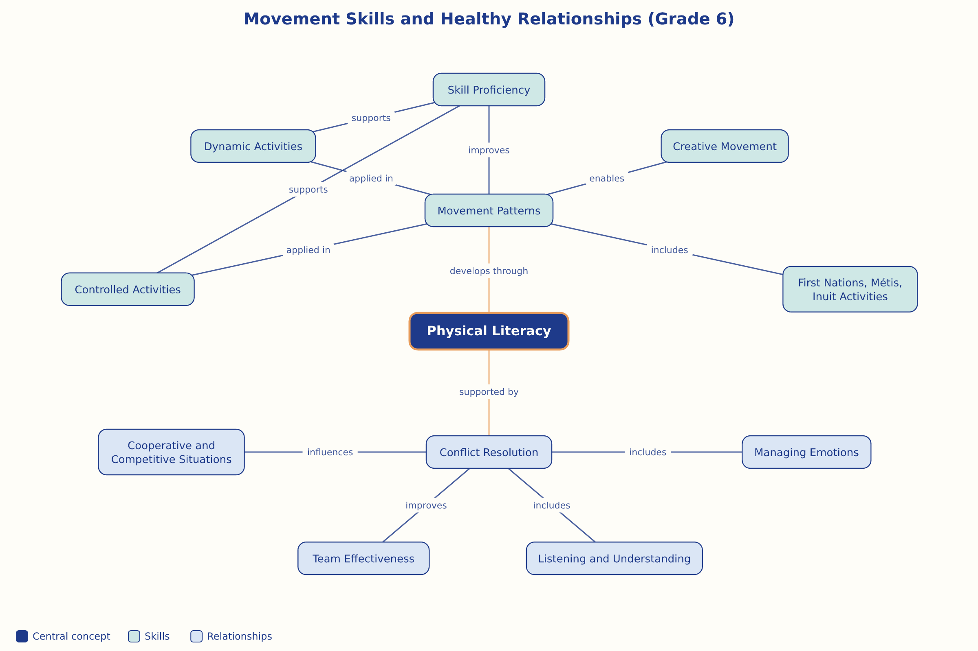

AILI word map · en · claude-haiku-4-5-20251001 · 2026-09-17

