Cells and Systems
Grade 8 Science: from single cells to whole-body systems

Slide 1: Cells and Systems
Grade 8 Science: from single cells to whole-body systems
Sources: Topic
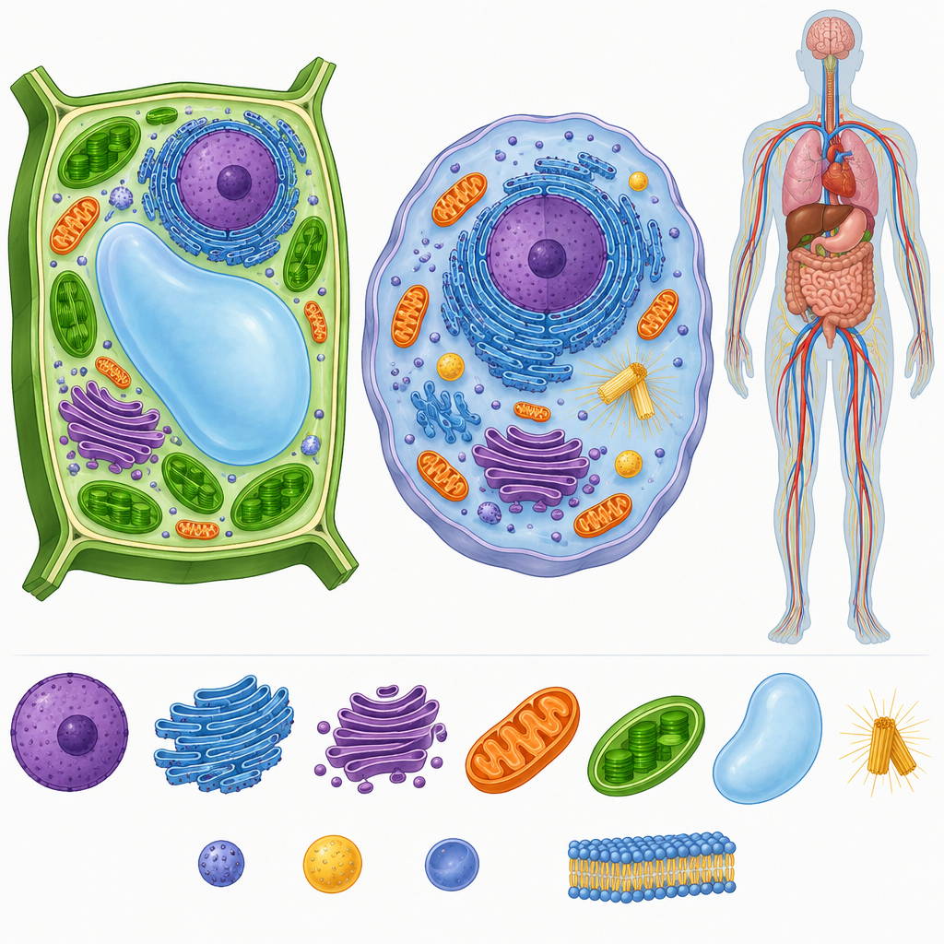
Notes: Introduce the unit by connecting the idea that all living things, from single cells to complex organisms, are organized into systems. Preview that students will investigate cells, tissues, organs, and body systems.

Slide 2: Why Study Cells and Systems?
- Living things take many forms, but scientists use ideas like systems, cells, structures and functions to make sense of that diversity (Topic).
- Finding pattern within diversity is a major challenge in biology, from individual cells to complex organisms (Topic).
- Healthy organisms, including healthy humans, function as balanced systems within a life-supporting environment (Topic).
- Focusing question: what do living things have in common, from the smallest to the largest? (Topic)
Sources: Topic
Notes: Set the stage using the Grade 8 unit overview. Ask students to brainstorm what a single-celled organism and a human have in common before revealing the focusing questions.

Slide 3: Cells: The Basic Unit of Life
What is a cell?
Cells are the basic unit of life (Outcome). Scientists compare single-celled and multicelled organisms, such as an amoeba versus a grizzly bear, or a single-celled alga versus a poplar tree (Outcome). Plant and animal cells differ: plant cells have cell walls while animal cells have only cell membranes (Outcome).
The movement of gases and liquids into and out of cells occurs during diffusion and osmosis, based on concentration differences.
Gases and liquids move into and out of cells through diffusion and osmosis, driven by concentration differences (Outcome). Students examine plant and animal structures to see how cells, tissues and organs each contribute a role (Outcome).
Sources: Outcome
Notes: Use a simple diagram or model to show diffusion across a membrane. Check understanding by asking students to name one similarity and one difference between plant and animal cells. Support: provide a labeled diagram; Extension: ask students to predict what happens if concentration gradients reverse.

Slide 4: How Human Body Systems Work Together
- Digestive system: Breaks down food and absorbs nutrients in the mouth, stomach, intestines, liver and pancreas (Details).
- Respiratory system: Exchanges oxygen and carbon dioxide using the trachea, lungs and diaphragm (Details).
- Circulatory system: Moves blood carrying oxygen and nutrients through the heart and blood vessels (Details).
- Body tissues and organs: Cells contribute to healthy functioning in nerves, muscle, blood, skin and bone (Outcome).
Sources: Details, Outcome
Notes: Walk through the flowchart step by step, emphasizing that these systems rely on each other rather than working alone. Ask students to trace the path of oxygen from lungs to a muscle cell. Formative checkpoint: have students draw their own arrow diagram connecting two systems.

Slide 5: Body Systems and Their Reactions to Stimuli
- Circulation: Blood circulates throughout the body to carry oxygen and nutrients to tissues and organs (Outcome).
- Respiration: Lungs exchange oxygen and carbon dioxide; bronchia provide a passageway for air (Outcome).
- Digestion, excretion, and sensory awareness are among the body systems that support healthy function and allow the body to react to internal and external stimuli(Outcome).
- Response to stimuli: Body functions change with conditions, such as heart rate rising during exercise or reflexes reacting to stimuli (Outcome).
Sources: Outcome
Notes: Use real-life examples students know, like heart rate during a soccer game or shivering in cold weather. Formative check: ask students to give their own example of a stimulus and body response. Support: provide sentence starters; Extension: ask students to explain why the response is useful for survival.

Slide 6: Systems Within Systems
Cells are the basic unit of life, and they organize into tissues and organs that contribute to the functioning of living things(Outcome). The digestive, respiratory, and circulatory systems work together to supply oxygen and nutrients to the human body(Details). Healthy organisms respond to internal and external stimuli, with body functions changing in response to changing conditions(Outcome).
Question: If one body system stops working properly, how might that affect the other systems it normally works with?
Sources: Details, Outcome, Outcome
Notes: Wrap up by returning to the unit's focusing question about diversity and common structure. Use the closing question as an exit ticket or think-pair-share to assess understanding of system interdependence.

AILI presentation · en · claude-sonnet-5 · 2026-09-17

