Reading and Responding to Texts
Central concept: Reading and Responding to Texts

Connections
- Reading and Responding to Texts (uses) -> Prior Knowledge
- Reading and Responding to Texts (uses) -> Comprehension Strategies
- Reading and Responding to Texts (leads to) -> Construct Meaning
- Reading and Responding to Texts (leads to) -> Appreciate Artistry
- Reading and Responding to Texts (analyzes) -> Forms and Genres
- Prior Knowledge (shapes) -> Multiple Interpretations
- Comprehension Strategies (enables) -> Construct Meaning
- Construct Meaning (includes) -> Character Analysis
- Construct Meaning (includes) -> Theme and Point of View
- Appreciate Artistry (examines) -> Literary Techniques
- Appreciate Artistry (examines) -> Plot, Setting and Mood
- Forms and Genres (includes) -> Media Texts
- Multiple Interpretations (deepens) -> Construct Meaning

Notes
- Reading and Responding to Texts: Grade 9 ELA: using strategies, constructing meaning, and appreciating artistry in texts Outcome, Outcome, Outcome, Outcome
- Prior Knowledge: Personal experiences and previous reading shape interpretation of texts Outcome, Outcome
- Comprehension Strategies: Identifying explicit and implicit ideas; selecting reading rate and previewing complex texts Outcome, Outcome
- Construct Meaning: Analyze character choices, identify theme and point of view, relate to personal experience Outcome
- Appreciate Artistry: Discuss techniques like irony, symbolism and perspective that enhance effect Outcome
- Character Analysis: Examine choices, motives, development and consistency across texts Outcome, Outcome, Outcome
- Theme and Point of View: Identify and discuss how narrator perspective affects meaning Outcome, Outcome
- Literary Techniques: Irony, symbolism, figurative language, imagery that create mood and tone Outcome, Outcome
- Plot, Setting and Mood: Interrelated elements developed through language choices and structure Outcome
- Forms and Genres: Relationships between purposes and characteristics of different text types Outcome
- Media Texts: Oral, print and other media including advertisements and digital content Outcome, Outcome
- Multiple Interpretations: Discuss and integrate various readings of the same text with peers Outcome, Outcome
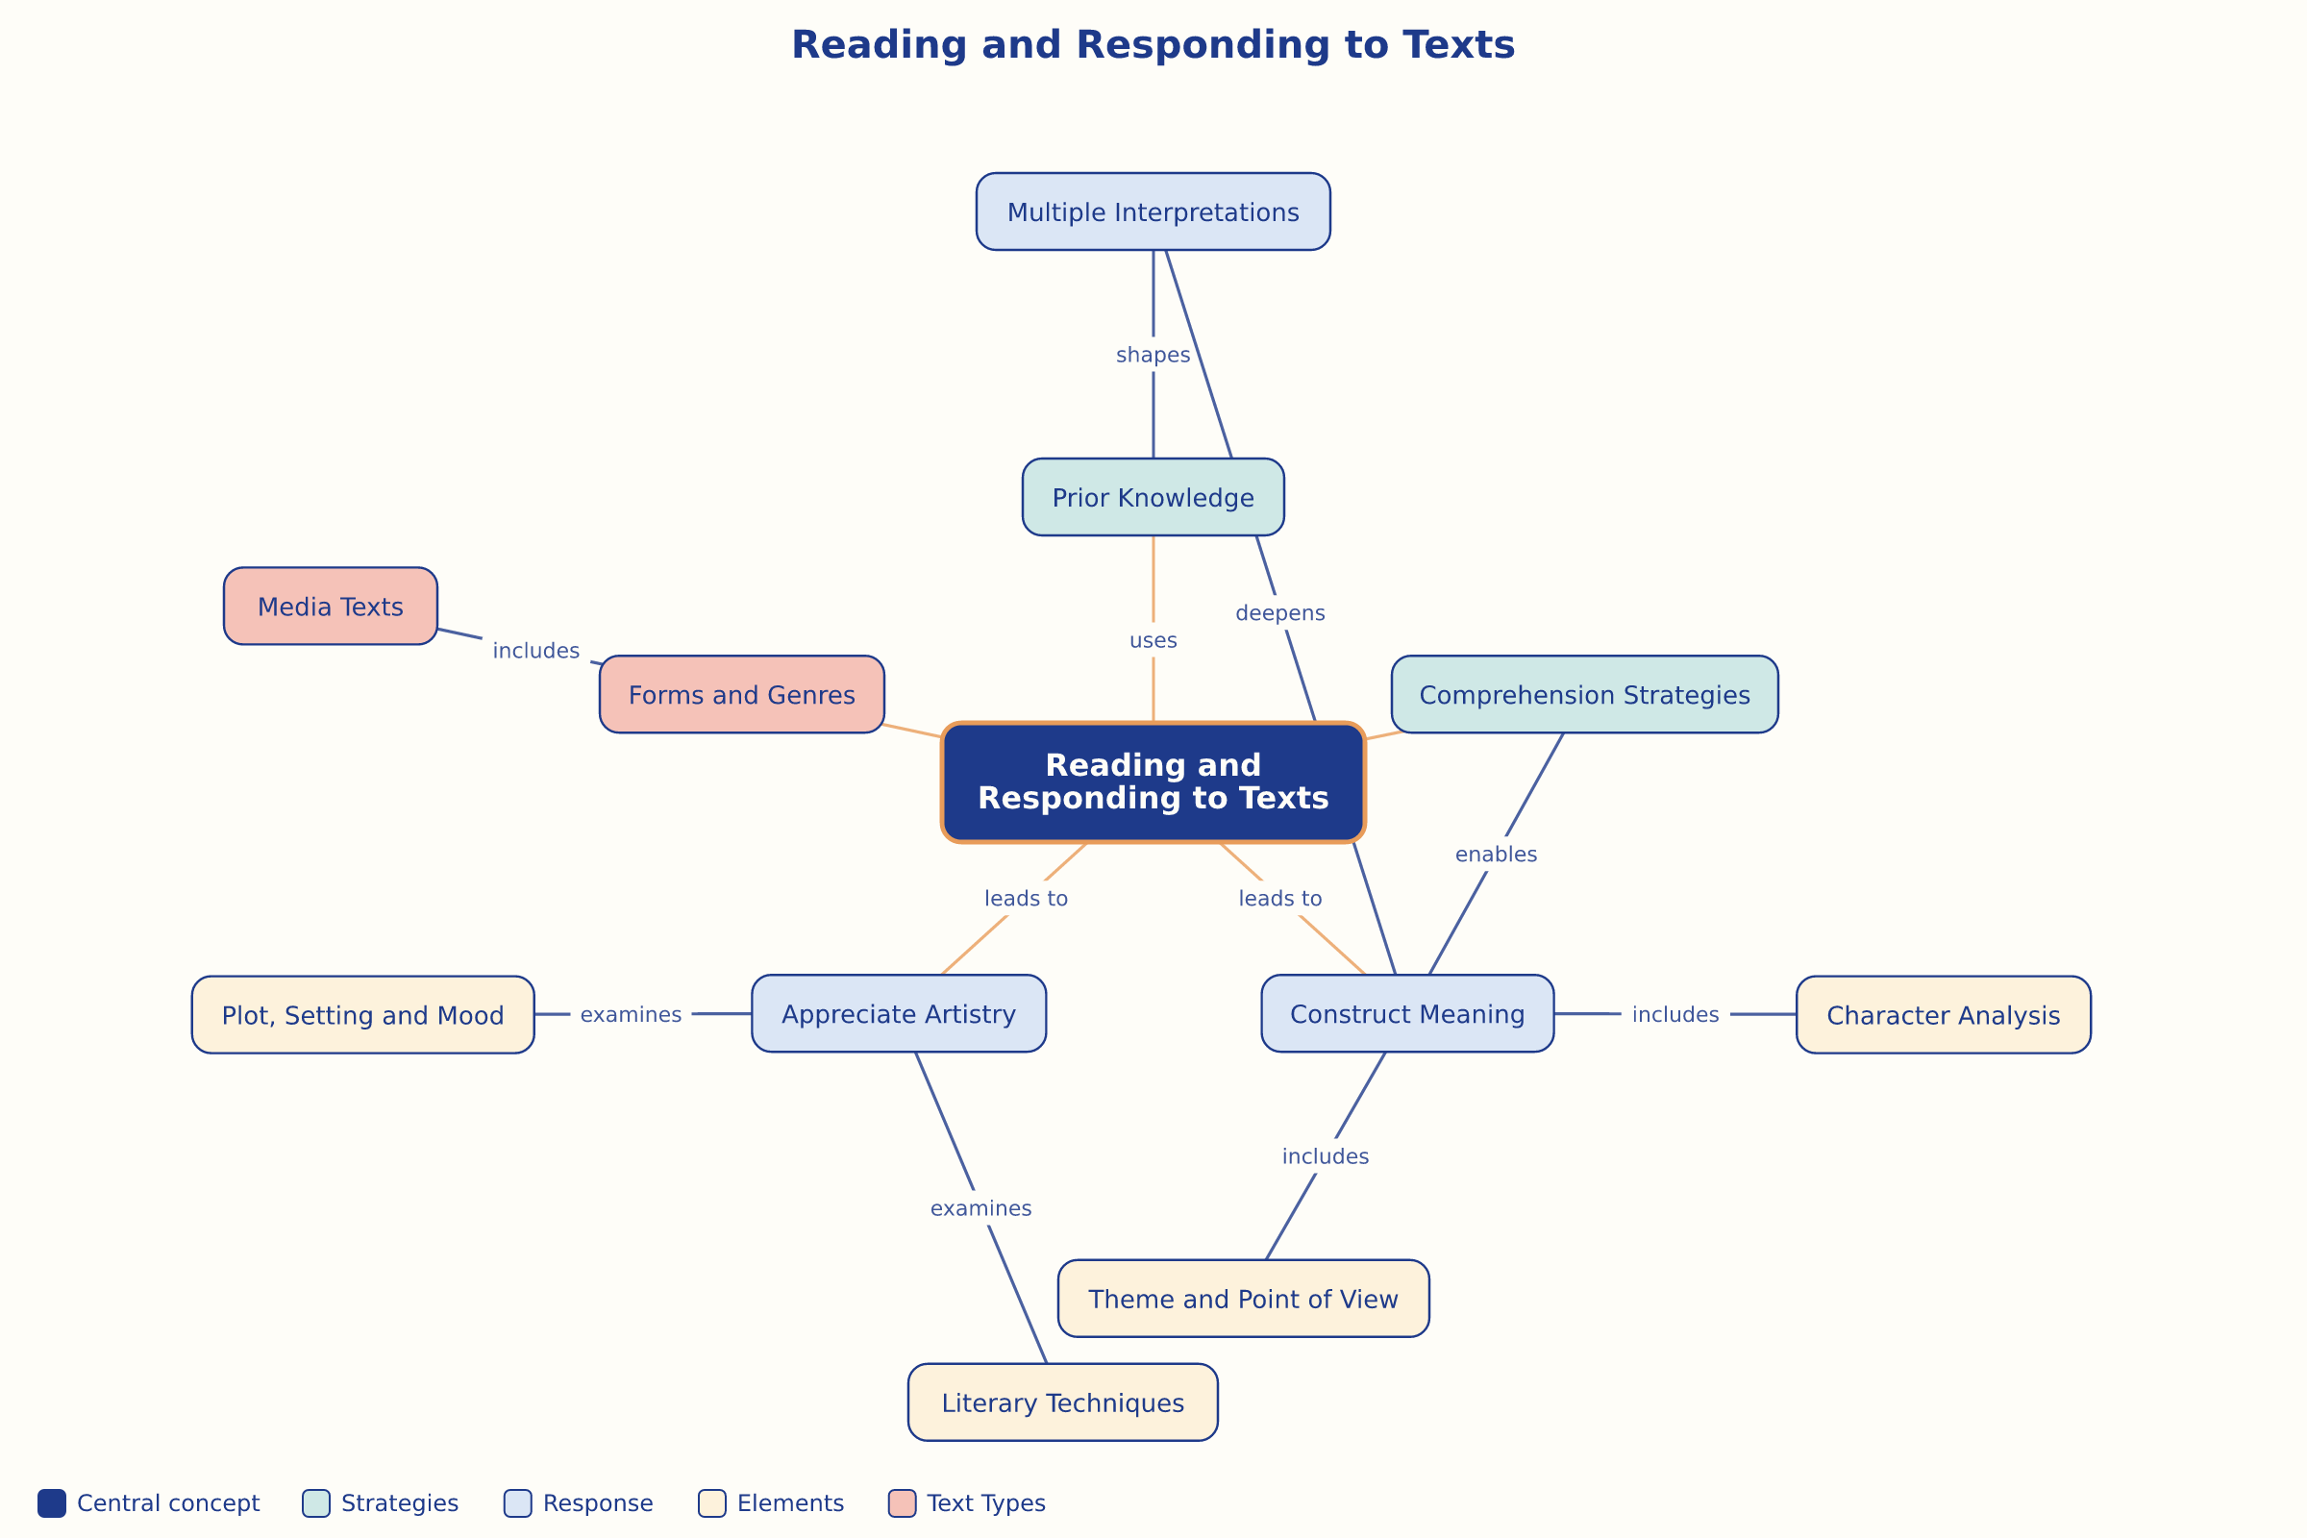

AILI word map · en · claude-haiku-4-5-20251001 · 2026-09-17

