The Early Morning Run
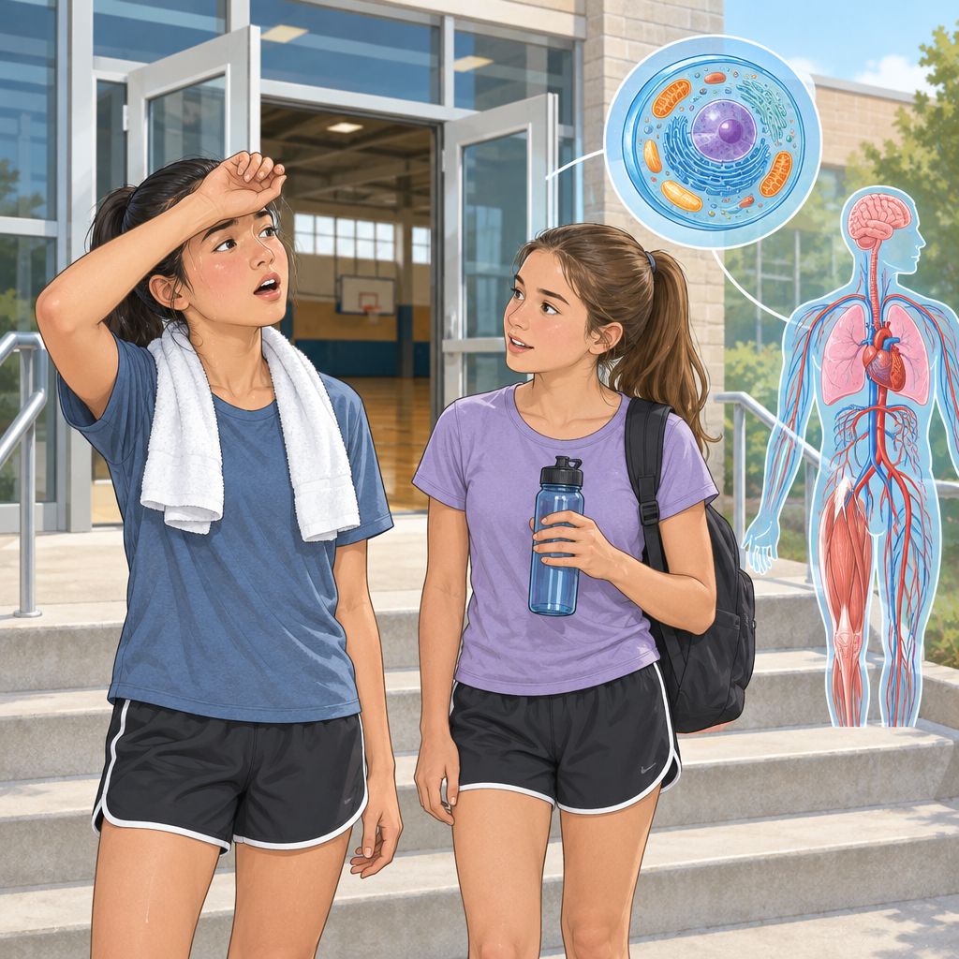
Maya stretched on the school gym steps, breathing hard from her morning jog. Her friend Kai walked over, water bottle in hand. "You're sweating buckets," Kai said. "What's going on in your body right now?" "My muscle cells are burning through glucose," Maya said. "My heart's pumping blood faster. My lungs are pulling in oxygen." Kai nodded. "That's what Mr. Chen was talking about. All those systems working together." "Right. When I run, my cells need more energy. So my digestive system breaks down food into nutrients. My circulatory system moves those nutrients and oxygen through my blood to my muscle cells. My respiratory system keeps feeding oxygen to every cell." "So they're not separate," Kai said. "Not even close. My musculoskeletal system contracts and pulls on my bones to create movement. Without it, none of the other systems would matter—I wouldn't be able to run at all. Every system depends on the others."
Maya pulled out her phone and showed Kai a microscope image. "Look—this is what a muscle cell looks like under magnification. See these tiny structures inside? They're called mitochondria. That's where the glucose actually gets converted into energy that the cell can use. The mitochondria are like the powerhouse of the cell." Kai leaned in. "So the organs and systems deliver the glucose and oxygen, but the mitochondria inside each cell is where the real energy work happens?" "Exactly. And all these cells—muscle cells, nerve cells, blood cells—they all have similar structures. That's cell theory: all living things are made of cells, and cells come from other cells. The systems we were talking about are really just millions of cells organized together, all communicating and working at the cellular level."

Words to know
- circulatory system: the heart and blood vessels that move blood and oxygen around the body
- respiratory system: the lungs and airways that take in oxygen and release carbon dioxide
- digestive system: the organs that break down food and absorb nutrients
- musculoskeletal system: muscles and bones that move the body and give it structure
- glucose: a simple sugar that cells use for energy
- cells: the smallest living units that make up all organisms
- nutrients: substances in food that the body uses for energy and growth
- mitochondria: organelles inside cells where glucose is converted into usable energy
- organelles: specialized structures inside cells that perform specific functions
- cell theory: the scientific principle that all living things are made of cells, and cells come from existing cells
- microscopy: the use of microscopes to observe cells and cellular structures
Curriculum link: Details, Outcome, Outcome
Listen to the narration

AILI audio story · en · claude-haiku-4-5-20251001 · 2026-09-17

