The Waterfall Power Plant Energy Efficiency Challenge Puzzle
This brain teaser asks you to trace energy as it moves through a hydroelectric system, from falling water to the electricity delivered to a home. It draws on the definitions of gravitational potential energy and kinetic energy and the relationship Ep = mgh (Outcome), on the description of hydroelectric generators as energy-transforming technologies (Outcome), and on the concept of "useful" energy and efficiency set out for technological systems such as a hydroelectric dam (Outcome). Solving it requires you to combine a quantitative energy calculation with an explanation of energy transformations in mechanical systems.

The puzzle
A small hydroelectric station draws water from a reservoir and drops it through a vertical height of 20 m before it strikes a turbine. Water flows through the system at a steady rate of 50 kilograms per second. Use g = 9.8 m/s² and assume no energy is lost to friction or air resistance as the water falls.
The turbine and generator together convert the kinetic energy of the falling water into electrical energy, but this conversion is only 80% efficient. The electricity then travels along transmission lines to town, and 5% of the electrical energy delivered by the generator is lost as heat in the wires before it reaches homes.
Determine:
- The gravitational potential energy converted each second as the water falls (that is, the power input to the system, in watts).
- The useful electrical power that actually reaches homes, in watts, after both stages of energy loss.
- Which law of thermodynamics explains why some energy is unavoidably lost as heat at each conversion stage, and why the station can never deliver 100% of its input energy as useful electricity.
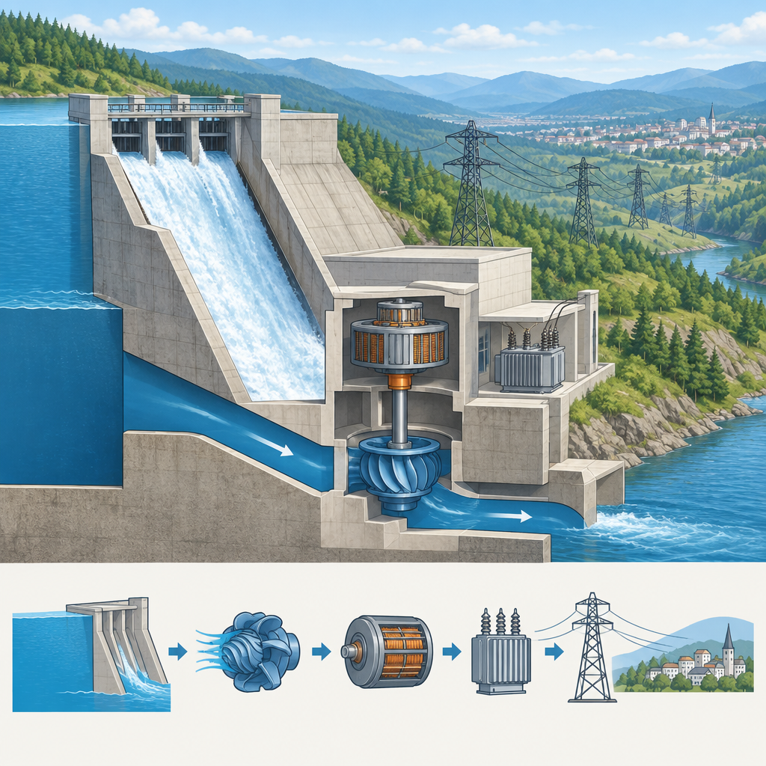

Hints
- Start by treating the falling water as a stream of small masses. Each second, 50 kg of water falls through 20 m. The energy converted per second is a power, measured in watts, and it comes directly from the potential energy equation Ep = mgh (Outcome).
- Once you have the power input, apply the 80% efficiency of the turbine-generator stage to find how much of that power becomes electrical energy. Then apply the second loss (5% lost in transmission) to the electrical power you just found, not to the original input power. Efficiency losses at each stage multiply, they do not simply add together (Outcome).
- For the conceptual question, recall that the first law of thermodynamics says energy is conserved overall, so no energy vanishes. The reason the station still cannot deliver 100% useful output lies in the second law: every real energy conversion produces some low-grade heat that cannot be fully recovered as useful work, which is also why real heat engines are never 100% efficient (Outcome).

Answer key
Step 1: Power input from falling water
Energy converted per second = mgh, applied to the mass flow rate:
Power = (mass per second) × g × h = 50 kg/s × 9.8 m/s² × 20 m = 9 800 W (9.8 kW)
This is the rate at which gravitational potential energy becomes kinetic energy as the water falls (Outcome).
Step 2: Useful electrical power delivered to homes
First loss stage (turbine and generator, 80% efficient):
9 800 W × 0.80 = 7 840 W
Second loss stage (transmission lines, 95% of the electrical power survives after a 5% loss):
7 840 W × 0.95 = 7 448 W
The useful power actually delivered to homes is 7 448 W, or about 7.4 kW. The overall efficiency of the whole system is 7 448 W ÷ 9 800 W = 0.76, or 76% (node:n%). This matches the outcome that efficiency compares the useful work obtained to the total energy put into the process (Outcome).
Step 3: Why energy is lost at each stage
The first law of thermodynamics states that energy is conserved: the total amount of energy in the system stays the same, it only changes form. No energy actually disappears when the water falls, when the turbine spins the generator, or when current flows through the transmission wires (Outcome).
The second law of thermodynamics explains why the station can never deliver 100% of that energy as useful electricity. Every real energy conversion produces some energy in a less useful form, almost always heat, that cannot be fully recovered and turned back into useful work. This is the same reason heat engines are never 100% efficient (Outcome). In the turbine and generator, friction and electrical resistance convert some kinetic energy directly into heat. In the transmission lines, resistance in the wires converts some electrical energy into heat as current flows. In both cases, the "lost" energy has not vanished, it has simply become unusable for the purpose of lighting homes and running appliances, which is why engineers describe it as a limit on the "useful" energy that a technological device can deliver (Outcome).

AILI game · en · claude-sonnet-5 · 2026-09-17

