The Particle Model of Matter
Exploring solids, liquids, and gases through tiny particles

Slide 1: The Particle Model of Matter
How tiny particles explain solids, liquids, and gases
Sources: Topic, Guiding question
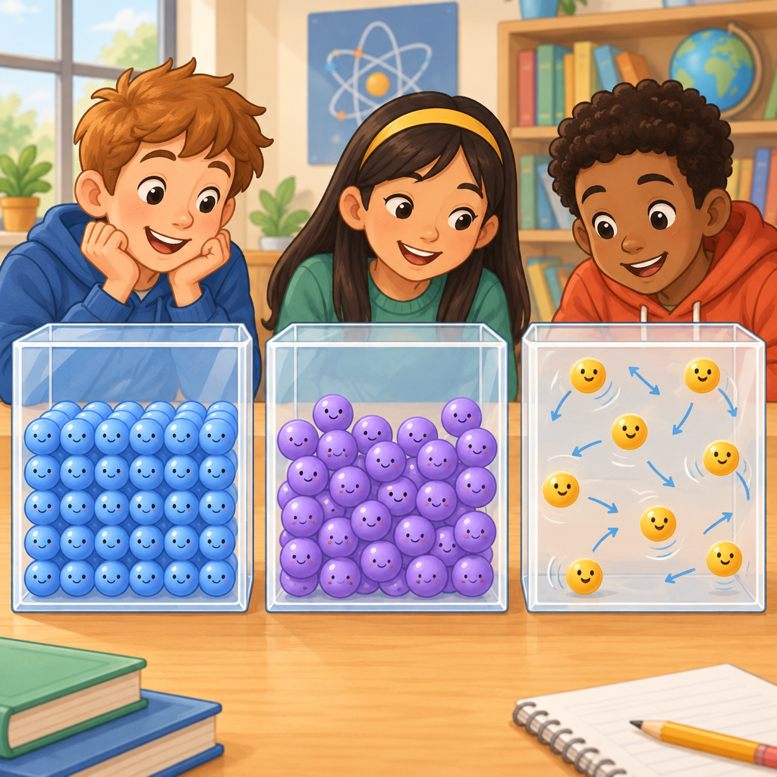
Notes: Introduce the big idea: everything around us is made of tiny particles too small to see. Ask students to name solids, liquids, and gases they see in the classroom before moving on.

Slide 2: What the Particle Model Tells Us
- All matter is made up of small particles (Details).
- Particles of matter are always moving (Details).
- There are spaces between particles (Details).
- The particle model explains how solids, liquids, and gases behave (Outcome).
Sources: Outcome, Details
Notes: Learning outcome: Students investigate the particle model of matter in relation to physical properties of solids, liquids, and gases (Outcome). Success criteria: I can state the three main ideas of the particle model. Formative checkpoint: cold-call a few students to repeat one idea in their own words. Support: pair the three ideas with a simple hand motion (fists together, wiggling, spread apart) to help memory. Extension: ask students to predict what happens to particles when a balloon is squeezed.

Slide 3: Particles in Solids, Liquids, and Gases
- Solids: Particles are close together and vibrate in place (Details).
- Liquids: Particles have spaces between them and can slide past each other (Details).
- Gases: Particles have large spaces and move constantly in all directions (Details).
- Attractive forces: Strongest in solids, weakest in gases (Details).
Sources: Details
Notes: Materials: three clear containers or three hoops on the floor with students acting as particles. Have groups act out each state by moving as described. Formative checkpoint: watch which group correctly shows spacing and movement for their assigned state. Differentiation: support students by giving a movement card with one action word; extension students explain why attractive forces change between states.

Slide 4: Mass, Volume, and Density
Mass and Volume
Matter exists in three states: solids, liquids, and gases, each with different particle arrangements and movement(Details). Volume is the amount of space matter takes up, measured in millilitres (mL) or litres (L) for liquids (Details).
Density
Density compares the mass of matter to its volume (Details). A denser object has more mass packed into the same space. Something less dense than a liquid will float on it, and something denser will sink (Details).
Sources: Details
Notes: Materials: balance scale, graduated cylinder, small objects of similar size but different density (e.g., wood block, metal block). Skill: measure mass and volume using SI units and a balance scale (Details). Formative checkpoint: exit ticket asking students to explain why a cork floats but a coin sinks. Support: give sentence starters. Extension: have students research the density of an object at home and compare it to water.

Slide 5: Heating and Cooling Change Particle Behaviour
- Heat matter: Particles move faster (Details).
- Attractive forces weaken: Space between particles increases (Details).
- Cool matter: Particles move slower (Details).
- Attractive forces strengthen: Space between particles decreases (Details).
- Phase change: Matter changes state; mass stays the same, volume may change (Details).
Sources: Outcome, Details
Notes: This connects to Grade 6 outcomes on heating and cooling particles (Outcome), useful as an extension or preview for students ready to go further. Formative checkpoint: ask students to predict what happens to the spacing of particles in a pot of water as it boils. Support: use an ice cube melting demonstration to make the sequence concrete. Extension: introduce the Celsius scale and its connection to water's melting and boiling points (Details).

Slide 6: Bringing It Together
Summary: The particle model of matter helps us explain why solids, liquids, and gases look and act the way they do. Particles are always moving, and the spaces and forces between them determine whether matter is a solid, a liquid, or a gas (Details). These same ideas help explain mass, volume, and density, and they connect to how matter changes when heated or cooled (Outcome).
Question: If you could shrink down and stand between the particles of your favourite drink, would you be sliding past your neighbours or zooming around in wide open space? What state of matter would that be?
Sources: Details, Outcome
Notes: Wrap-up discussion: have students share their answer with a partner, then a few volunteers with the class. Formative checkpoint: use this as an exit question to gauge understanding of liquid versus gas particle behaviour before moving to the next lesson on density and buoyancy.

AILI presentation · en · claude-sonnet-5 · 2026-09-17

