Listening to Our Bodies: Food and Fun in Motion
A Grade 2 lesson connecting healthy eating cues, food traditions, and active movement
Audience: Grade 2 students in a Physical Education and Wellness classroom or gym setting
Grades: Grade 2
Subjects: Physical Education and Wellness
Time: about 60 minutes
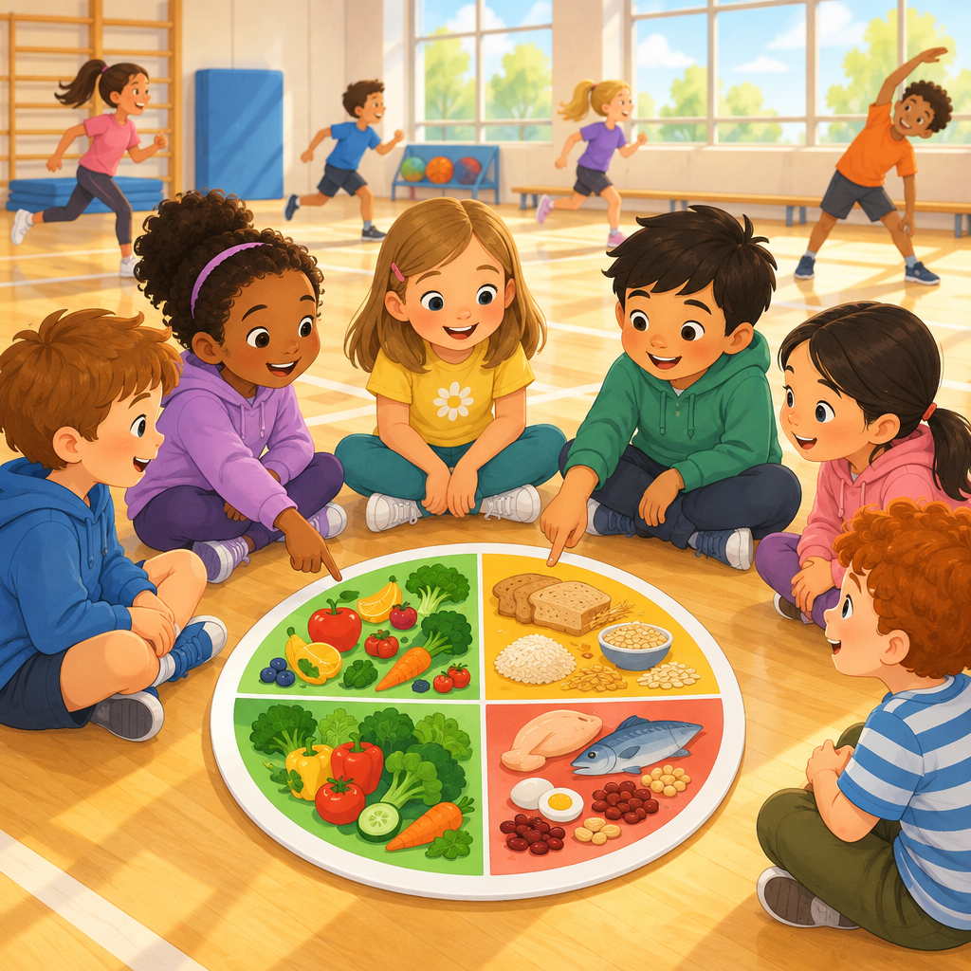

Overview
This lesson invites Grade 2 students to explore two connected ideas: how their bodies tell them what they need through hunger and thirst cues (Knowledge, Skills, Understanding), and how movement can be adjusted, enjoyed, and shared with others (Outcome, Knowledge, Skills).
Students sort foods using a simple food guideline model (Knowledge, Skills, Understanding), reflect on personal food preferences, allergies, and family traditions (Knowledge, Skills, Knowledge, Skills, Understanding), then move their bodies through light, moderate, and vigorous activity with proper warm-up and cool-down (Knowledge, Skills, Knowledge). A partner challenge builds in adventurous play and positive social interaction (Knowledge, Skills, Skills, Understanding), tying eating and moving together as parts of one healthy day.

Outcomes covered
- Students examine internal and external factors that influence food choices and decisions. (Outcome)
This helps children understand what makes movement enjoyable and meaningful for them personally, building lifelong habits of active living.
- Students investigate physical activity and relate it to personal experience. (Outcome)
Students investigate physical activity and relate it to personal experience.
- Identify how factors influence physical activity, and describe experiences as a result of participating in adventurous play. (Skills, Knowledge)
Recognizing what shapes their activity choices helps students build confidence and independence in staying active.
- Participate in physical activities that require various levels of exertion and energy. (Skills, Knowledge)
Experiencing light, moderate, and vigorous movement helps students understand how their body responds to different kinds of activity.
- Demonstrate appropriate preparation for and recovery from physical activity. (Skills, Knowledge)
Warming up and cooling down helps prevent injury and teaches lifelong habits for safe movement.
- Demonstrate positive interactions with others during physical activity. (Skills, Understanding)
Working with others during play builds social skills and supports mental well-being.
- Discuss cues associated with hunger and thirst. (Skills, Understanding)
Recognizing body cues such as a growling stomach or dry mouth helps students respond to what their body needs.
- Use food guidelines to identify the variety of foods the body needs. (Skills, Understanding)
Food guidelines give students information about the variety of foods their body needs to grow and feel well.
- Identify foods that may cause allergic reactions and describe why awareness matters. (Skills, Knowledge)
Students can investigate how different foods affect their energy levels during physical activity.
- Discuss ways that food provides insights into various cultures, practices, and traditions. (Skills, Knowledge, Understanding)
Sharing family and cultural food traditions helps students see how food connects people and communities.

Materials
- Chart paper and markers
- Large paper plate outlines divided into food guideline sections
- Food picture cards (apple, broccoli, egg, bread, milk, chicken, rice, orange, yogurt, carrot)
- Journal pages with three boxes for food preferences, allergens, and traditions
- Drawing pencils or crayons
- Open gym space or cleared classroom area
- One soft object per pair, such as a beanbag or foam ball
- Timer or stopwatch

Sequence of activities

1. Hungry Tummy, Thirsty Body: Reading Our Cues (12 min, whole class)
- Gather students in a circle on the floor.
- Ask: "What does your body do when it needs food?" Let three or four students share.
- Write student answers on chart paper under a heading called Hunger Cues. Guide toward: stomach growling, low energy, feeling grumpy (Knowledge).
- Ask: "What does your body do when it needs water?" Add a second list called Thirst Cues: dry mouth, low energy, headache (Knowledge).
- Play a quick game called Cue or Not. Say a body clue out loud, such as "dry mouth" or "jumping high." Students give a thumbs up if it is a hunger or thirst cue, and a thumbs down if it is not.
- Ask: "Why is it helpful for your body to send you these signals?" Guide students to see that the body tells us what it needs (Understanding).
- Have each student turn to a partner and whisper one cue they noticed in their own body this week.
This activity builds background for Skills and Understanding. Keep the tone light and curious, not clinical. Some children may not recognize hunger or thirst cues yet, and that is expected at this age. Watch for a student who mentions feeling irritable, and gently connect it to hunger without singling anyone out.
Sources: Knowledge, Skills, Understanding

2. Our Food Guideline Plate Sort (14 min, small group)
- Show a large paper plate divided into sections labeled with pictures for vegetables and fruit, protein foods, and whole grains.
- Explain: "A food guideline is like a helpful map. It shows us foods our body needs to grow and feel good" (Knowledge).
- Give each small group a set of food picture cards (apple, broccoli, egg, bread, milk, chicken, rice, orange, yogurt, carrot).
- Groups sort their cards onto a shared paper plate outline, placing each food in the section it best fits.
- Circulate and ask each group: "Why did you put that food there?"
- Bring the class back together. Ask one group to share one surprising sort.
- Discuss: "How does looking at a food guideline help us make choices?" Guide toward the idea that it gives us information to decide what to eat (Skills, Understanding).
This activity addresses Knowledge, Skills and Understanding. If picture cards are not available, students can draw quick food pictures instead. Avoid labeling any food as bad. Frame all foods as having a place, some eaten often and some eaten sometimes. Note: Dairy items such as milk and yogurt belong in the protein foods section of Canada's Food Guide. If students sort these items differently, guide them to the protein foods section.
Sources: Knowledge, Skills, Understanding

3. My Food Story: Preferences, Allergies, and Traditions (10 min, individual)
- Give each student a small journal page with three boxes: A Food I Love, A Food My Body Needs Me To Avoid (if any), and A Food From My Family's Traditions.
- Model your own example first, such as "I love oranges. My family eats bannock at celebrations."
- Students record their observations. Remind them the middle box can stay blank if no allergy applies to them (Knowledge, Skills).
- Invite volunteers to share their favourite food and their family tradition food with the class.
- Ask: "How can food help bring people together?" Guide toward ideas of celebration, family, and connection (Knowledge, Understanding).
- Collect journal pages to review food allergens quietly and privately. Food allergies are when one's body reacts unusually to food, and allergic reactions can range from mild to severe, including anaphylactic shock. Verify allergy information against official school medical records rather than relying on student self-report alone.
Addresses Knowledge, Skills, Knowledge, Skills, Understanding. Handle allergy sharing with care since some allergies can be severe, including anaphylactic shock (Knowledge). Frame this box as optional and private if a student prefers not to share aloud. Celebrate the variety of family traditions that emerge.
Sources: Knowledge, Skills, Knowledge, Skills, Understanding

4. Light, Moderate, Vigorous: Move Your Body (16 min, whole class)
- Move to the gym or an open space.
- Introduce a short warm-up: arm circles and gentle stretches. Explain warm-ups help our body get ready and lower the chance of getting hurt (Knowledge, Skills).
- Teach three movement zones: Light (slow walking), Moderate (marching or skipping), Vigorous (running or jumping jacks) (Knowledge).
- Call out a zone and have students move that way for 30 seconds, then freeze.
- After each round, ask: "How does your body feel right now?" Connect to breathing and heart rate in simple words.
- Play three rounds mixing all three zones in a fun order, like a game of Simon Says.
- Finish with a cool-down: slow walking and deep breaths for one minute (Knowledge, Understanding).
- Ask: "Which zone did you enjoy the most, and why?" Connect answers to personal enjoyment (Skills, Understanding).
Covers Knowledge, Skills, Understanding for exertion levels, and Knowledge, Skills, Understanding for warm-up and cool-down routines. Also touches personal enjoyment from Knowledge, Skills, Understanding. Watch for students needing rest breaks and remind everyone that stopping to catch a breath is normal and healthy. Use a simple checklist or tally to record which students demonstrate appropriate movement for each zone (light, moderate, vigorous) and can describe how their body felt, sampling 4–5 students per round to make observation manageable while leading the activity.
Sources: Knowledge, Skills, Understanding, Knowledge, Skills, Understanding, Knowledge, Skills, Understanding

5. Partner Adventure Challenge (8 min, pairs)
- Pair students up and give each pair one soft object, such as a beanbag or foam ball.
- Explain the challenge: partners must move the object across the room together without using their hands, such as by balancing it between their elbows, on their backs, or between their knees while walking slowly side by side. Adventurous play can provide individuals with opportunities to establish personal physical activity limits and develop confidence and independence.
- Give pairs two minutes to plan and try their idea.
- Ask: "What made this activity feel exciting or a little tricky?" Connect to the idea of healthy stress and problem-solving during adventurous play (Knowledge, Skills).
- Ask: "How did working with a partner feel?" Guide toward positive interaction and shared goals (Knowledge, Skills, Understanding).
- Celebrate every pair's effort, not just successful attempts.
This activity connects to Knowledge, Skills on adventurous play, and Knowledge, Skills, Understanding on positive interaction and mental health benefits of activity. Keep objects soft for safety. Support pairs who struggle to agree on a plan by suggesting they try one idea, then switch.
Sources: Knowledge, Skills, Knowledge, Skills, Understanding

Differentiation
Extension
- Ask early finishers in the plate sort to add one more food they know from home to each plate section.
- Invite students confident with writing to add a sentence in their journal explaining why their tradition food matters to their family.
- Challenge capable pairs in the Partner Adventure Challenge to complete the task using an additional rule, such as moving backward.
Support
- For the hunger and thirst cue discussion, provide picture cards showing facial expressions and body signals to help students who need visual prompts.
- During the food sort activity, pre-sort one or two example cards as a model before groups begin independently.
- For the movement zones activity, allow students who tire quickly to choose their own pace within each zone while still participating.
Inclusive supports
- Keep food allergy sharing private and optional, allowing students to speak with the teacher one-on-one if they prefer not to share aloud.
- Offer alternate seating or standing options during the circle discussion for students who find sitting on the floor difficult.
- Use simple, repeated visual icons for light, moderate, and vigorous zones to support English language learners and students who benefit from visual cues.

Assessment
Formative. During the Hungry Tummy, Thirsty Body discussion, listen for students correctly naming at least one hunger cue and one thirst cue.
Look for: Student can name a body signal such as stomach growling or dry mouth and connect it to needing food or water. (Knowledge, Skills, Understanding)
Formative. During the plate sort activity, observe whether groups can explain their reasoning for placing a food card in a section.
Look for: Group gives a reason connected to the food guideline, such as "an apple is a fruit, so it goes in this section." (Knowledge, Skills, Understanding)
Self. Students identify food preferences as ways an individual chooses what to eat or drink.
Look for: Journal page shows a personal food preference and, where relevant, a food to avoid, plus one tradition food connected to family or culture. (Knowledge, Skills, Knowledge, Skills, Understanding)
Formative. During the movement zones activity, use a simple checklist or tally to record which students demonstrate appropriate movement for each zone (light, moderate, vigorous) and can describe how their body felt. Sample 4–5 students per round to make observation manageable while leading the activity.
Look for: Student changes pace and effort correctly when the teacher calls each zone, and can describe how their body felt after vigorous movement. (Knowledge, Skills, Understanding, Knowledge, Skills)
Peer. During the Partner Adventure Challenge, pairs describe one thing that worked well and one thing that felt tricky when solving the challenge together.
Look for: Pairs can identify one successful strategy and one challenge they experienced, and explain how they worked together to solve the problem. (Knowledge, Skills, Skills, Understanding)

Vocabulary
- Hunger cue: A signal your body gives when it needs food, like a growling stomach or feeling grumpy.
- Thirst cue: A signal your body gives when it needs water, like a dry mouth or a headache.
- Food guideline: A helpful guide that shows the different foods our body needs to grow and stay well.
- Food allergy: When a person's body reacts in an unusual way to a certain food. This can be mild or very serious.
- Adventurous play: Play that lets you try new challenges, take safe risks, and build confidence.
- Warm-up: Gentle movements you do before activity to get your body ready.
- Cool-down: Slow, calm movements you do after activity to help your body rest.
- Vigorous activity: Movement that makes your heart beat fast and your breathing quicken, like running.

For families
- Ask your child what their body feels like when it is hungry or thirsty. Practise naming those feelings together at home.
- Look at a food guideline together in your kitchen and talk about which foods you eat often and which you enjoy sometimes.
- Share a family food tradition with your child and ask them to draw or describe it at school.
- Go for a family walk or play a movement game together, and notice how your bodies feel during light, moderate, and vigorous movement.

Sources
- Outcome: "Students investigate physical activity and relate it to personal experience."
- Outcome: "Students examine internal and external factors that influence food choices and decisions."
- Knowledge: "Adventurous play can provide individuals with opportunities to establish personal physical activity limits"
- Skills: "Identify how factors influence physical activity."
- Understanding: "Physical activity can be influenced by a variety of factors."
- Knowledge: "Many physical activities experienced on the land can be enjoyed across a lifespan"
- Skills: "Participate in physical activities on the land."
- Understanding: "Physical activity can be connected to experiences on the land."
- Knowledge: "Personal factors affecting physical activity include time, injury, enjoyment"
- Skills: "Participate in physical activities that can provide personal enjoyment."
- Understanding: "Physical activity can be modified in response to a variety of personal factors."
- Knowledge: "Preparation and recovery actions can support endurance, improve flexibility, and reduce the risk of injury."
- Skills: "Demonstrate appropriate preparation for and recovery from physical activity."
- Understanding: "Physical activities can be enhanced through preparation and recovery."
- Knowledge: "Physical activity can promote positive interactions with others"
- Skills: "Demonstrate positive interactions with others during physical activity."
- Understanding: "Participation in physical activity supports mental health"
- Knowledge: "Physical activity can be categorized as light, moderate, and vigorous."
- Skills: "Participate in physical activities that require various levels of exertion and energy."
- Understanding: "Physical activity can require varying degrees of exertion and energy."
- Knowledge: "Cues associated with hunger include stomach growling, low energy, irritability"
- Skills: "Discuss cues associated with hunger and thirst."
- Understanding: "The human body provides cues that tell an individual when they are hungry or thirsty."
- Knowledge: "Food guidelines provide information about the variety of foods the body needs."
- Skills: "Explore recommendations from a variety of food guidelines to support nutritional decisions."
- Understanding: "Food guidelines help to inform decision making."
- Knowledge: "Food allergies are when one's body reacts unusually to food."
- Skills: "Examine personal food preferences. Identify personal food allergens."
- Understanding: "Foods can contain risks and benefits to an individual's health."
- Knowledge: "Food can foster community, connection, family, tradition, celebration"
- Skills: "Discuss ways that food provides insights into various cultures, practices, and traditions."
- Understanding: "Food can provide an opportunity for individuals to experience various cultures and traditions."

All activities use age-appropriate language, soft equipment, and private handling of food allergy information, making the content safe and respectful for Grade 2 students.

AILI detailed pack · en · claude-sonnet-5 · 2026-09-17

