Cells as the Basic Unit of Life
Discover how cells form the foundation of all living things and work together to build complex organisms.
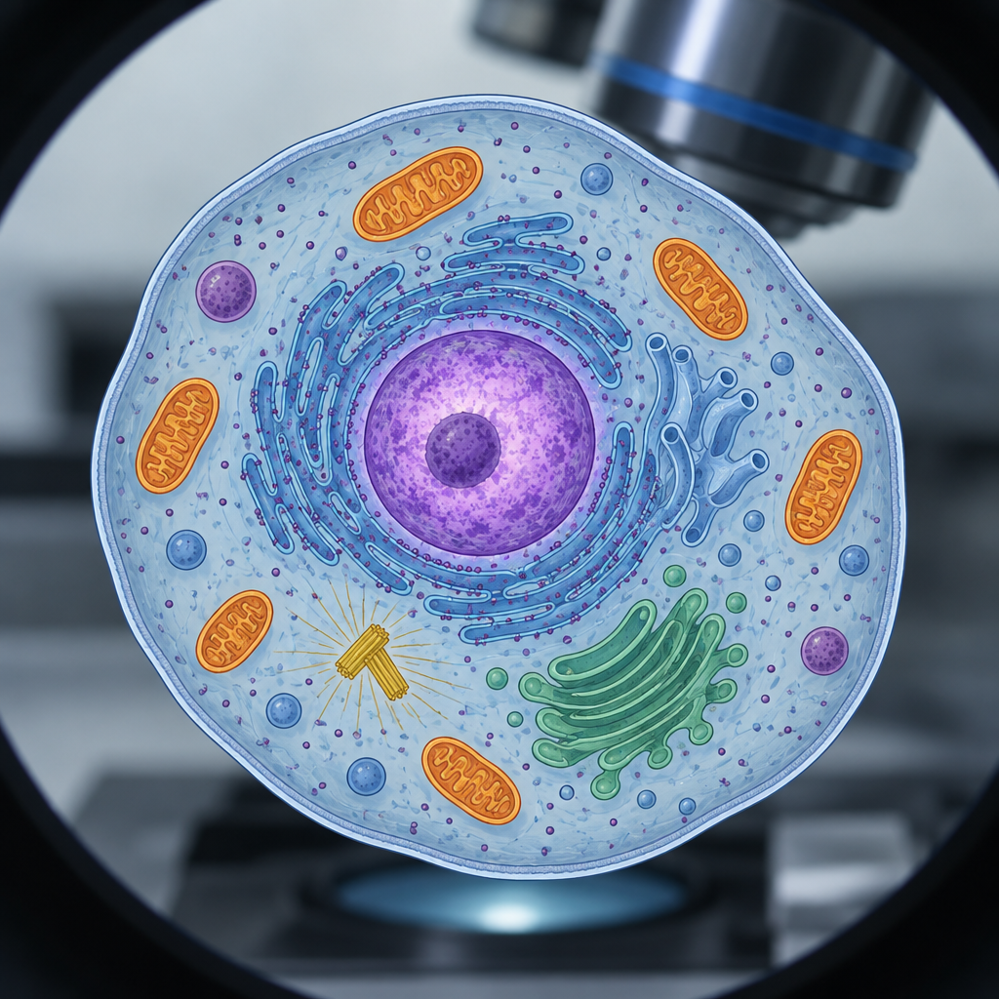

Learning intentions
We are learning to understand that cells are the basic unit of life and to identify how cells, tissues and organs work together in living organisms (Outcome).

Success criteria
I can describe the role of cells as a basic unit of life.
I can distinguish between plant and animal cells and explain the function of key structures.
I can identify how cells combine to form tissues and organs in both plants and animals.
I can explain how cells, tissues and organs work as a system.

Curriculum alignment
- Describe the role of cells as a basic unit of life (Outcome)
- Distinguish between plant and animal cells (Outcome)
- Examine plant and animal structures and identify contributing roles of cells, tissues and organs (Outcome)
- Apply the concept of system in describing familiar organisms and analyzing their general structure and function (Outcome)

Materials
- Microscope slides with prepared plant and animal cells (onion skin and human cheek cells)
- Microscopes or high-magnification images of plant and animal cells (printed or digital)
- Large diagram of a plant cell and an animal cell (one per pair or group)
- Coloured pencils or markers
- Chart paper or whiteboard
- Index cards with the following labels: cell, tissue, organ, system
- Optional: video clip (2 to 3 minutes) showing cells under magnification

Lesson sequence

1. Hook (5 minutes)
Show students a microscope image of a plant cell and an animal cell side by side (or display on a screen). Ask: "What do you notice? Are they the same? What structures can you see?"
Invite three or four responses. Do not correct yet; just listen.
Then say: "Every living thing you can see, your skin, a leaf, a mosquito, a tree, is made of these tiny units. They're so small you need a microscope to see them. Today we're going to find out what cells do and why they matter."

2. Direct instruction (12 minutes)
Part A: What is a cell? (4 minutes)
Explain: A cell is the smallest unit of life that can do all the things a living thing does. Every living organism is made of at least one cell. Some organisms, like bacteria, are single cells. Others, like you, are made of trillions of cells working together.
Write on the board: "Cells are the basic unit of life."
Ask: "Why do you think we call cells a 'unit'?" (A unit is a single thing that can stand alone or combine with others.) Accept answers such as "because one cell can be a whole organism" or "because many cells join together."
Part B: Plant cells and animal cells (5 minutes)
Display a large diagram of a plant cell. Point to and name these structures:
- Cell membrane: the outer boundary that controls what enters and leaves the cell
- Nucleus: the control centre that holds instructions for what the cell does
- Cytoplasm: the jelly-like substance inside the cell where work happens
- Cell wall: a rigid outer layer (plants only) that gives the plant its shape and strength
- Chloroplasts: structures that trap light energy to make food (plants only)
Then display a diagram of an animal cell. Point to the same structures (cell membrane, nucleus, cytoplasm) and note what is different: animal cells do not have a cell wall or chloroplasts.
Ask: "Why might a plant need a cell wall but an animal cell doesn't?" (Plants don't move around; they need rigid structure to stand up. Animals move, so they need flexibility.)
Part C: From cells to tissues to organs (3 minutes)
Explain: Cells do not work alone. Many cells of the same type join together to form a tissue. Many tissues work together to form an organ.
Write on the board:
Cell → Tissue → Organ → System
Give an example: In your skin, many skin cells join together to form skin tissue. Different tissues combine to form the skin organ. Your skin works with your nervous system, your blood vessels and your muscles to protect your body and sense the world around you.
Give a plant example: Many leaf cells join together to form leaf tissue. The leaf is an organ that traps sunlight to make food for the plant.

3. Guided practice (12 minutes)
Activity: Build a cell diagram (12 minutes)
Pair students. Give each pair a large blank diagram of either a plant cell or an animal cell (assign half the class each type).
Provide a list of structures and their functions:
Plant cell: cell membrane, nucleus, cytoplasm, cell wall, chloroplasts
Animal cell: cell membrane, nucleus, cytoplasm
Ask students to:
- Label each structure on their diagram.
- Write one sentence next to each structure describing what it does.
Circulate. Ask guiding questions such as:
- "What does the nucleus do?"
- "Why does a plant cell have a cell wall?"
- "What would happen if the cell membrane didn't control what enters the cell?"
After 8 minutes, ask students to hold up their diagrams. Choose two or three to show to the class. Ask the student: "Tell us one thing you learned about this structure" (pointing to one they labelled).

4. Independent practice (8 minutes)
Activity: Cells, tissues and organs matching
Give each student an index card with one of these terms: cell, tissue, organ, system.
Read aloud a series of examples. Students hold up their card if the example matches their term.
Examples:
- "A single skin cell" (cell)
- "All the skin cells working together to cover your body" (tissue)
- "Your skin, which protects you and senses touch" (organ)
- "Your skin, nervous system and blood vessels working together to sense and protect" (system)
- "A single leaf cell" (cell)
- "Many leaf cells joined together" (tissue)
- "A leaf that makes food for the plant" (organ)
- "The leaf, stem and roots working together to feed and support the plant" (system)
After each example, ask one student holding the correct card to explain why that term fits.

5. Consolidation (3 minutes)
Bring the class together. Ask:
"Today we learned that cells are the basic unit of life. Why is that important? What would happen if cells didn't exist?"
Accept responses such as "Nothing could be alive" or "We wouldn't exist."
Say: "Next lesson, we'll look at how cells move things in and out, and how your body's systems keep you healthy."

Differentiation

Support
- Provide a partially labelled cell diagram with a word bank. Students fill in the missing labels.
- Pair struggling readers with a stronger reader during the guided practice activity.
- Use only three or four cell structures (nucleus, cell membrane, cytoplasm, cell wall) instead of the full list.
- During the matching activity, allow students to use their diagram as a reference.

Extension
- Ask students to research and sketch a prokaryotic cell (bacteria) and compare it to a eukaryotic cell (plant or animal). What structures does it lack?
- Challenge students to explain why a single-celled organism like an amoeba can survive and reproduce, but an animal cell from your body cannot (Outcome). What does the single cell do that a multicelled organism's cells do together?
- Ask students to choose an organ (heart, leaf, stomach) and trace how its cells, tissues and organs work as a system to perform its function.

Assessment
Formative check: Cell structure and function matching
During the guided practice activity, circulate and ask each student or pair to point to a structure on their diagram and explain what it does.
What to look for:
- Can the student name the structure correctly?
- Does the explanation match the structure's function? (For example, "The nucleus holds instructions for what the cell does" is correct; "The nucleus is in the middle" describes location, not function.)
- Can the student explain why a plant cell has a structure an animal cell does not?
If a student struggles, ask a follow-up: "What would happen to the cell if this structure was missing?" This often helps them connect structure to function.
Record which students need reinforcement on cell structures before the next lesson.

AILI rapid lesson · en · claude-haiku-4-5-20251001 · 2026-09-17

