Enthalpy Changes and Calorimetry
Central concept: Enthalpy Changes

Connections
- Enthalpy Changes (defines) -> Enthalpy
- Enthalpy Changes (includes) -> Molar Enthalpy
- Enthalpy Changes (measured by) -> Calorimetry
- Enthalpy Changes (expressed as) -> ΔH Notation
- Calorimetry (uses) -> Heat Transfer Equation
- Calorimetry (requires) -> Calorimeter Design
- Calorimetry (measures) -> Temperature Change
- Heat Transfer Equation (includes) -> Temperature Change
- Calorimetry (applies to) -> Combustion Analysis
- Calorimetry (generates) -> Data Analysis
- Data Analysis (produces) -> Energy Diagrams
- Calorimeter Design (evaluated for) -> Experimental Error

Notes
- Enthalpy Changes: Energy change in chemical reactions at constant pressure Outcome, Outcome
- Enthalpy: Heat content of a system; defined for chemical reactions Outcome, Outcome
- Molar Enthalpy: Enthalpy change per mole of reactant or product Outcome, Outcome
- Calorimetry: Experimental technique to measure heat transfer in reactions Outcome, Resource, Resource
- Heat Transfer Equation: Q = mcΔt relates heat to mass, specific heat capacity, and temperature change Outcome, Outcome
- ΔH Notation: Standard notation to communicate and calculate energy changes Outcome
- Calorimeter Design: Simple apparatus using insulated containers to measure heat transfer Resource
- Temperature Change: ΔT is measured to determine heat absorbed or released Outcome, Outcome, Resource
- Combustion Analysis: Measuring heat released when substances burn in calorimetry Resource
- Data Analysis: Applying mathematical models to compare energy changes and assess solutions Outcome
- Energy Diagrams: Visual representation of energy changes in chemical reactions Outcome, Resource
- Experimental Error: Evaluation of calorimeter precision and accuracy in repeated trials Resource
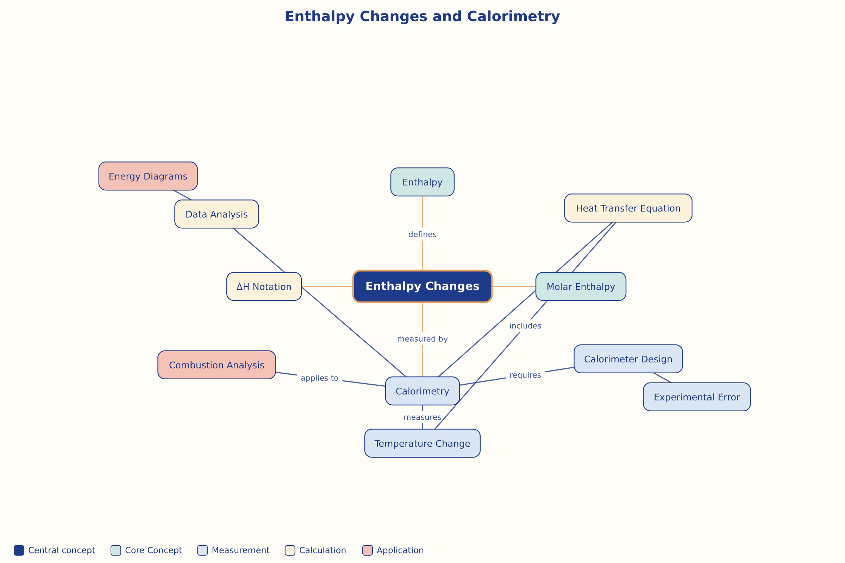

AILI word map · en · claude-haiku-4-5-20251001 · 2026-09-17

