Using Comprehension Strategies to Interpret Texts
Learn how to use six key strategies to understand what you read and respond to it thoughtfully.
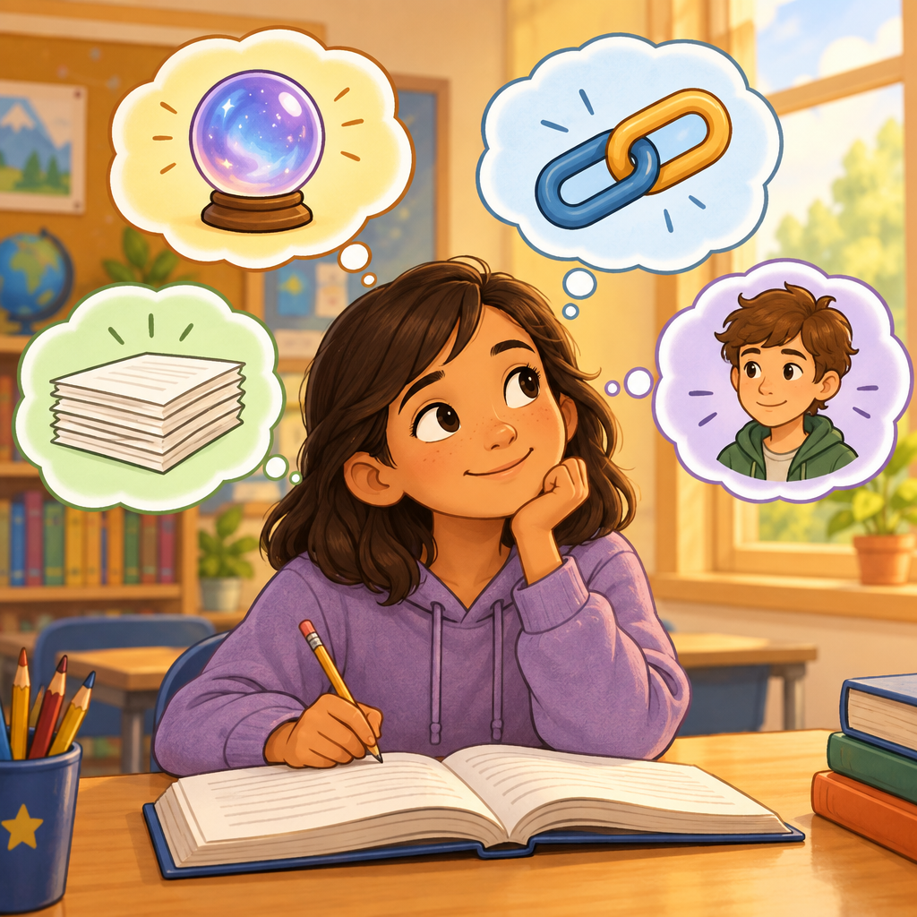

Learning intentions
We are learning to apply comprehension strategies to interpret and respond to texts (Outcome).

Success criteria
I can identify and use comprehension strategies including predicting, inferring, making connections, summarizing, synthesizing, and evaluating (Knowledge).
I can use context clues to infer word meanings and draw conclusions from texts (Skills).
I can explain how a comprehension strategy helped me understand a text better (Skills).

Curriculum alignment
Students interpret and respond to texts through application of comprehension strategies (Outcome). Comprehension strategies include predicting, inferring, making connections, summarizing, synthesizing, and evaluating (Knowledge). Students incorporate a variety of strategies to comprehend, interpret, and manage information from texts and evaluate the effectiveness of strategies used (Skills). Context clues include words, phrases, punctuation, dialogue, and information in pictures, diagrams, charts, or graphs (Knowledge). Students infer meanings from texts based on context clues and distinguish between information that is stated and inferred (Skills).

Materials
One short text (fiction or non-fiction, 300 to 400 words). A picture book or illustrated text works well for this grade. Copies for all students or display on screen.
Chart paper or whiteboard with the six strategy names written down.
Sticky notes (three per student).
Pencils.
Optional: a short video clip (30 to 60 seconds) to use as a hook.

Lesson sequence
1. Hook (5 minutes)
Show the opening of a short text or a picture from a story without reading the words aloud. Ask students: "What do you think will happen next? Why do you think that?"
Take two or three predictions. Write them on the board. Explain that what they just did is called predicting, and it is one of six tools readers use to understand texts better.
Say: "Today we are going to learn six strategies that will help you understand what you read and think more deeply about it."
2. Direct instruction: Introduce the six strategies (10 minutes)
Point to your chart with the six strategy names: predicting, inferring, making connections, summarizing, synthesizing, and evaluating.
Define each one in plain language:
Predicting: Making a guess about what will happen next based on what you have read so far.
Inferring: Using clues in the text and what you already know to figure out something the author did not say directly. For example, if a text says "Maya put on her coat and grabbed her backpack," you can infer she is going somewhere, even though the text does not say that word.
Making connections: Linking ideas in the text to something you know from your own life (text to self), from another book or movie (text to text), or from the world around you (text to world) (Knowledge).
Summarizing: Telling the main idea and most important details of what you read in your own words (Skills).
Synthesizing: Putting together ideas from different parts of the text to come up with a new understanding or answer a question (Skills).
Evaluating: Thinking about whether something in the text makes sense, is fair, or is true (Knowledge).
Explain that context clues help readers infer meaning. Context clues are words, phrases, punctuation, dialogue, and pictures around an unfamiliar word or idea (Knowledge).
Model one strategy with a short paragraph from your chosen text. Read aloud: "Jamie's hands were shaking as she stepped onto the stage. She took a deep breath and began to sing."
Think aloud: "I can infer that Jamie is nervous. The text does not say 'Jamie is nervous,' but her hands are shaking and she is taking a deep breath. Those are clues that tell me she feels nervous."
3. Guided practice with a shared text (15 minutes)
Read the full text aloud while students follow along. Stop at three or four points and ask students to use one strategy at a time.
After the first section, ask: "What do you predict will happen next? What clues in the text make you think that?"
After the middle section, ask: "What can you infer about the main character's feelings? What context clues helped you?"
After another section, ask: "Does this remind you of anything from your own life or from another story? Tell a partner."
Near the end, ask: "What is the main idea so far? What are the most important details?"
After finishing, ask: "What did you learn or understand by putting all these ideas together? How did that help you understand the story better?"
Write student responses on the board under each strategy name. Celebrate specific examples: "You used context clues from the dialogue to infer that. That is exactly what readers do."
4. Independent practice (8 minutes)
Give each student a short excerpt (one paragraph or one page) from the text or a new short text.
Ask students to use sticky notes to mark three moments where they used a strategy. On each sticky note, they write the strategy name and one sentence explaining what they thought.
Example: "Predicting: I thought the character would run away because she looked scared."
Example: "Making a connection: This reminds me of when I was nervous before my soccer game."
Circulate and listen. Ask students: "What strategy did you use there? How did it help you understand?"
5. Consolidation (2 minutes)
Gather the class. Ask two or three students to share one sticky note and read it aloud.
Ask the class: "Which strategy did they use? How did it help them understand the text?"
Remind students: "Good readers use these six strategies every time they read. When you read at home or in class, try using one or two of these strategies. It will help you understand and enjoy your reading more."

Differentiation
Support
Provide a shorter text (150 to 200 words) with simpler vocabulary.
Pair the student with a partner during guided practice. Ask the partner to help identify context clues.
Offer sentence frames for sticky notes: "I predicted that ___ because ___." "I inferred that ___ because the text said ___."
Focus on two strategies only (predicting and inferring) rather than all six.
Extension
Ask the student to use all six strategies with the same text and compare which strategy gave them the deepest understanding.
Introduce the idea of bias and perspective (Knowledge, Skills). Ask: "Does the author seem to favour one character or idea? What words or details show that?"
Have the student write a paragraph explaining how understanding context changed their interpretation of a character's actions (Skills).
Ask the student to find a second text on the same topic and synthesize ideas across both texts (Skills).

Assessment
Formative check: Sticky note review
Collect or photograph the sticky notes students created during independent practice.
Look for:
Does the student correctly name the strategy they used?
Does the sticky note show evidence of thinking (a prediction, an inference, a connection, a summary, a synthesis, or an evaluation)?
Can the student point to a clue in the text that supports their thinking?
If a student writes "I liked this part" or "This was funny," ask them to go deeper: "What strategy could you use? Can you infer why the character did that? Can you make a connection to your own life?"
Use this information to decide which strategies to revisit in the next lesson and which students need more practice with context clues.

AILI rapid lesson · en · claude-haiku-4-5-20251001 · 2026-09-17

