Communities in Alberta
We are learning about the people, cultures, and governments that make Alberta home.
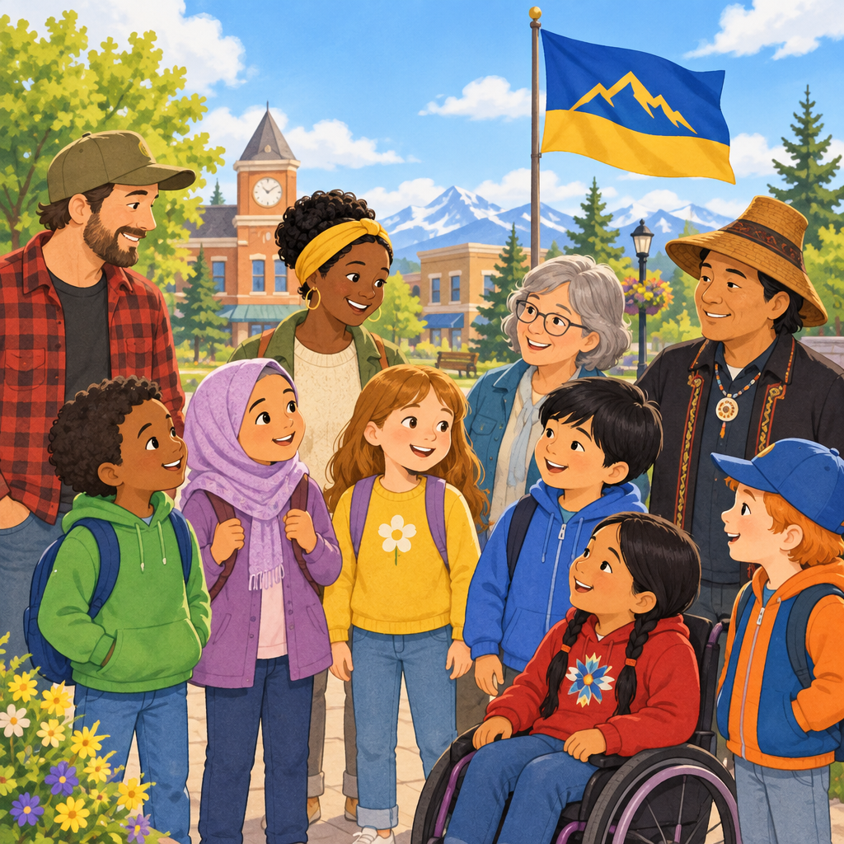

Learning intentions
We are learning to identify the diverse communities and cultures in Alberta (Outcome).
We are learning to understand how local governments serve communities (Outcome).

Success criteria
I can name some of the different groups of people who live in Alberta.
I can explain why Alberta is a diverse place.
I can tell the difference between what a local government does and what a provincial government does.
I can describe one symbol that represents Alberta.

Curriculum alignment
Students relate diversity to Alberta's western identity (Outcome, Understanding, Understanding).
Students compare municipal and provincial governments (Outcome, Understanding, Understanding).

Materials
- Large map of Alberta (printed or digital)
- Picture cards showing: First Nations symbols (tipi ring, standing bear), Métis sash, Red River cart, fleur-de-lis, Alberta flag, wild rose, Rocky Mountain bighorn sheep
- Chart paper and markers
- Index cards with names of Alberta communities (both First Nations and settler communities)
- Optional: video of Métis Settlement (Resource)
- Sticky notes

Lesson sequence

1. Hook (5 minutes)
Show the picture cards one at a time without naming them. Ask children: "What do you see? What does this remind you of? Who might use this?"
After showing all cards, say: "These are all symbols of different communities in Alberta. Today we are going to learn about the amazing people who live here."
Ask: "Who lives in your community? What languages do people speak? What celebrations do people have?" Take 2 to 3 answers.

2. Direct instruction: Who are Albertans? (12 minutes)
Say: "Alberta is home to many different groups of people. Let me tell you about them."
First Nations:
"First Nations people were the first to live on the land now called Alberta. There are 48 different First Nations communities here. Each one has its own language, culture, and history (Knowledge)."
Point to the tipi ring and standing bear cards. "These are symbols from different First Nations. The tipi ring is from the Blackfoot Confederacy. The standing bear is from the Kapawe'no First Nation. Some First Nations speak Cree, some speak Blackfoot, and some speak Dené (Knowledge)."
Métis:
"Métis people have their own unique culture. It blends First Nations and European ways of living (Knowledge). They hunt, farm, and trap like both groups do. Métis communities are called Métis Settlements, and the people who live there make their own decisions about their community (Knowledge)."
Point to the Métis sash and Red River cart. "These are Métis symbols. The sash is a special piece of clothing. The Red River cart was used to carry things across the land (Knowledge)."
Francophones:
"French was the first European language spoken in Alberta (Knowledge). French-speaking missionaries came here long ago. Today, many French speakers from all over the world live in Alberta. The fleur-de-lis is a symbol of French-speaking communities (Knowledge)."
Early settlers:
"People from many countries came to Alberta looking for farmland. Some came from Ukraine, some from China, some from the United States. They faced hard times, the land was unfamiliar and they did not always speak English (Knowledge). But they built communities and made Alberta their home (Knowledge)."
Immigrants:
"People still come to Alberta from all over the world. They come for jobs, to be with family, or to find safety. Today, Alberta has people who are Jewish, Chinese, Muslim, Arab, Hindu, Sikh, and Filipino (Knowledge). All of these people make Alberta more interesting and stronger (Understanding)."
Show the Alberta flag. "This flag represents all of us. It shows that Alberta is a place for many kinds of people (Knowledge)."

3. Guided practice: Government services (10 minutes)
Say: "Alberta has two kinds of government that help our communities. Let me show you the difference."
Draw two columns on chart paper. Label one "Local Government" and one "Provincial Government."
Ask: "What does your local government do? Who has been to a library? A local park? Who has seen a fire truck?"
Write children's answers in the Local Government column. Add: "Local governments run libraries, parks, fire departments, and fix roads (Knowledge). The leader might be a mayor, a chief, or a reeve (Knowledge)."
Ask: "What does the provincial government do? Who goes to school? Who has been to a hospital?"
Write in the Provincial Government column. Add: "The provincial government runs schools and hospitals. The premier is the leader (Knowledge). They make big decisions for the whole province (Knowledge)."
Point to the Alberta flag again. "The premier and other leaders meet at the Legislative Assembly to make decisions (Knowledge)."

4. Independent practice: Community symbols (8 minutes)
Give each child or pair an index card with a picture or name of a community symbol (tipi ring, Métis sash, fleur-de-lis, Alberta flag, wild rose, Rocky Mountain bighorn sheep).
Say: "Your job is to find where your symbol belongs on this chart." Point to a large chart with columns: First Nations, Métis, Francophone, Alberta.
Children place their card in the right column. As they work, ask: "Why did you put it there? What does this symbol tell us about that community?"

5. Consolidation (5 minutes)
Gather children together. Review the chart.
Ask: "What did you learn today about Alberta?"
Listen for: Alberta has many different groups of people. First Nations, Métis, Francophones, settlers, and immigrants all live here. Local and provincial governments help communities.
Say: "Alberta is special because so many different people live here. Each group brings their own language, food, celebrations, and stories. When we learn about each other, we build a stronger community (Knowledge)."
Close with: "Tomorrow we will learn more about how people in communities help each other."

Differentiation
Support:
Pair children who need support with a partner during independent practice. Provide picture cards instead of words. Ask simpler questions: "Is this First Nations or Métis?" Reduce the number of symbols to sort (four instead of six).
Extension:
Ask children to research one symbol more deeply. "Why do you think the wild rose is the flower for Alberta?" Invite them to draw their own symbol for their family or classroom community. Ask: "If you could add a new symbol for Alberta, what would it be and why?"

Assessment
Formative checkpoint during independent practice:
As children sort symbols, listen to their explanations. Look for:
- Can they name at least two different groups in Alberta?
- Do they understand that each group has its own culture and symbols?
- Can they explain why a symbol belongs to a particular community?
If a child cannot explain their choice, ask: "Tell me what you know about this symbol. Who uses it?" Provide a hint if needed: "Remember, the Métis sash is a special piece of clothing."

AILI rapid lesson · en · claude-haiku-4-5-20251001 · 2026-09-17

