Nationalism in Social Studies 20-1
Central concept: Nationalism

Connections
- Nationalism (relates to) -> Identity and Nation
- Nationalism (manifests as) -> Expressions of Nationalism
- Nationalism (has) -> Dimensions of Nationalism
- Nationalism (drives) -> National Interest
- Nationalism (can become) -> Ultranationalism
- Nationalism (competes with) -> Contending Loyalties
- Nationalism (tensions with) -> Internationalism
- Nationalism (undergoes) -> Evolution of Nationalism
- Nationalism (enables) -> Identity Promotion
- Historical Factors (shapes) -> Nationalism
- Ultranationalism (appears in) -> Nationalism in Conflict
- Identity and Nation (develops through) -> Historical Factors

Notes
- Nationalism: Identity, internalized feeling, and collective consciousness shared by a people Outcome
- Identity and Nation: Relationship between personal and collective identity and the nation-state Topic, Outcome
- Expressions of Nationalism: Range of ways nationalism is expressed across cultures and contexts Outcome
- Dimensions of Nationalism: Geographic, collective, civic, ethnic, cultural, linguistic, political, spiritual, religious, patriotic aspects Outcome
- Historical Factors: How nationalism develops through historical, geographic, political, economic and social factors Outcome
- National Interest: Pursuit of national interest as related to nationalism Outcome
- Ultranationalism: Extreme form of nationalism, distinct from moderate nationalism Outcome
- Nationalism in Conflict: Nationalism and ultranationalism during World Wars, Japanese ultranationalism, Canadian internments and conscription Outcome
- Contending Loyalties: Religion, region, culture, race, ideology, class loyalties that compete with nationalism Outcome
- Internationalism: Global cooperation and shared interests that may conflict with nationalism Outcome
- Evolution of Nationalism: Understandings of identity, nation and nationalism continue to evolve Outcome
- Identity Promotion: Why peoples seek to promote their identity through nationalism Outcome
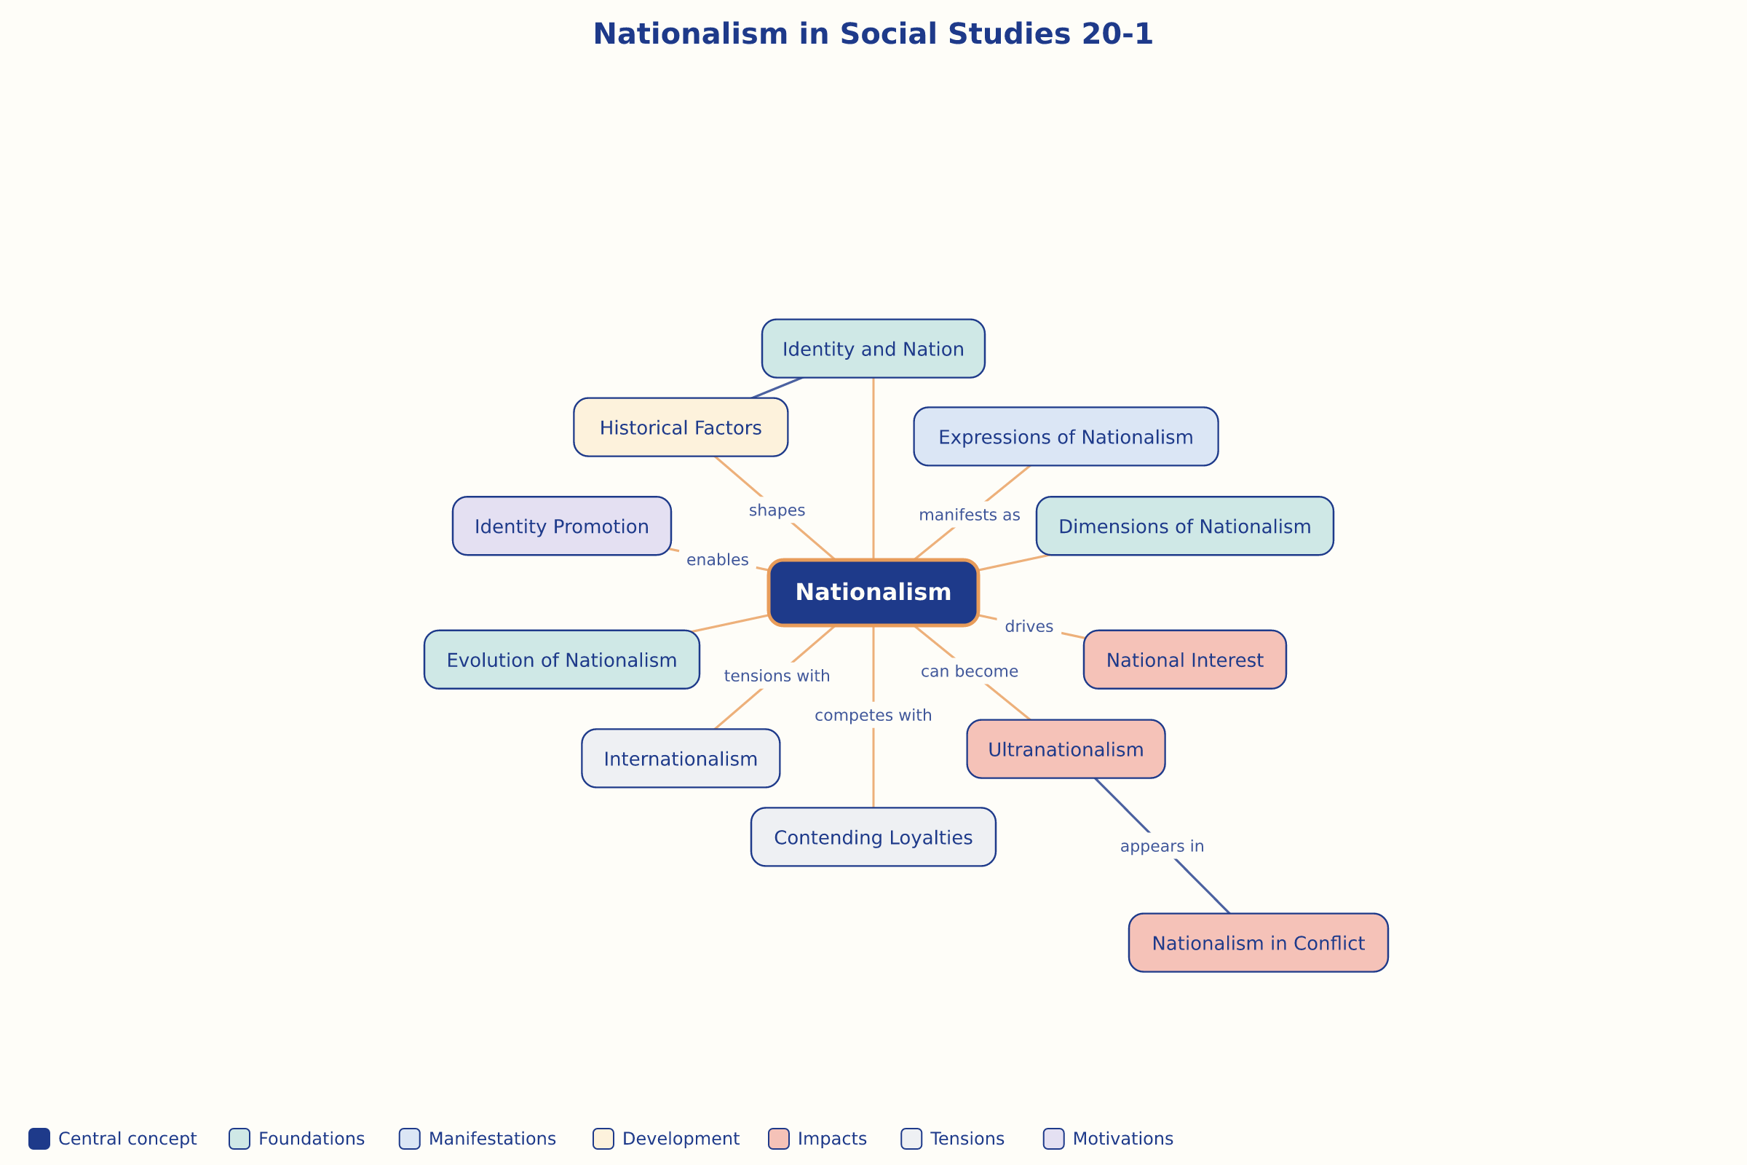

AILI word map · en · claude-haiku-4-5-20251001 · 2026-09-17

