Sounds, Letters, and Smooth Reading
Building letter-sound knowledge and reading fluency through hands-on phonics activities
Audience: Grade 1 students in an Alberta elementary classroom, ages six to seven, working on early reading skills.
Grades: Grade 1
Subjects: English Language Arts and Literature
Time: about 60 minutes
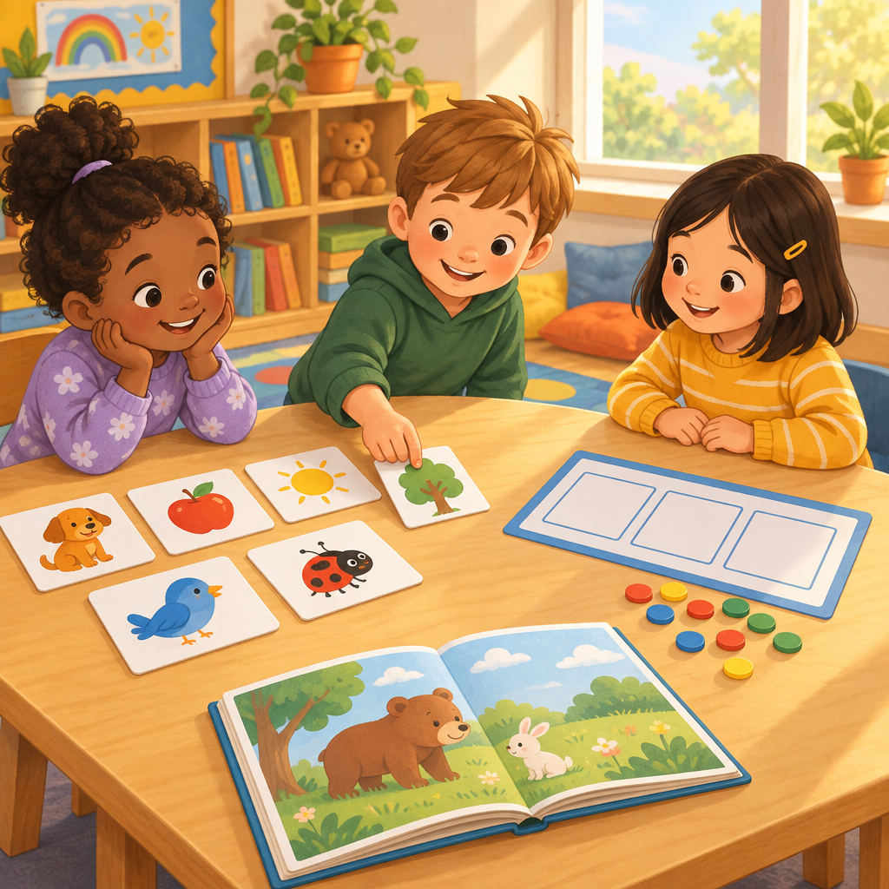

Overview
This Grade 1 lesson builds phonics and fluency skills through short, hands-on activities. Students review letter and sound recognition, blend and build words using Elkonin boxes and counters, sort words by vowel sound, hunt for high-frequency words in text, and practice reading aloud with expression (Outcome, Outcome). The lesson moves from quick warm-up drills to deeper phonics work, then to a fluency-focused read-aloud, ending with a playful word-building wrap-up. Each activity gives the teacher a clear moment to check for understanding before moving on.

Outcomes covered
- Students recognize and analyze letters and sounds in words. (Outcome)
Knowing how letters and sounds connect gives students the tools to read and spell new words on their own.
- Recognize both upper case and lower case letters of the alphabet fluently. Distinguish between letters that are consonants and letters that are vowels. Make connections between letters and sounds in words. (Skills)
Fast, accurate letter recognition is the foundation for decoding words in any text.
- Associate sounds to letters and letter sequences. Experiment with letters, sounds, and words to create new words. Recognize and use long and short vowel sounds in words. (Skills)
Building and changing words helps students see patterns they can apply to unfamiliar words.
- Students recognize and analyze letters and sounds in words. (Outcome)
Students recognize and analyze letters and sounds in words.
- Identify all 26 letters of the alphabet quickly and accurately. Blend sounds in words with speed and accuracy to decode unfamiliar words. (Skills)
Quick blending frees up a reader's attention for understanding the story, not just the words.
- Read 125 high-frequency words automatically. Read 125 high-frequency words in sentences and texts. (Skills)
Recognizing common words by sight lets students read more smoothly without stopping to sound out every word.
- Read phrases smoothly, taking punctuation into consideration. Read texts aloud, with appropriate expression. (Skills) Phrased, expressive reading sounds like spoken language and supports comprehension.

Materials
- Upper case and lower case letter cards
- Elkonin box mats (three boxes each)
- Small counters or chips
- Picture-word cards for vowel sort (cat, cake, pin, pine, hop, hope)
- Short familiar texts with high-frequency words
- Class list of high-frequency words posted on the wall
- Whiteboard or chart paper for word building
- Simple sentence cards with periods, question marks, and exclamation marks

Sequence of activities

1. Letter and Sound Warm-Up (8 min, whole class)
- Show upper case and lower case letter cards, one at a time, fast.
- Students say the letter name and its sound together (e.g., "B, /b/").
- Mix up upper case and lower case cards so students match both forms (Knowledge, Skills, Skills).
- Speed round: flip through 10 cards. Count how many the class names in 20 seconds.
- Ask: which letters are vowels? Students give a thumbs up for a, e, i, o, u and thumbs down for the rest. Note: y is sometimes a vowel, as in words like my and happy (Skills).
Watch for students who mix up letters that look similar, like b and d. Keep the pace brisk but calm. This builds quick, accurate letter recognition, which supports fluency (Skills, Knowledge).
Sources: Knowledge, Skills, Knowledge, Skills

2. Sound Blending with Elkonin Boxes (12 min, pairs)
- Give each pair a mat with three boxes drawn on it, plus small counters.
- Say a three-sound word slowly, like c-a-t.
- Students push one counter into a box for each sound they hear.
- Students blend the sounds back together fast and say the whole word.
- Repeat with words: sun, hop, cat, mud, ship.
For ship, point out that the letters and together represent the sound /sh/.
- Circulate and ask pairs to blend one word aloud for you to check speed and accuracy (Knowledge).
This activity targets blending three-phoneme words quickly and accurately (Knowledge). The word fish introduces a two-letter, one-sound pattern (digraph) without naming the term yet if the class is not ready (Knowledge, Understanding).
Sources: Knowledge, Skills, Understanding, Knowledge

3. Vowel Sound Sort (10 min, small group)
- Give each group a pile of picture-word cards: cat, cake, pin, pine, hop, hope.
- Groups sort cards into two piles: short vowel sound and long vowel sound.
- Say each word aloud together before sorting.
- Ask: what is different about cat and cake? (The silent e at the end changes the vowel sound.) (Knowledge, Skills)
- Groups circle the vowel letter in each word once sorted.
- Share back: one group reads their short vowel pile, another reads their long vowel pile.
This targets identifying short and long vowel sounds and the letters that represent them (Skills). Support struggling groups by modeling the first pair together before they sort independently.
Sources: Understanding, Knowledge, Skills

4. High-Frequency Word Hunt (10 min, individual)
- Give each student a short, familiar text with some high-frequency words highlighted.
- Students circle the word the every time they find it in the text.
- Explain that the cannot be sounded out easily. We just know it by sight (Knowledge).
- Students then circle three more high-frequency words from a class list: said, was, they.
- Students read their circled words aloud to a partner.
This builds automatic recognition of high-frequency words (Skills, Understanding). Keep a running class list of the 125 target words posted for reference.
Sources: Knowledge, Skills, Understanding

5. Fluent and Expressive Read-Aloud (15 min, whole class)
- Teacher reads a short, simple sentence with flat, choppy expression: "The cat sat on the mat."
- Teacher reads it again with smooth phrasing and a period pause at the end.
- Ask students which reading sounded more like talking (Knowledge, Understanding).
- Show a sentence with a question mark: "Where is the cat?" Model raising the voice at the end (Knowledge).
- Show a sentence with an exclamation mark: "The cat ran fast!" Model excited voice (Knowledge).
- Students echo-read each sentence back, copying the expression.
- Students practice one short passage in pairs, taking turns reading with expression and pausing at punctuation (Skills).
- Two or three pairs share a sentence aloud for the class.
Focus feedback on accuracy, phrasing, and expression rather than speed alone (Outcome, Understanding). Praise students who pause at periods and commas and who change their voice for question marks and exclamation marks (Knowledge, Skills).
Sources: Outcome, Understanding, Knowledge, Skills, Understanding

6. Word Building Wrap-Up (5 min, whole class)
- Write the word hop on the board.
- Ask a student to change one letter to make a new word, like hip or hot.
- Repeat two more times, changing beginning, middle, or end sounds.
- Ask the class to blend and read each new word chorally (Skills).
- Close by asking: what did we learn about letters and sounds today? Take two quick answers.
This closing activity reinforces experimenting with letters and sounds to build new words, a quick formative check before dismissal (Skills).
Sources: Skills

Differentiation
Extension
- Invite students who blend three-phoneme words easily to try four-phoneme words like frog or stop in the Elkonin box activity.
- Ask fast finishers in the vowel sort to write one new sentence using a long vowel word from their pile.
- During the fluency read-aloud, invite confident readers to add a second voice change, such as a whisper for a sad sentence.
Support
- Use fewer, larger letter cards during the warm-up and focus only on letters the student is still learning.
- Reduce the Elkonin box word list to two-sound words like at or up before moving to three sounds.
- Provide a highlighted copy of the high-frequency word list with only three target words instead of the full set.
Inclusive supports
- Pair students needing more practice with a supportive partner for the blending and fluency activities.
- Allow extra think time before calling on students during whole-class choral responses.
- Offer picture cues alongside word cards for students who benefit from visual supports.

Assessment
Formative. During the letter and sound warm-up, note which students hesitate or mix up upper case and lower case letters or vowel identification.
Look for: Student names letters and sounds within a few seconds and correctly sorts vowels from consonants. (Knowledge, Skills, Skills)
Formative. During Elkonin box blending, listen to each pair blend at least one word aloud.
Look for: Student pushes one counter per sound and blends three-phoneme words smoothly and quickly. (Knowledge)
Formative. Check vowel sort groups for correct placement of short and long vowel words.
Look for: Student correctly sorts words and can explain the role of silent e in changing the vowel sound. (Knowledge, Skills)
Formative. Review circled high-frequency words during the word hunt.
Look for: Student recognizes and reads target high-frequency words automatically, without sounding them out. (Skills, Understanding)
Peer. Partners listen to each other read a short passage aloud during the fluency activity and give one piece of feedback.
Look for: Reader pauses at periods and commas and changes voice for question marks and exclamation marks. (Knowledge, Skills, Understanding)

Vocabulary
- phoneme: A phoneme is the smallest sound in a word. The word cat has three phonemes: /k/, /a/, /t/.
- grapheme: A grapheme is a written letter or group of letters that stands for a sound.
- blend: To blend means to push sounds together smoothly to say a whole word, like turning /k/ /a/ /t/ into cat.
- high-frequency word: A high-frequency word is a word that shows up often in books, like the or said. Some of these words must be learned by sight.
- vowel: A vowel is one of the letters a, e, i, o, u, and sometimes y. Every word needs at least one vowel sound.
- expression: Expression is how your voice moves up, down, loud, or soft when you read, to match the feeling of the words.

For families
- Practice letter sounds during everyday moments, like naming the first sound of a food item at snack time.
- Read a favorite short book together and take turns using an excited voice for exclamation marks.
- Point out the word the whenever you see it on a sign, box, or book cover and remind your child it is a sight word.

Sources
- Outcome: "Students recognize and analyze letters and sounds in words."
- Outcome: "Students apply accuracy, appropriate rate, and expression in the development of fluency."
- Knowledge: "The English alphabet consists of a set of 26 letters that represent sounds."
- Skills: "Recognize both upper case and lower case letters of the alphabet fluently."
- Understanding: "Letters represent sounds in words."
- Knowledge: "There is a relationship between written letters (graphemes) and the sounds they represent (phonemes)."
- Skills: "Associate sounds to letters and letter sequences."
- Understanding: "Letter combinations represent units of sound within a word."
- Knowledge: "Sounds in words can be blended quickly and accurately."
- Skills: "Identify all 26 letters of the alphabet quickly and accurately."
- Understanding: "Fluency involves the ability to decode new words with accuracy and at an appropriate rate."
- Knowledge: "Some words that appear often in print cannot be decoded and must be read by sight (e.g., the)."
- Skills: "Read 125 high-frequency words automatically."
- Understanding: "Fluency involves the ability to recognize high-frequency words with accuracy and at an appropriate rate."
- Knowledge: "Expression includes purposeful movement of the voice (pitch)."
- Skills: "Read texts aloud, with appropriate expression."
- Understanding: "Fluent and phrased reading can increase the ability to comprehend written messages."

All activities use everyday classroom materials, simple words, and familiar concepts appropriate for six- and seven-year-olds, with no sensitive or unsafe content.

AILI detailed pack · en · claude-sonnet-5 · 2026-09-17

