The Vanishing Vertex: A Quadratic Function Puzzle Challenge
This puzzle asks you to reconstruct a full quadratic function from partial graph information, the same analytical work required when identifying vertex, intercepts, direction of opening and axis of symmetry from a quadratic function (Outcome, Outcome, Outcome). Recovering the equation from its roots draws on factoring polynomial expressions (Outcome) and on solving problems that involve quadratic equations (Outcome).
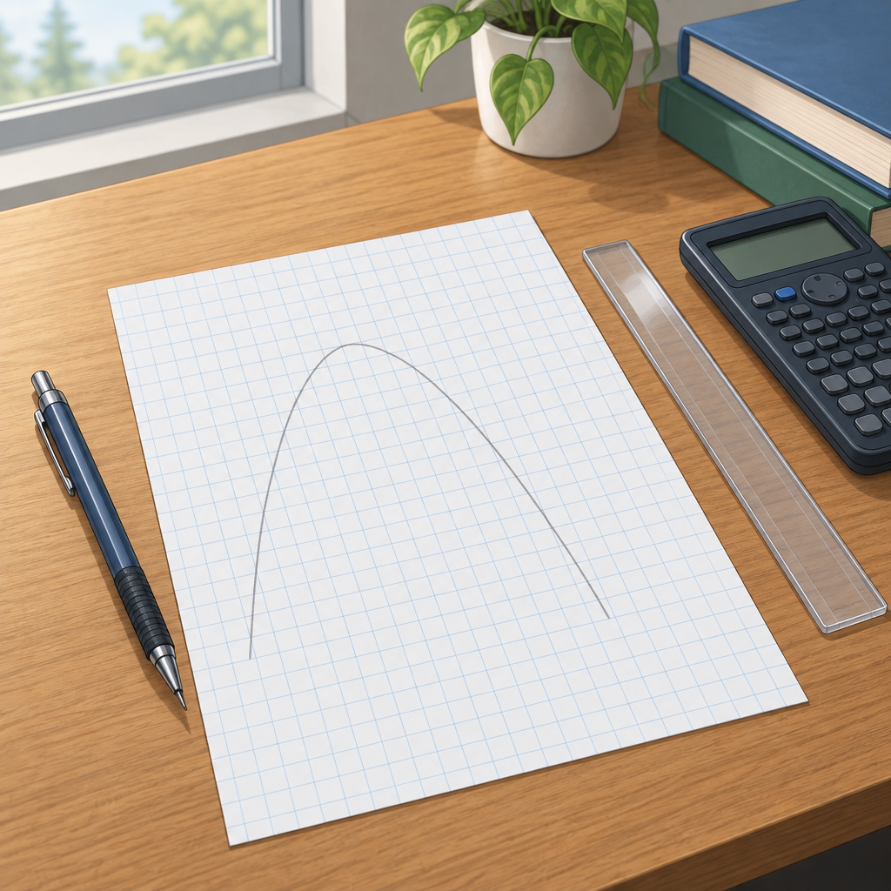

The puzzle
A parabola crosses the x-axis at x = 1 and x = 5. It opens downward, and its y-intercept is (0, −10).
Without graphing, determine:
- The coordinates of the vertex.
- The equation of the parabola written in the form y = a(x − p)² + q.
- The maximum value of the function.

Hints
- The axis of symmetry of a parabola always lies exactly halfway between its two x-intercepts.
- Write the function in factored form, y = a(x − 1)(x − 5), then use the given y-intercept to solve for a.
- The axis of symmetry is x = 3. Substitute x = 0 into y = a(x − 1)(x − 5) and set the result equal to −10 to find a. Then substitute x = 3 into the factored equation to find the vertex's y-value.

Answer key
Vertex: (3, 8)
Equation in vertex form: y = −2(x − 3)² + 8
Maximum value: 8
Reasoning:
The x-intercepts, x = 1 and x = 5, give the factored form y = a(x − 1)(x − 5), an application of factoring polynomial expressions (Outcome). The axis of symmetry sits halfway between the roots, at x = (1 + 5)/2 = 3.
Substituting the y-intercept (0, −10) into the factored form solves for a:
−10 = a(0 − 1)(0 − 5)
−10 = a(−1)(−5)
−10 = 5a
a = −2
The negative value of a confirms the parabola opens downward, consistent with the given description and with the direction of opening identified when analyzing quadratic functions (Outcome, Outcome).
The full factored equation is y = −2(x − 1)(x − 5).
To find the vertex, substitute x = 3 (the axis of symmetry) into this equation:
y = −2(3 − 1)(3 − 5)
y = −2(2)(−2)
y = 8
The vertex is (3, 8), and since a is negative, this point is a maximum. The maximum value of the function is 8, occurring at x = 3.
Writing the equation in vertex form, y = a(x − p)² + q, using vertex (3, 8) and a = −2, gives:
y = −2(x − 3)² + 8
This matches the structure required when analyzing quadratic functions of the form y = a(x − p)² + q to determine vertex, direction of opening and axis of symmetry (Outcome).

AILI game · en · claude-sonnet-5 · 2026-09-17

