Sam's Hike and Snack
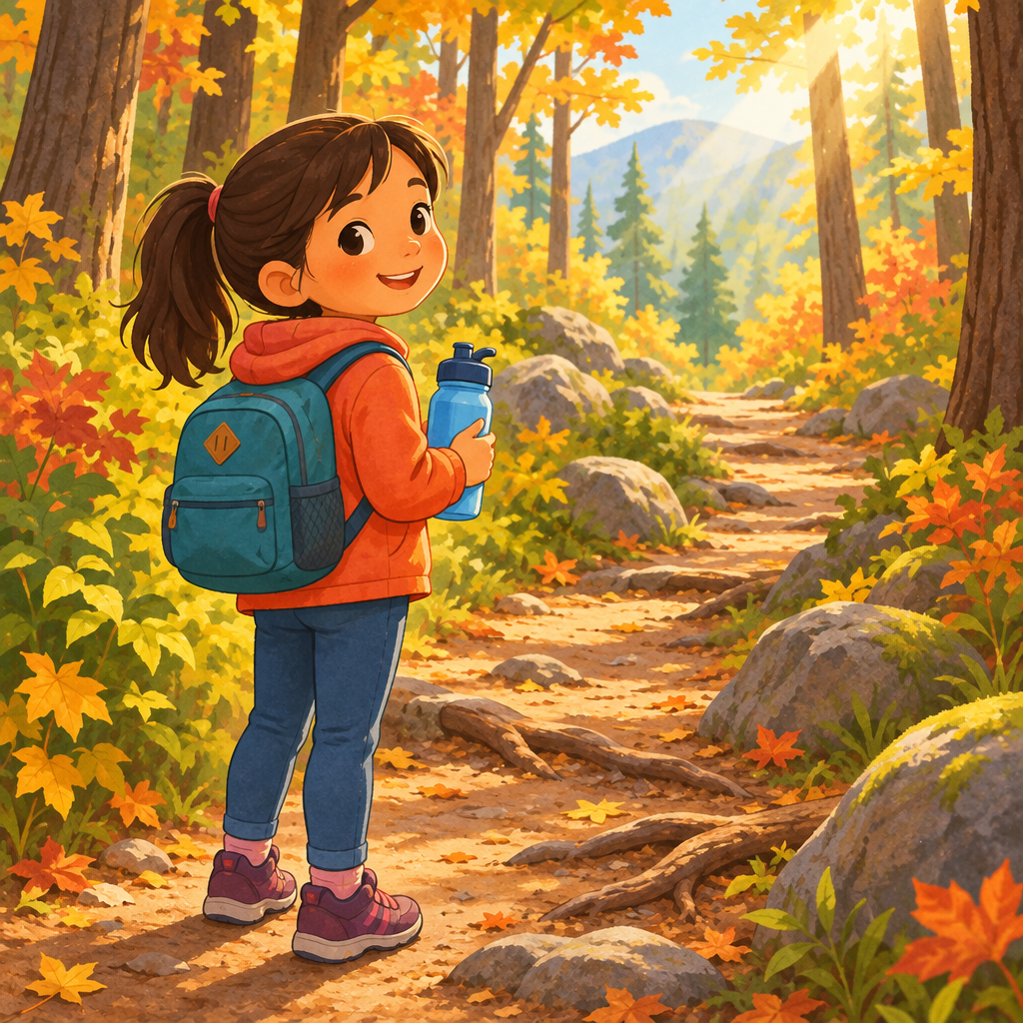
Sam's tummy growled loud. "That means I'm hungry," Sam said.
Mom smiled. "Good noticing. Let's eat before our hike."
Sam packed rice, a peach, and water. "No peanuts," Sam said. "Peanuts make my body react."
"Smart thinking," Mom said. "That keeps you safe."
At the trail, Sam drank water first. "My mouth felt dry. That's a thirsty cue."
They walked slow, then faster over rocks. "This is moderate exertion," Sam said, breathing quicker.
Sam's friend Leyla joined them. They watched for tree roots and wet spots. "Safety first," Leyla said.
After hiking, they stretched their legs. "Cooling down helps our muscles relax and lowers the chance of getting hurt," Mom said.
Later, Grandma's soup warmed the table. "Soup means family time," Sam smiled, feeling full and happy.

Words to know
- hunger cue: a sign your body gives when it needs food, like a growling tummy
- allergen: a food that makes some bodies react in an unsafe way
- cool-down: slow, gentle movement after exercise to help muscles relax
- moderate exertion: how hard your body is working during an activity
Curriculum link: Knowledge, Understanding, Knowledge, Skills, Knowledge, Knowledge, Understanding, Knowledge, Knowledge, Understanding, Knowledge, Skills
Listen to the narration

AILI audio story · en · claude-sonnet-5 · 2026-09-17

