Cells and Systems: Grade 8 Concept Map
Central concept: Cells and Systems

Connections
- Cells and Systems (built on) -> System Concept
- Cells and Systems (shows) -> Common Functions
- Cells and Systems (starts with) -> Cell as Basic Unit
- Cells and Systems (organizes as) -> Cells, Tissues, Organs
- Cells and Systems (seen in) -> Human Body Systems
- Cell as Basic Unit (compares) -> Single vs Multicelled
- Cell as Basic Unit (distinguishes) -> Plant vs Animal Cell
- Cell as Basic Unit (moves materials by) -> Diffusion and Osmosis
- Cells, Tissues, Organs (made of) -> Plant vs Animal Cell
- Human Body Systems (includes) -> Organ Roles
- Human Body Systems (depends on) -> Cell Roles in Body
- Human Body Systems (reacts through) -> Response to Stimuli
- System Concept (explains) -> Common Functions

Notes
- Cells and Systems: Living things function as systems built from cells, organized to support life (Topic). Topic
- System Concept: Structures and functions organized so parts work together (Outcome, Outcome). Outcome, Outcome
- Common Functions: Different organisms meet similar needs, like food gathering, in different ways (Outcome). Outcome
- Cell as Basic Unit: Cells are the basic unit of life shared by all organisms (Outcome). Outcome
- Single vs Multicelled: Compares organisms like amoeba to grizzly bear or algae to a poplar tree (Outcome, Outcome). Outcome, Outcome
- Plant vs Animal Cell: Distinguishes structures such as cell walls versus cell membranes (Outcome, Outcome). Outcome, Outcome
- Diffusion and Osmosis: Gases and liquids move into and out of cells based on concentration differences (Outcome, Outcome). Outcome, Outcome
- Cells, Tissues, Organs: Cells build tissues, tissues build organs, contributing to plant and animal structures (Outcome, Outcome, Topic). Outcome, Outcome, Topic
- Human Body Systems: Includes respiration, circulation, digestion, excretion and sensory awareness (Outcome). Outcome
- Organ Roles: Organs like lungs and bronchia support healthy body functioning (Outcome). Outcome
- Cell Roles in Body: Nerve, muscle, blood, skin and bone cells each contribute to healthy function (Outcome). Outcome
- Response to Stimuli: Body functions change with conditions, such as heart rate rising during exercise (Outcome, Topic). Outcome, Topic
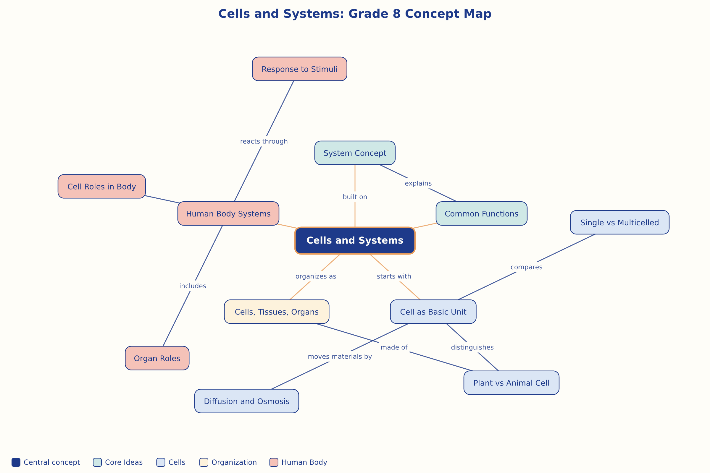

AILI word map · en · claude-sonnet-5 · 2026-09-17

