Multiplying and Dividing Positive Fractions
We are learning to multiply and divide fractions and apply these operations to solve real-world problems.
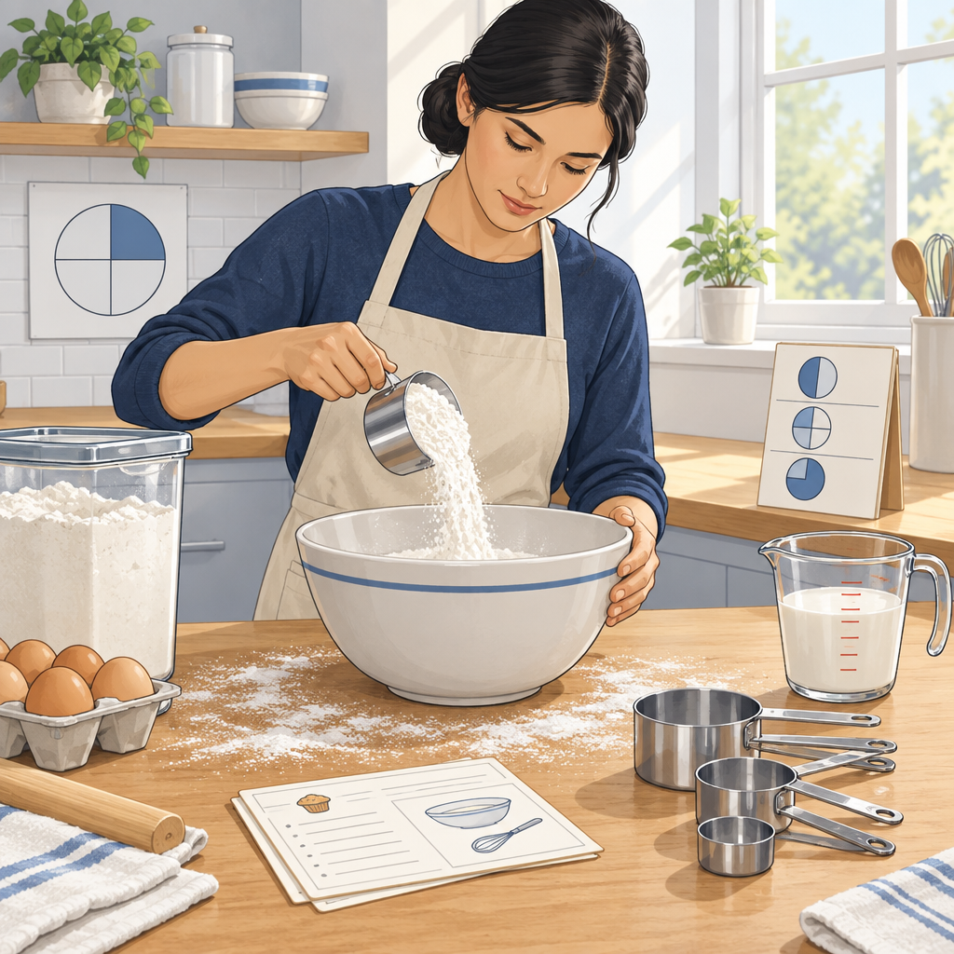

Learning intentions
We are learning to multiply and divide fractions by interpreting these operations as part-of-a-part and as grouping.

Success criteria
I can multiply two fractions and interpret the result as part of a part (Understanding).
I can divide a fraction by a fraction using the reciprocal method (Knowledge).
I can divide a whole number by a fraction and explain why the quotient is larger than the original number (Knowledge).
I can solve a real-world problem that involves multiplying or dividing fractions (Skills).

Curriculum alignment
Students interpret multiplication and division of positive fractions, applying part-of-a-part and grouping models to real-world contexts.

Materials
Whiteboard or chart paper and markers
Fraction strips or fraction circles (printed or drawn)
Recipe card (provided in lesson)
Ruler for each student
Grid paper (1 sheet per student)
Calculators (optional, for checking)

Lesson sequence

1. Hook: The Recipe Problem (5 minutes)
Display this scenario:
A recipe for chocolate chip cookies calls for 3/4 cup of butter. You want to make half the recipe. How much butter do you need?
Ask students: What operation do you think we use here? Why?
Take three responses. Do not confirm yet. Write the three ideas on the board.
Explain: Today we are going to figure out how to multiply and divide fractions, starting with a problem exactly like this one.

2. Direct Instruction: Multiplying Fractions as Part of a Part (10 minutes)
Draw a rectangle on the board and divide it into 4 equal columns. Shade 3 of them. Label this as 3/4.
Say: This rectangle represents 1 whole. The shaded part is 3/4 of the whole.
Now we want half of this 3/4. To find half of 3/4, I divide the rectangle horizontally into 2 rows. The shaded region now has 2 rows. The overlap, the part that is both shaded and in the top row, is what we are looking for.
Count the small rectangles in the overlap. There are 3. Count the total small rectangles. There are 8.
Write on the board: 1/2 × 3/4 = 3/8.
Now show the rule (Knowledge):
To multiply two fractions, multiply the numerators and multiply the denominators.
a/b × c/d = ac/bd
Write: 1/2 × 3/4 = (1 × 3)/(2 × 4) = 3/8.
Say: The product of two fractions is part of a part. We took a part (3/4) and then took a part of that part (1/2 of it). The answer is smaller than either fraction we started with. That is because we are taking a piece of a piece.
Work through a second example: 2/3 × 3/5.
Draw a 3-by-5 grid. Shade 2 rows (showing 2/3). Then shade 3 columns (showing 3/5). The overlap is 6 small squares out of 15 total.
Write: 2/3 × 3/5 = 6/15 = 2/5.
Ask: Is 2/5 smaller than 2/3? Smaller than 3/5? (Yes to both.)

3. Guided Practice: Multiplying Fractions (8 minutes)
Hand out grid paper. Ask students to work in pairs.
Problem 1: Use a grid to show 1/3 × 2/5. Draw the grid, shade the regions, count the overlap, and write the answer as a fraction.
Circulate. Look for students who shade one dimension, then the other, and correctly identify the overlap.
After 3 minutes, ask one pair to show their grid on the board. Confirm: 1/3 × 2/5 = 2/15.
Problem 2: Calculate 3/4 × 4/5 using the rule. You do not need to draw a grid this time.
Students write: (3 × 4)/(4 × 5) = 12/20 = 3/5.
Ask: Can you simplify? (Yes, divide numerator and denominator by 4.)

4. Direct Instruction: Dividing Fractions Using Reciprocals (8 minutes)
Say: Now we move to division. Division of fractions uses a trick: we flip the second fraction and multiply instead (Knowledge).
Write on the board: 3/4 ÷ 1/2.
Say: The reciprocal of 1/2 is 2/1, or just 2. When we divide by a fraction, we multiply by its reciprocal.
Write: 3/4 ÷ 1/2 = 3/4 × 2/1 = 6/4 = 3/2.
Interpret this: We are asking, "How many 1/2s are in 3/4?" The answer is 1 and 1/2. So 3/4 ÷ 1/2 = 1 1/2.
Ask: Is 3/2 larger than 3/4? (Yes.) Why? (When we divide by a fraction smaller than 1, the answer gets bigger. We are counting how many small pieces fit into our amount.)
Work through a second example: 2 ÷ 1/3.
Say: How many thirds are in 2 wholes?
Write: 2 ÷ 1/3 = 2 × 3/1 = 6.
Confirm: If we have 2 wholes and cut them into thirds, we get 6 pieces. So there are 6 thirds in 2.

5. Guided Practice: Dividing Fractions (6 minutes)
Problem 1: Calculate 5/6 ÷ 1/2.
Students write: 5/6 × 2/1 = 10/6 = 5/3.
Ask: Is 5/3 bigger than 5/6? (Yes.) Why? (We are dividing by a fraction that is less than 1, so the answer grows.)
Problem 2: Calculate 3 ÷ 2/5.
Students write: 3 × 5/2 = 15/2 = 7 1/2.
Ask: Does this make sense? (Yes. If we have 3 wholes and divide by 2/5, we are asking how many 2/5s fit in 3. We expect a number bigger than 3.)

6. Consolidation: Real-World Application (3 minutes)
Apply multiplication and division by fractions to real-world situations such as sharing food and cutting materials.
You want to make half a recipe that calls for 3/4 cup of butter. How much butter do you need?
Students now calculate: 1/2 × 3/4 = 3/8 cup.
Ask: Is 3/8 less than 3/4? (Yes. We are taking half of the original amount, so the answer is smaller.)
Pose a second problem: A recipe calls for 2/3 cup of sugar per batch. You have 4 cups of sugar. How many batches can you make?
Students calculate: 4 ÷ 2/3 = 4 × 3/2 = 12/2 = 6 batches.
Ask: Does 6 make sense? (Yes. If each batch uses 2/3 cup, and we have 4 cups, we can make more than 4 batches because 2/3 is less than 1.)

Differentiation

Support
Provide pre-drawn grids for all multiplication problems. Students shade and count rather than drawing from scratch.
Use only proper fractions (numerator smaller than denominator) in the first round.
Offer a reference card showing the reciprocal method step-by-step:
- Write the division problem.
- Flip the second fraction.
- Change ÷ to ×.
- Multiply using the rule.

Extension
Ask students to solve problems where the answer must be simplified (Skills). For example: 4/5 × 5/6. (Answer: 20/30 = 2/3.)
Pose a multi-step problem: If 2/3 of a pizza is left and you eat 1/2 of that, how much of the whole pizza did you eat? (Answer: 1/2 × 2/3 = 2/6 = 1/3.)
Challenge students to verify that a fraction times its reciprocal always equals 1 (Knowledge). For example: 5/7 × 7/5 = 35/35 = 1.

Assessment
Formative checkpoint (during guided practice, minute 14):
Observe students as they calculate 1/3 × 2/5 on grid paper.
Look for:
- Correct shading of one dimension (rows or columns representing 1/3)
- Correct shading of the other dimension (columns or rows representing 2/5)
- Correct identification of the overlap region
- Accurate count of overlap squares and total squares
- Correct final fraction 2/15
If a student shades only one dimension or counts incorrectly, pause and ask: "Show me where 1/3 is on your grid. Now show me where 2/5 is. Where do they overlap?" Reteach the grid method using their own drawing.

AILI rapid lesson · en · claude-haiku-4-5-20251001 · 2026-09-17

