The Nervous System: A Logic Puzzle
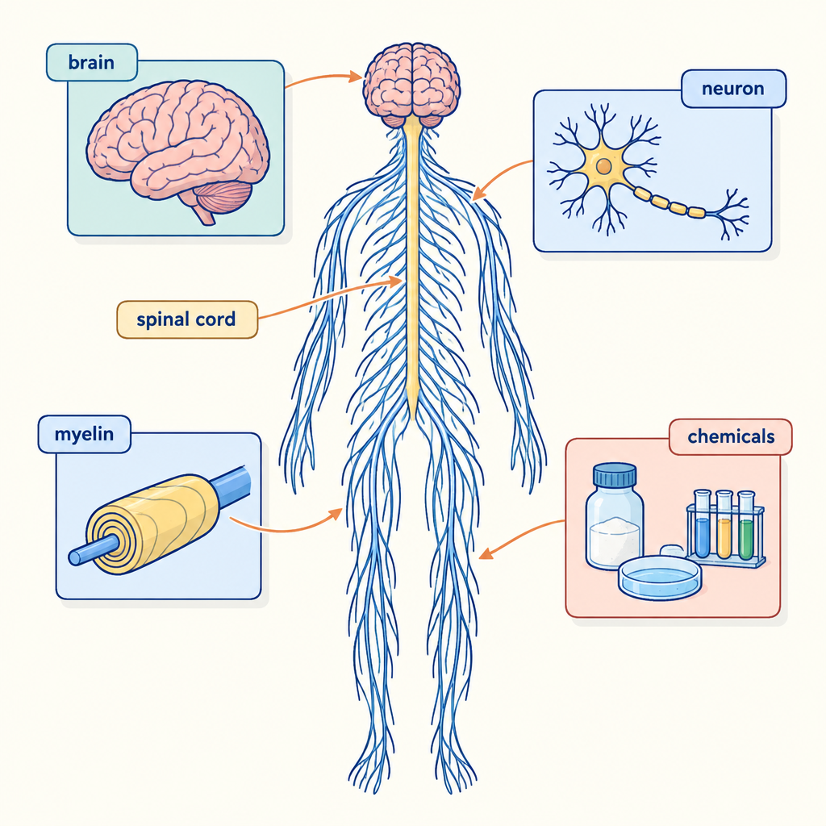
This logic puzzle challenges you to apply your understanding of nervous system structures and functions, including neurons, the central and peripheral nervous systems, reflex arcs, and sensory receptors (Topic, Outcome, Outcome, Outcome, Outcome, Outcome, Outcome). Solving it requires the same deductive reasoning you use when tracing a nerve impulse through a reflex arc or comparing sensory pathways across different receptor types.

How to play
- The puzzle is about 4 students and 3 categories. Each one has exactly one value in each category, and each value is used once.
- Read the 8 clues. Every clue is true. Use the grid to mark what is certain and cross out what is impossible.
- Exactly one arrangement fits every clue; the server has checked it. The hints go from gentle to direct, and the answer key shows the solution with the reasoning.

The puzzle
Four Biology 30 students each research a different part of the nervous system for a group presentation on homeostasis. Use the clues to match each student to the structure they studied and the function they will explain to the class.
Priya, Dawson, Mei and Kiran each have one item from every category below, and no two of them share an item.
- Structure researched: the neuron and myelin sheath, the cerebral hemispheres and lobes, the patellar reflex arc, the cochlea and organ of Corti
- Function explained to the class: transmission of an action potential, regulation of voluntary and involuntary responses, an automatic muscle response to a stimulus, conversion of sound vibrations into nerve impulses
- The order of presenting (in order, from first to fourth): first, second, third, fourth
Use the clues to work out who has what. Mark in the grid what each clue rules out.
Name | Structure researched | Function explained to the class | The order of presenting
Priya
Dawson
Mei
Kiran

- Dawson has second.
- The student with regulation of voluntary and involuntary responses also has second.
- The student with the cerebral hemispheres and lobes also has second.
- The student with the patellar reflex arc is between the student with transmission of an action potential and the student with the cochlea and organ of Corti in the order of presenting.
- The student with an automatic muscle response to a stimulus is between the student with regulation of voluntary and involuntary responses and the student with conversion of sound vibrations into nerve impulses in the order of presenting.
- Kiran does not have fourth.
- Mei does not have the cochlea and organ of Corti.
- Mei does not have an automatic muscle response to a stimulus.

Hints
- Start with clue 1. Mark in the grid what it rules out before you read on.
- Clues 1 and 2 together show that Dawson has regulation of voluntary and involuntary responses.
- Dawson has the cerebral hemispheres and lobes, regulation of voluntary and involuntary responses and second.

Answer key
Name | Structure researched | Function explained to the class | The order of presenting
Priya | the cochlea and organ of Corti | conversion of sound vibrations into nerve impulses | fourth
Dawson | the cerebral hemispheres and lobes | regulation of voluntary and involuntary responses | second
Mei | the neuron and myelin sheath | transmission of an action potential | first
Kiran | the patellar reflex arc | an automatic muscle response to a stimulus | third

Reasoning
- Clue 1: Dawson has second. This fixes Dawson has second; 3456 arrangements remain.
- Clue 2: The student with regulation of voluntary and involuntary responses also has second. This fixes Dawson has regulation of voluntary and involuntary responses; 864 arrangements remain.
- Clue 3: The student with the cerebral hemispheres and lobes also has second. This fixes Dawson has the cerebral hemispheres and lobes; 216 arrangements remain.
- Clue 4: The student with the patellar reflex arc is between the student with transmission of an action potential and the student with the cochlea and organ of Corti in the order of presenting. Nothing is fixed yet; 24 arrangements remain.
- Clue 5: The student with an automatic muscle response to a stimulus is between the student with regulation of voluntary and involuntary responses and the student with conversion of sound vibrations into nerve impulses in the order of presenting. Nothing is fixed yet; 6 arrangements remain.
- Clue 6: Kiran does not have fourth. Nothing is fixed yet; 4 arrangements remain.
- Clue 7: Mei does not have the cochlea and organ of Corti. This fixes Priya has the cochlea and organ of Corti, Priya has conversion of sound vibrations into nerve impulses and Priya has fourth; 2 arrangements remain.
- Clue 8: Mei does not have an automatic muscle response to a stimulus. This fixes Mei has the neuron and myelin sheath, Kiran has the patellar reflex arc, Mei has transmission of an action potential, Kiran has an automatic muscle response to a stimulus, Mei has first and Kiran has third, and only one arrangement remains.

AILI game · en · claude-sonnet-5 · 2026-09-17

