Integer and Fraction Detectives
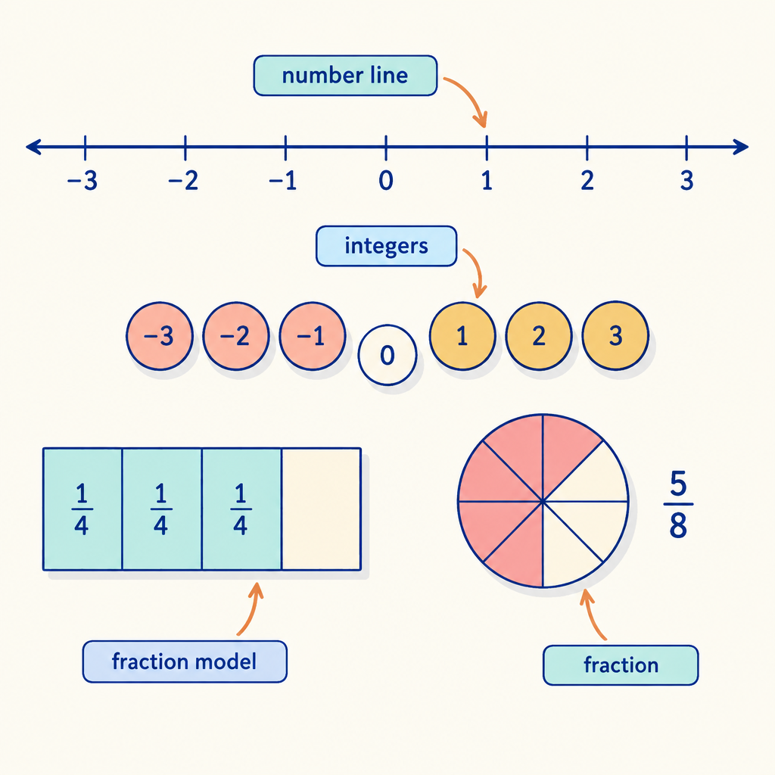
This logic puzzle draws on the number sense students build around integers and fractions: understanding magnitude, direction, and additive inverses of positive and negative numbers (Outcome, Details), and working with fractions as quotients, equivalent forms, and sums or differences with related denominators (Outcome, Outcome, Outcome). Solving the clues below calls on the same reasoning skills used to compare, order, and operate with these numbers on the number line.

How to play
- The puzzle is about 4 students and 2 categories. Each one has exactly one value in each category, and each value is used once.
- Read the 6 clues. Every clue is true. Use the grid to mark what is certain and cross out what is impossible.
- Exactly one arrangement fits every clue; the server has checked it. The hints go from gentle to direct, and the answer key shows the solution with the reasoning.

The puzzle
Four students are each working on a different number concept for their math journal, using the number line to make sense of positive numbers, negative numbers, and fractions.
Priya, Dawit, Mackenzie and Owen each have one item from every category below, and no two of them share an item.
- Topic: the additive inverse of an integer, a fraction added to a fraction with a common denominator, a natural number multiplied by a unit fraction, an equal-sharing situation expressed as a fraction
- The order of presenting (in order, from first turn to fourth turn): first turn, second turn, third turn, fourth turn
Use the clues to work out who has what. Mark in the grid what each clue rules out.
Name | Topic | The order of presenting
Priya
Dawit
Mackenzie
Owen

- Priya has first turn.
- Owen has the additive inverse of an integer.
- The student with an equal-sharing situation expressed as a fraction also has fourth turn.
- Owen does not have second turn.
- Mackenzie does not have second turn.
- The student with a fraction added to a fraction with a common denominator comes before the student with a natural number multiplied by a unit fraction in the order of presenting.

Hints
- Start with clue 1. Mark in the grid what it rules out before you read on.
- Clues 1 to 4 together show that Owen has third turn.
- Owen has the additive inverse of an integer and third turn.

Answer key
Name | Topic | The order of presenting
Priya | a fraction added to a fraction with a common denominator | first turn
Dawit | a natural number multiplied by a unit fraction | second turn
Mackenzie | an equal-sharing situation expressed as a fraction | fourth turn
Owen | the additive inverse of an integer | third turn

Reasoning
- Clue 1: Priya has first turn. This fixes Priya has first turn; 144 arrangements remain.
- Clue 2: Owen has the additive inverse of an integer. This fixes Owen has the additive inverse of an integer; 36 arrangements remain.
- Clue 3: The student with an equal-sharing situation expressed as a fraction also has fourth turn. Nothing is fixed yet; 8 arrangements remain.
- Clue 4: Owen does not have second turn. This fixes Owen has third turn; 4 arrangements remain.
- Clue 5: Mackenzie does not have second turn. This fixes Mackenzie has an equal-sharing situation expressed as a fraction, Dawit has second turn and Mackenzie has fourth turn; 2 arrangements remain.
- Clue 6: The student with a fraction added to a fraction with a common denominator comes before the student with a natural number multiplied by a unit fraction in the order of presenting. This fixes Priya has a fraction added to a fraction with a common denominator and Dawit has a natural number multiplied by a unit fraction, and only one arrangement remains.

AILI game · en · claude-sonnet-5 · 2026-09-17

