The Calorimeter Puzzle: Heat Lost or Heat Gained
Calorimetry lets chemists use temperature data from a controlled experiment to calculate the enthalpy change of a reaction (Outcome), applying Q = mcΔt to quantify heat transfer (Outcome) and expressing the result as a molar enthalpy with correct ΔH notation (Outcome, Outcome). This puzzle also asks you to classify the reaction as endothermic or exothermic (Outcome).
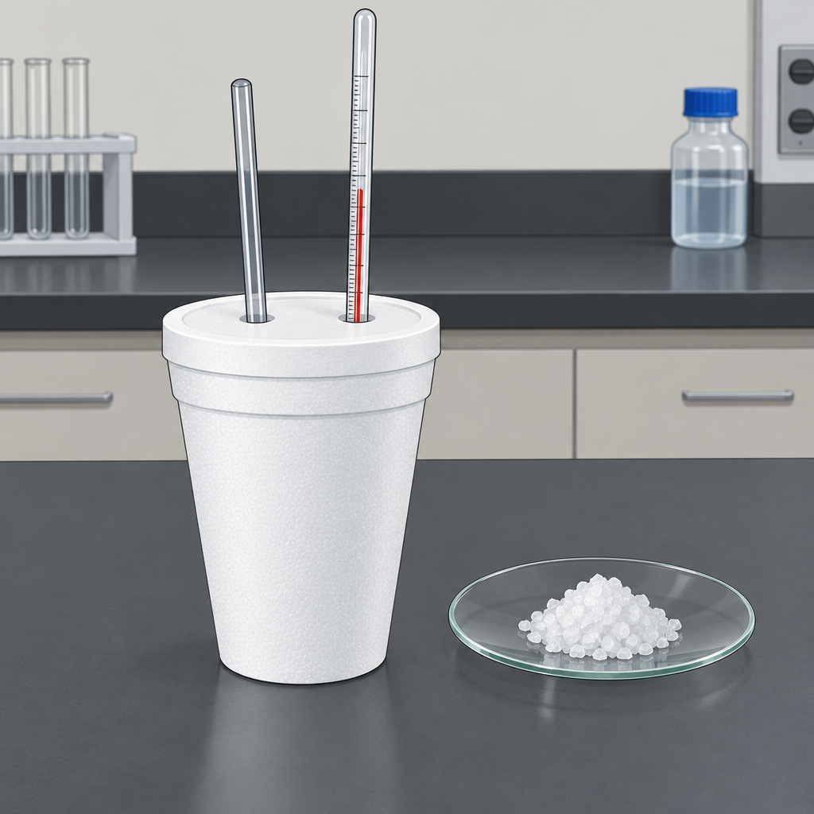

The puzzle
A student dissolves 4.00 g of solid sodium hydroxide, NaOH (molar mass 40.0 g/mol), in 50.0 g of water inside a coffee-cup calorimeter. The water's temperature rises from 21.5°C to 25.0°C. The specific heat capacity of water is 4.19 J/(g·°C). Assume the calorimeter absorbs no heat and that the mass of the solution equals the mass of the water.
Using these data, determine:
- The quantity of heat, in joules, transferred to the water.
- The number of moles of NaOH dissolved.
- The molar enthalpy of solution, ΔH_soln, in kJ/mol, written with the correct sign.
- Whether the dissolving process is endothermic or exothermic, and how you know from the temperature data.
Show your calculation for each step. Do not round until the final answer.

Hints
Hint 1: Start with Q = mcΔt. Identify which mass and which temperature change belong to the water, since the water is what actually absorbs or releases the heat you can measure.
Hint 2: The sign of ΔH depends on which way the heat flows, not on which way the temperature happens to move on the thermometer. Ask yourself: did the dissolving NaOH release energy into the water, or absorb energy from it?
Hint 3: Once you have Q in joules and the moles of NaOH, divide Q by the number of moles to get an enthalpy per mole. Convert to kJ/mol, then attach the sign that matches your answer to Hint 2.

Answer key
Step 1: Heat transferred to the water.
Q = mcΔt = 50.0 g × 4.19 J/(g·°C) × (25.0°C − 21.5°C)
Q = 50.0 × 4.19 × 3.5 = 733.25 J ≈ 733 J
Step 2: Moles of NaOH.
n = mass ÷ molar mass = 4.00 g ÷ 40.0 g/mol = 0.100 mol
Step 3: Molar enthalpy.
ΔH_soln = Q ÷ n = 733 J ÷ 0.100 mol = 7330 J/mol = 7.33 kJ/mol
The water's temperature rose, which means the water gained thermal energy. That energy came from the dissolving NaOH, so the chemical system lost energy to its surroundings. By the convention in ΔH notation (Outcome), a system that releases energy has a negative ΔH.
ΔH_soln = −7.33 kJ/mol
Step 4: Classification.
Because the system released energy and the surroundings warmed up, dissolving NaOH in water is exothermic (Outcome). A common student error is reporting +7.33 kJ/mol because the temperature reading went up. The temperature rise describes the surroundings, not the system, and the sign of ΔH always describes the system (Outcome, Outcome).

AILI game · en · claude-sonnet-5 · 2026-09-17

