Healthy Eating and Active Living
Central concept: Well-being

Connections
- Well-being (supported by) -> Active Living
- Well-being (supported by) -> Healthy Eating
- Active Living (develops) -> Physical Literacy
- Active Living (influenced by) -> Factors Influencing Activity
- Active Living (develops) -> Physical Literacy
- Active Living (enhanced by) -> Preparation and Recovery
- Active Living (promotes) -> Well-being across a lifespan
- Healthy Eating (examined through) -> Internal and External Factors
- Healthy Eating (supports) -> Optimal Well-being and Physical Wellness
- Healthy Eating (influenced by) -> Internal and External Factors
- Healthy Eating (impacts) -> Well-being
- Active Living (develops through) -> Movement and Physical Literacy

Notes
- Well-being: Supported by healthy eating and active living across a lifetime Outcome, Outcome
- Active Living: Physical activity and movement that develop physical literacy Outcome, Knowledge
- Healthy Eating: Nutrition choices that support physical wellness Outcome
- Physical Literacy: Competence, confidence, and motivation to be active Knowledge, Understanding
- Factors Influencing Activity: Peers, family, culture, environment, and cost affect choices Knowledge, Skills
- Activity Intensity: Light, moderate, and vigorous levels of exertion Knowledge, Skills
- Preparation and Recovery: Nutrition, hydration, warm-up, cool-down, and gear Knowledge, Skills
- Body Cues: Hunger and thirst signals like stomach growling and dry mouth Knowledge, Skills
- Food Guidelines: Information about variety of foods the body needs Knowledge, Skills
- Food Preferences and Allergies: Personal choices and reactions to foods Knowledge, Skills
- Food and Culture: Food fosters community, connection, tradition, and celebration Knowledge, Skills
- Social Interaction: Positive interactions through shared activity and goals Knowledge, Skills
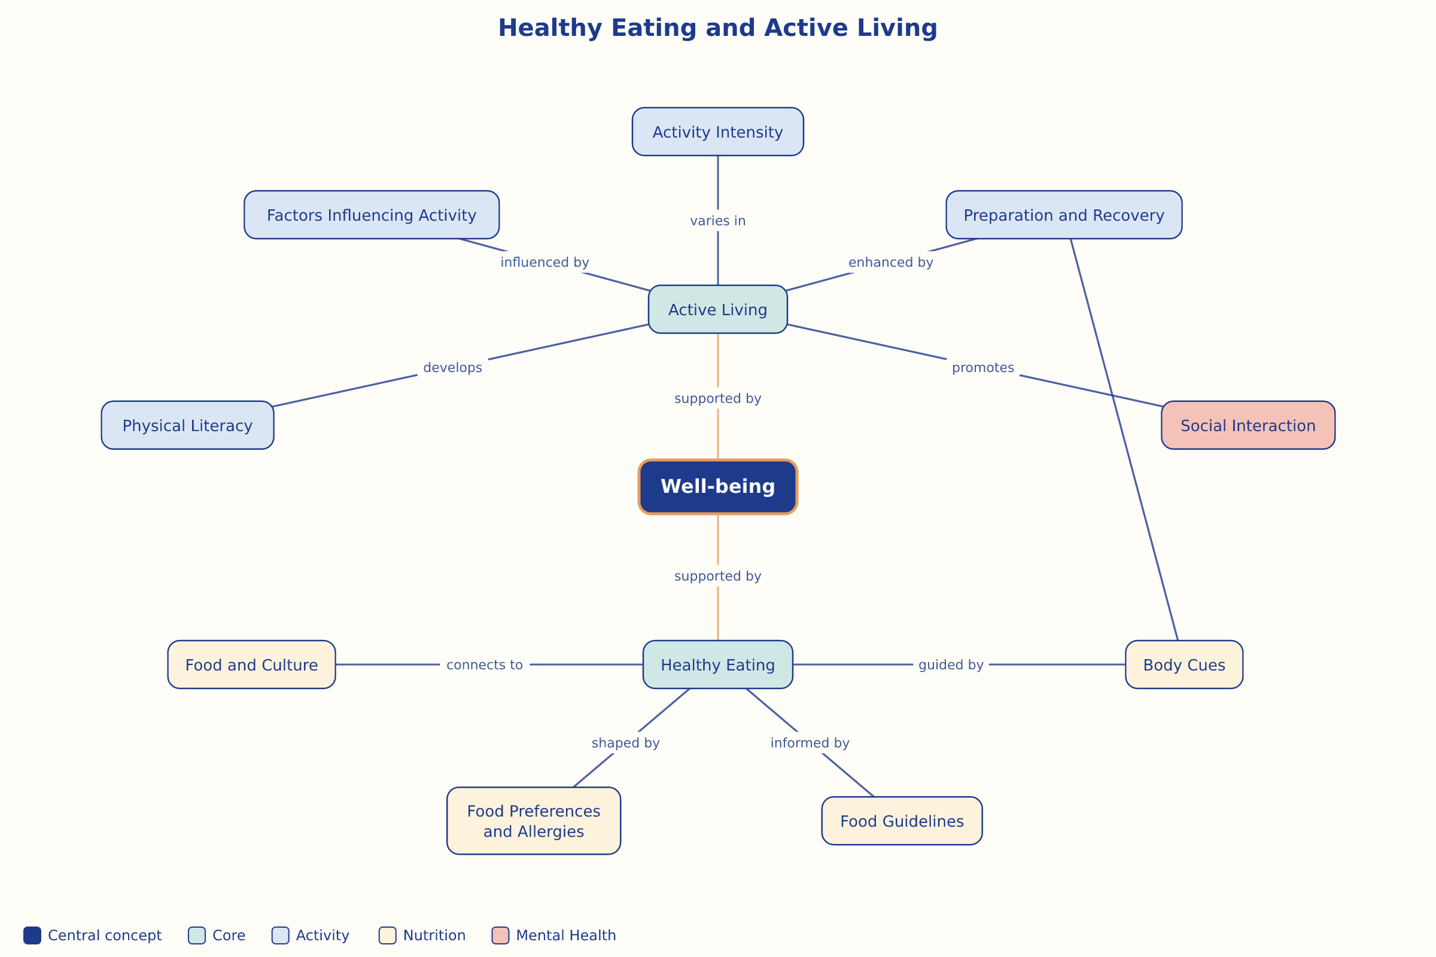

AILI word map · en · claude-haiku-4-5-20251001 · 2026-09-17

