Maya and the Meadow Chain
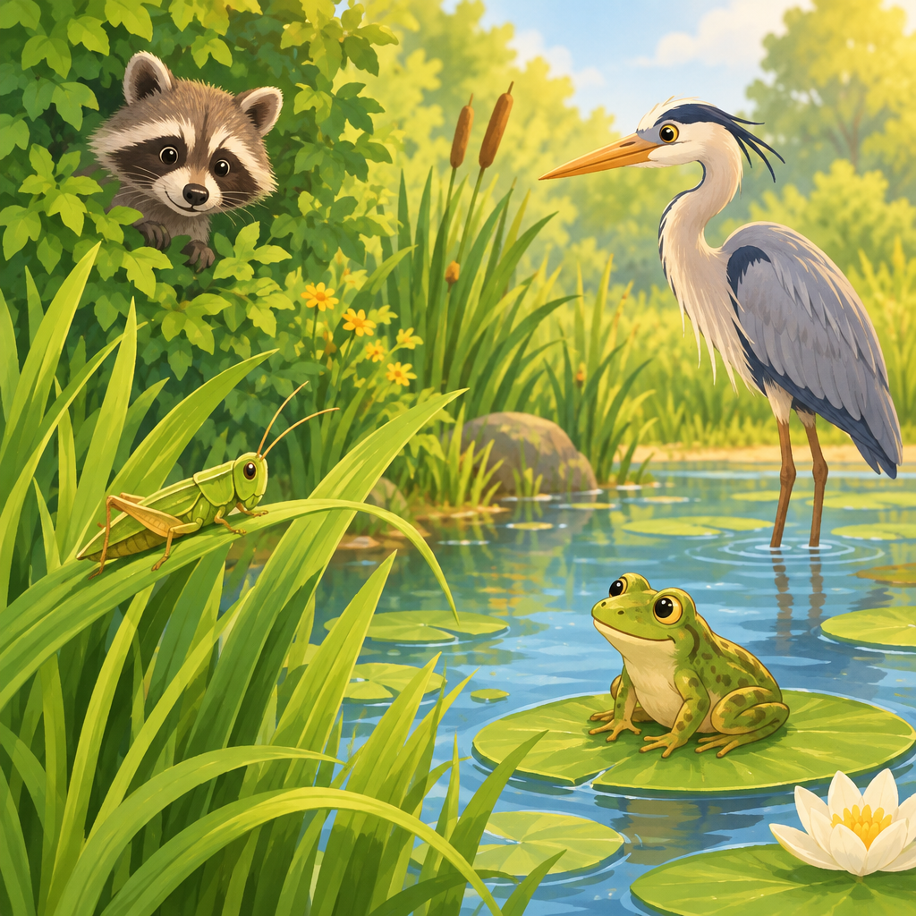
Maya knelt by the pond with her notebook. "Look, Grandpa," she said. "A grasshopper is eating grass."
Grandpa smiled. "That grasshopper is a herbivore. It only eats plants."
A frog flicked its tongue and caught the grasshopper.
"The frog eats meat," said Maya. "That makes it a carnivore."
Then a heron swooped down and gulped the frog.
"Grass, grasshopper, frog, heron," Maya wrote. "That's a food chain!"
A raccoon waddled by, sniffing berries and bugs.
"Raccoons eat both," Grandpa said. "That's an omnivore."
Maya watched a rabbit freeze when a shadow passed overhead. "It senses danger," she whispered.
"Let's step back gently," Grandpa said. "We watch, we don't disturb."
Maya nodded. "Protecting them helps the whole chain survive."

Words to know
- food chain: The order of who eats whom, starting with a plant.
- herbivore: An animal that eats only plants.
- carnivore: An animal that eats mostly meat.
- omnivore: An animal that eats both plants and meat.
- stimuli: Things like light, food, or danger that animals sense and react to.
Curriculum link: Knowledge, Skills, Understanding, Knowledge, Skills, Understanding, Knowledge, Skills, Understanding, Knowledge, Skills, Understanding
Listen to the narration

AILI audio story · en · claude-sonnet-5 · 2026-09-17

