Renaissance Worldviews: Trade, Humanism and a Changing Europe
How geography, trade and new ideas reshaped how Europeans saw themselves and the world
Audience: Grade 8 Social Studies students, ages 13 to 14, studying the origins of a Western worldview through Renaissance Europe.
Grades: Grade 8
Subjects: Social Studies
Time: about 60 minutes
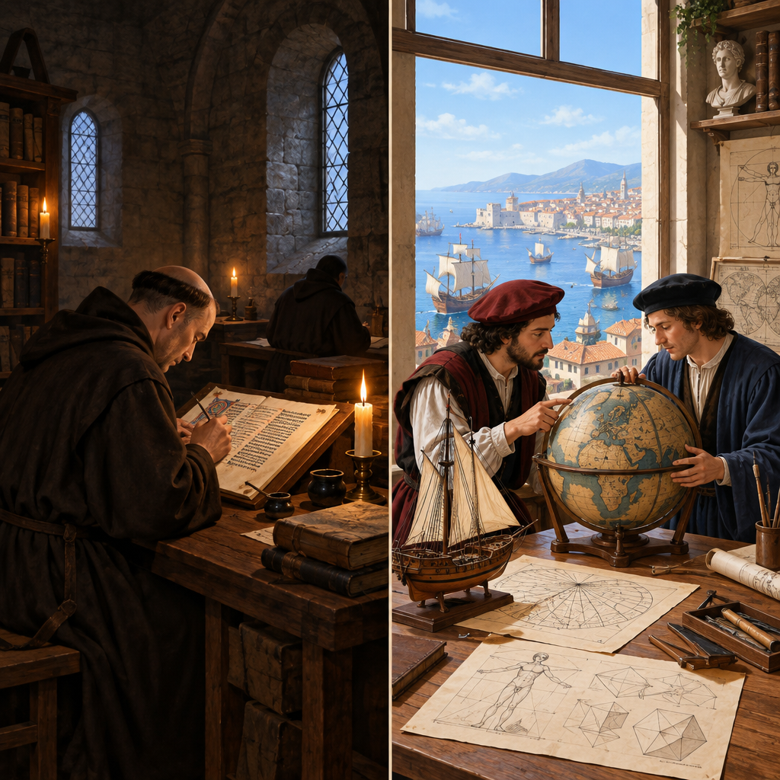

Overview
This lesson introduces the Renaissance as a turning point in the formation of a Western worldview (Topic). Students examine how geography and trade helped powerful Italian city-states such as Florence, Venice and Genoa emerge, and how humanist thinkers shifted focus toward human reason and potential alongside religious belief (Outcome). Through a small-group source study, students step into the perspectives of five Renaissance figures, a scholar, a merchant, a painter, an explorer and a scientist, to practice recognizing how beliefs are shaped by time, place and society (Outcome) and to build willingness to consider worldviews different from their own (Outcome, Outcome).
The lesson closes by asking students to connect Renaissance ideas to the present day, reinforcing the appreciation that Renaissance Europe formed the basis for the worldview of the Western world (Outcome, Outcome). Students leave with a comparison chart and a written response they can build on in future lessons covering the Age of Discovery and imperialism.

Outcomes covered
- Through an examination of Renaissance Europe, students will demonstrate an understanding and appreciation of how the exchange of ideas and knowledge contributed to shaping the worldview of the Western world. (Topic)
This is the general outcome anchoring the unit; today's lesson gives students their first structured look at how trade, geography and humanist thought combined to shift a worldview.
- 8.2.1 - appreciate how Renaissance Europe formed the basis for the worldview of the Western world (C, TCC) (Outcome, Outcome)
Students connect Renaissance ideas to values still present in Western society today, such as valuing individual achievement, scientific inquiry and the arts.
- 8.2.2 - demonstrate a willingness to consider differing beliefs, values and worldviews (C, I) (Outcome, Outcome)
The small group source study asks students to understand perspectives quite different from their own, building tolerance and historical empathy.
- 8.2.3 - recognize how beliefs and values are shaped by time, geographic location and societal context (C, TCC, LPP) (Outcome)
Students practice explaining why a belief made sense in its specific historical context rather than judging it by today's standards.
- 8.2.4 - examine, critically, the factors that shaped the worldview evolving in western Europe during the Renaissance, including what the Renaissance was, how it sparked growth and exchange of ideas, how geography affected trade and competition, how trade led to powerful city-states, and how thinkers and philosophers influenced a humanist worldview (Outcome)
This knowledge outcome gives students the factual base, trade, geography, city-states and humanism, needed to support the values and attitudes goals of the lesson.

Materials
- Whiteboard or chart paper for the class Renaissance Worldview chart
- Two-column comparison chart handout (Medieval vs. Renaissance worldview), one per student
- Five teacher-prepared profile cards representing a humanist scholar, a Florentine merchant, a court painter, an explorer and a scientist
- Small group worksheet with three guiding questions per profile card
- Exit slip handout or paper for the closing written response
- Optional: printed or projected images of a medieval manuscript and a Renaissance painting for the opening hook

Sequence of activities

1. Hook: What Shapes a Worldview? (8 min, whole class)
- Display two contrasting images in your mind's eye for students to picture: a medieval manuscript page showing religious scenes only, versus a Renaissance painting like Botticelli's work showing human bodies, classical myths and realistic perspective.
- Ask: "If you only saw art from one time period, what would you guess people believed was important?" Take three or four quick responses, no wrong answers yet.
- Introduce the key question for the lesson, written on the board: What was the Renaissance, and how did it change the way Europeans saw the world?
- Explain that a worldview is the set of beliefs, values and assumptions a society uses to understand life, and that today's lesson traces how one worldview shifted into another (Topic).
- Tell students they will build a two-column comparison chart (Medieval vs. Renaissance worldview) across the lesson and use it to answer the key question at the end.
This activates prior knowledge from Grade 8's earlier medieval Europe unit if your sequence includes it. If not, a one-sentence teacher summary of medieval worldview (God-centered, feudal, little questioning of authority) is enough contrast. Keep this brisk; the goal is curiosity, not full content delivery.
Sources: Topic

2. Direct Instruction: Ideas on the Move (12 min, whole class)
- Present a short teacher-led explanation (use notes below) covering: what the Renaissance was, why it began in Italian city-states, and how trade and geography fueled it.
- Explain that Renaissance Europe's location on the Mediterranean gave city-states like Florence, Venice and Genoa direct access to trade routes linking Europe, North Africa and Asia (Outcome).
- Explain that increased trade generated wealth, and wealthy merchant families (such as the Medici in Florence) used that money to fund artists, scholars and architects, which is part of why powerful city-states emerged (Outcome).
- Introduce humanism: a worldview that focused on human potential, reason, and life on Earth, alongside (not necessarily against) religious faith. Give one concrete example: physicians and astronomers began testing ideas through observation rather than only accepting ancient authorities.
- Ask two comprehension checks aloud: "Why did Italy's location matter for the Renaissance?" and "What is one thing humanism valued that medieval thinking emphasized less?" Cold-call two students.
- Students add two entries to their comparison chart: one for geography/trade, one for humanism.
Teacher background: The Renaissance (roughly 1350-1600) began in Italian city-states because of geography (Mediterranean trade hub), wealth from banking and commerce, and access to preserved classical Greek and Roman texts, some reintroduced through contact with the Byzantine Empire and the Islamic world (Outcome). Humanist thinkers, such as Petrarch, studied classical texts and emphasized human reason, individual achievement and civic life. This directly supports Outcome's questions on trade, city-states and humanism. Avoid overstating Italy as the only origin point; mention northern Europe (Erasmus, the printing press) only briefly if time allows, since the outcome focuses on European exchange broadly.
Sources: Outcome

3. Small Group Source Study: Voices of the Renaissance (15 min, small group)
- Divide the class into groups of three or four. Give each group one short profile card (teacher-prepared, one paragraph each, roughly 80-100 words) representing a different Renaissance perspective: a humanist scholar, a Florentine merchant, a court painter, an explorer sponsored by a monarch, and a scientist questioning old astronomical ideas.
- Each group reads its card and answers three questions on a worksheet: What does this person believe is important? How might this belief differ from someone living 200 years earlier? What questions would you ask this person if you could?
- Circulate and prompt groups that finish early: "How does your person's belief connect to trade, geography or humanism?"
- Each group prepares a 30-second verbal summary of their person's worldview to share in the next activity.
- Remind groups this connects to the key skill of considering worldviews different from their own (Outcome, Outcome).
This activity builds toward Outcome's question on thinkers and philosophers and Outcome's question on exploration and expansionism. Sample profile ideas: a humanist scholar reading rediscovered Cicero texts and arguing that studying classical literature makes better citizens; a Florentine merchant funding a chapel to display his family's status and piety at once; a court painter using new techniques of perspective and human anatomy to paint religious scenes more realistically; an explorer seeking new trade routes to Asia and claiming land for a monarch; an astronomer questioning whether Earth is the center of the universe. Adjust reading level as needed; keep cards short and concrete.
Sources: Outcome, Outcome, Outcome

4. Whole Class Share and Worldview Map (15 min, whole class)
- Each group delivers its 30-second summary. As they present, the teacher (or a student scribe) adds each figure's core belief to a class chart on the board titled "Renaissance Worldview: What People Believed and Why."
- After all groups present, lead a discussion: "Do all these people agree with each other? Where do you see tension or disagreement?" (Example: a devout merchant funding art versus a scientist questioning church-approved astronomy.)
- Ask: "How did exploration and contact with other peoples and lands change how Europeans saw themselves and their place in the world?" Connect responses to the idea that increased contact shaped both identity and a more expansionist outlook (Outcome).
- Ask students to recognize that these beliefs did not appear from nowhere; they were shaped by the specific time, place and society these people lived in (Outcome). Prompt: "Would a Florentine merchant's beliefs make sense in a small farming village with no trade route nearby? Why or why not?"
- Close the discussion by asking students to individually finish their two-column comparison chart, adding at least one new idea drawn from the group presentations.
This activity is the heart of the lesson's values and attitudes focus, since it asks students to notice and respect differing beliefs (Outcome, Outcome) while recognizing that beliefs are products of context (Outcome). Watch for students dismissing historical figures' beliefs as simply wrong; redirect toward understanding why those beliefs made sense at the time. This also surfaces Outcome's question on exploration's effect on European identity.
Sources: Outcome, Outcome, Outcome, Outcome

5. Exit Task: Worldview Shift in Your Own Words (10 min, individual)
- Students respond in writing (4-6 sentences) to the key question posed at the start of class: What was the Renaissance, and how did it change the way Europeans saw the world?
- Require students to reference at least two specific ideas from the lesson: one related to trade, geography or city-states, and one related to humanism or a specific historical figure discussed.
- Ask students to add one sentence connecting the Renaissance worldview to something in the world today (technology, art, science, global trade) to reinforce that this worldview still shapes the Western world (Outcome, Outcome).
- Collect exit slips as a formative check before the next class.
This closes the loop on the general outcome (Topic) and directly assesses appreciation of Renaissance Europe's lasting influence (Outcome, Outcome). Look for students naming at least two concrete factors rather than vague statements like "things changed." Students who cannot connect the Renaissance to the present may need the modern connection modeled with one class example (e.g., scientific method, museums, universities).
Sources: Outcome, Outcome, Topic

Differentiation
Extension
- Ask advanced students to research one additional Renaissance figure not covered in class (such as Machiavelli or Copernicus) and add a card to the class chart explaining how that person's worldview fits or challenges the patterns discussed.
- Challenge students to write their exit slip as a short letter written in the voice of one of the profile-card figures, explaining the Renaissance worldview to a person living 200 years earlier.
Support
- Provide a partially filled comparison chart with one or two example entries already completed as a model.
- Pair students who need support with a stronger reader during the small group source study, and consider reading the profile card aloud to the whole group before independent work begins.
- Offer a sentence-starter for the exit slip: 'The Renaissance was a time when... One example of a changed belief is... This still matters today because...'
Inclusive supports
- Provide profile cards in advance for students who benefit from pre-reading unfamiliar vocabulary.
- Allow verbal response (recorded or spoken to the teacher) as an alternative to the written exit slip for students who need it.
- Use visual supports (map of Italy, images of Florence, Venice and Genoa) alongside verbal explanation during direct instruction to support English language learners.

Assessment
Formative. Teacher circulates during the small group source study, listening for whether groups can articulate their assigned figure's belief and link it to trade, geography or humanism.
Look for: Groups can state their figure's core belief in their own words and attempt to explain why that belief made sense given the person's location, wealth or role in society. (Outcome, Outcome)
Formative. Cold-call comprehension checks during direct instruction on geography, trade and humanism.
Look for: Students can name at least one reason Italian city-states became centers of Renaissance activity and describe humanism in one sentence. (Outcome)
Summative. Exit slip: a short written response explaining what the Renaissance was and how it changed European worldviews, citing two specific pieces of evidence from the lesson.
Look for: Response names at least two concrete factors (such as trade, city-states, humanism or exploration) and makes a defensible connection between Renaissance ideas and the modern Western world. (Topic, Outcome, Outcome)
Self. Students review their own two-column comparison chart (Medieval vs. Renaissance worldview) and highlight the entry they find most convincing or surprising.
Look for: Student can explain in one sentence why the highlighted entry shows a shift in beliefs, values or worldview. (Outcome, Outcome)

Vocabulary
- Worldview: The set of beliefs, values and assumptions a person or society uses to understand and explain the world.
- Humanism: A Renaissance way of thinking that emphasized human reason, individual potential and life on Earth, often alongside continued religious faith.
- City-state: An independent political unit made up of a city and its surrounding territory; Florence, Venice and Genoa were powerful Renaissance examples that grew wealthy through trade.
- Expansionism: A worldview or policy focused on expanding a country's territory, trade or influence, seen in the Age of Discovery and the rise of European imperialism.

For families
- Ask your student to explain one Renaissance idea they learned today and how it still shows up in daily life, such as in art, science or how cities are built.
- If you visit a museum, library or historical site together, ask what the artists, thinkers or builders of that time seemed to believe was important.

Sources
- Outcome: "8.2.2 - demonstrate a willingness to consider differing beliefs, values and worldviews (C, I)"
- Outcome: "8.2.1 - appreciate how Renaissance Europe formed the basis for the worldview of the Western world (C, TCC)"
- Outcome: "8.2.4 - examine, critically, the factors that shaped the worldview evolving in western Europe during the Renaissance"
- Outcome: "8.2.1 - appreciate how Renaissance Europe formed the basis for the worldview of the Western world (C, TCC)"
- Topic: "Through an examination of Renaissance Europe, students will demonstrate an understanding and appreciation of how the exchange of ideas and knowledge contributed to shaping the worldview of the Western world."
- Outcome: "8.2.3 - recognize how beliefs and values are shaped by time, geographic location and societal context (C, TCC, LPP)"
- Outcome: "8.2.2 - demonstrate a willingness to consider differing beliefs, values and worldviews (C, I)"

The content presents historical figures and ideas factually and respectfully, uses no graphic or sensitive material, and is appropriate for Grade 8 students.

AILI detailed pack · en · claude-sonnet-5 · 2026-09-17

