Living Systems: Plants and Animals
Grade 3 Science: How plants and animals interact

Slide 1: Living Systems: Plants and Animals
Grade 3 Science: How plants and animals interact
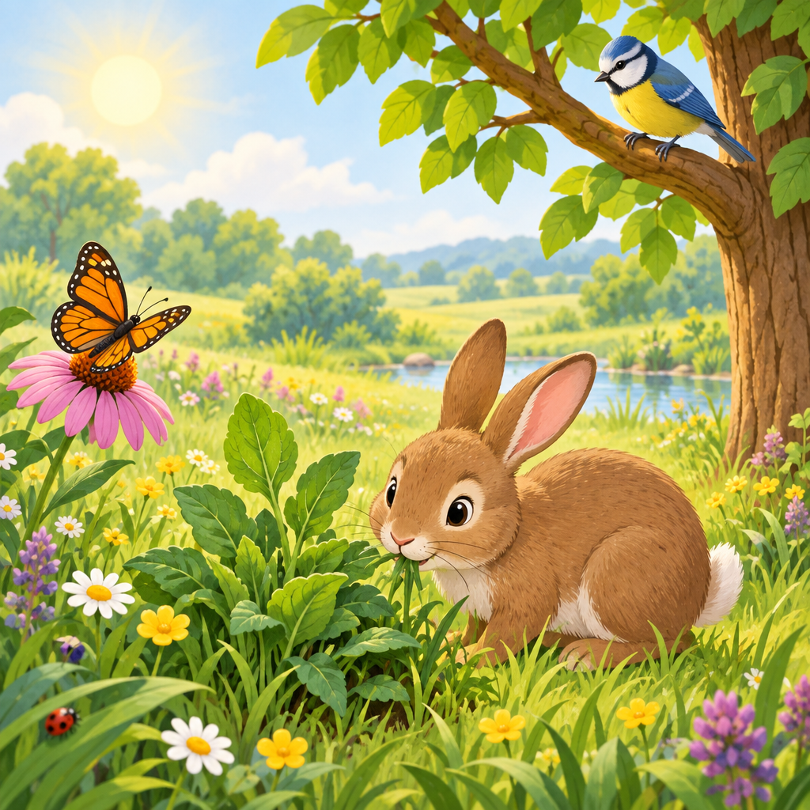
Notes: Introduce the unit. Ask students to name a plant and an animal they saw this week. Set a warm, curious tone for the lesson.

Slide 2: Learning Intentions and Success Criteria
- We are learning how plants and animals interact with each other (Outcome).
- We are learning what a food chain is (Details).
- I can build a simple food chain using pictures or words (Details).
- I can sort animals into carnivores, herbivores, and omnivores (Details).
- I can tell how plants and animals depend on each other for food(Details).
Sources: Outcome, Details
Notes: Read each success criterion aloud. Have students give a thumbs signal to show how confident they feel. Timing: 5 minutes. Formative checkpoint: quick thumbs check.

Slide 3: What Is a Food Chain?
- Sun: The sun gives energy to plants (Details).
- Plant: A plant, like grass, makes its own food (Details).
- Herbivore: A rabbit eats the plant. Herbivores eat only plants (Details).
- Carnivore: A fox eats the rabbit. Carnivores eat mostly meat (Details).
Sources: Details
Notes: Draw this chain on the board. Ask students to suggest a different food chain from their own backyard or local park. Materials: chart paper, markers. Timing: 10 minutes. Extension: add a decomposer step. Support: use picture cards instead of words.

Slide 4: Three Kinds of Eaters
- Herbivore: Eats only plants, like a deer eating leaves (Details).
- Carnivore: Eats mostly meat, like a wolf eating a rabbit (Details).
- Omnivore: Eats plants and meat, like a bear eating berries and fish (Details).
Sources: Details
Notes: Show real or picture examples of local animals. Have students sort animal cards into three piles. Formative checkpoint: check sorted piles for accuracy. Timing: 10 minutes. Support: provide two choices instead of three for struggling learners. Extension: ask students to name a local animal for each category.

Slide 5: Senses Help Plants and Animals Survive
Plants and animals are part of many different food chains(Details). A food chain shows the order in which plants and animals depend on each other for food(Details).
- A deer is part of a food chain(Details).
- A plant is part of a food chain(Details).
- External structures of plants and animals serve functions including eating, moving, protecting, sensing, and reproducing(Details).
Sources: Details
Notes: Take students outside or show a video of an animal reacting to a stimulus. Discuss respectful ways to observe wildlife. A food chain represents one possible way that plants and animals interact(Details). Timing: 10 minutes. Formative checkpoint: exit ticket, one sentence about a food chain.

Slide 6: Plants and Animals Need Each Other
Summary: Plants and animals interact through food chains, and animals eat plants or other animals to survive (Outcome, Details). Plants depend on animals and animals depend on plants (Details). We can protect them by watching quietly and following rules that keep habitats safe (Details).
Question: What is one way you can protect a plant or animal near your home?
Sources: Outcome, Details
Notes: Wrap up with a class discussion. Collect answers as an exit slip. Extension: research a local animal crossing sign. Support: sentence starter, I can protect animals by...

AILI presentation · en · claude-sonnet-5 · 2026-09-17

