The Particle Model of Matter
Exploring solids, liquids, and gases through movement, measurement, and the particle model
Audience: Grade 5 science students in an Alberta classroom
Grades: Grade 5
Subjects: Science
Time: about 60 minutes
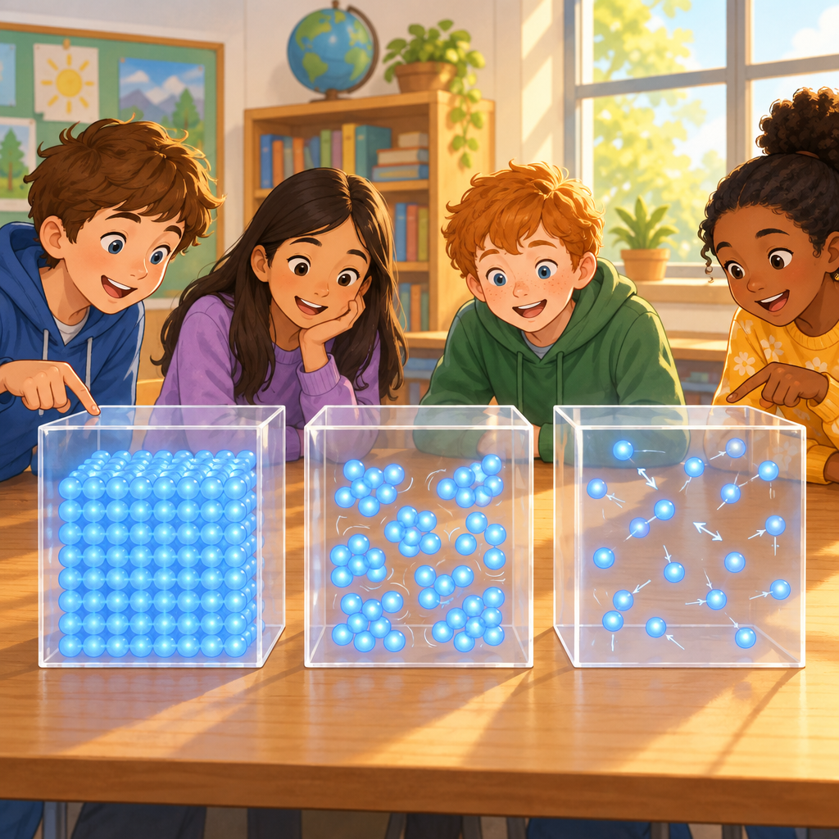

Overview
This Grade 5 science lesson introduces the particle model of matter and connects it to the physical properties of solids, liquids, and gases (Guiding question, Outcome). Students begin by acting out particle movement with their own bodies, watch a short video showing particles in motion (Resource), then draw and label the particle arrangement in each state of matter along with the strength of attractive forces (Knowledge, Skills). The lesson moves into hands-on measurement, where small groups use a balance scale to compare the mass and density of two liquids and test how air and water respond to pressure (Knowledge, Skills). The lesson closes with a quick exit ticket to check understanding.
By the end of the lesson, students should be able to describe how particles are arranged and moving in solids, liquids, and gases, and explain how this arrangement relates to properties like density and compressibility (Understanding, Understanding).

Outcomes covered
- How can states of matter and other physical properties be explained using the particle model of matter? (Guiding question)
This guiding question frames the whole lesson: students use the particle model to explain why solids, liquids, and gases behave the way they do.
- Students investigate the particle model of matter in relation to the physical properties of solids, liquids, and gases. (Outcome)
This is the core learning outcome for the lesson, connecting particle behaviour to observable properties students can measure and describe.
- Represent solids, liquids, and gases, using the particle model of matter. Relate the movement and arrangement of particles to the state of matter. Describe the impact that attractive forces have on the movement and arrangement of particles in solids, liquids, and gases. (Skills)
These skills give students a concrete way to draw, act out, and explain what is happening inside matter that they cannot see directly.
- Measure the mass of solids and liquids, using a balance scale and SI units. Measure the volume of liquids, using appropriate instruments and SI units. Directly compare the densities of solid objects that have the same volume. Directly compare the densities of liquids. Relate densities of solids, liquids, and gases using the particle model of matter. Compare the compressibility of air and water. Practise safe and appropriate use of materials, tools, and equipment. (Skills)
Hands-on measurement builds real scientific skill and lets students see density and compressibility for themselves rather than just hearing about them.
- The particle model of matter explains the behaviour of particles in matter. (Understanding)
This big understanding ties the whole lesson together and gives students a tool they can reuse in future science topics.
- The movement and arrangement of particles affect the physical properties of matter. (Understanding)
This understanding helps students see the connection between an invisible model (particles) and things they can directly observe and measure, like density and compressibility.

Materials
- Tape or chairs to mark three floor zones
- Video described in Resource and a way to play it
- Particle model worksheet with four boxes (Solid, Liquid, Gas, Attractive Forces) for each student
- Pencils and crayons or coloured pencils
- Balance scales (one per small group)
- Gram masses
- Two identical small containers, one filled with water and one filled with vegetable oil, per group
- Measuring cylinder marked in millilitres
- Clear cups for the float-or-sink test
- Paper towels for spills
- Two identical syringes without needles per pair, one filled with air and one with water (or two balloons, one with air and one with water)
- Exit ticket slips

Sequence of activities

1. Wiggle, Jiggle, Zoom: Acting Out Particles (10 min, whole class)
- Ask students: "What do you think matter is made of?" Take a few guesses.
- Share the big idea from PDF p.1: all matter is made up of small particles, particles of matter are always moving, and particles of matter have spaces between them.
- Explain that today the class will use their bodies to become particles.
- Mark three zones on the floor with tape or chairs: Solid Zone, Liquid Zone, Gas Zone.
- Call out "Solid!" Students huddle close together in a tight group and only vibrate or jiggle on the spot without moving their feet (Knowledge).
- Call out "Liquid!" Students spread out a little, keep touching a neighbour with one hand, and slide slowly past each other (Knowledge).
- Call out "Gas!" Students spread across the whole room and move freely in any direction at a normal walking pace, without bumping (Knowledge).
- Repeat the calls in a different order two or three times, checking that movement matches each state.
- Stop and ask: "Which state had the particles closest together? Which had the most space between them?" Confirm solid is closest and gas has the most space (Knowledge, Skills).
Watch for students who move their feet during Solid or who spread out too far during Liquid. Gently coach them back. This activity builds the mental model students will draw on in the next task. Keep the room large enough for the Gas Zone so movement stays safe.
Sources: PDF p.1, Knowledge, Skills

2. Watch and Talk: Particles in Motion (8 min, whole class)
- Play the video described in Resource, which shows how particle movement and spacing change in solids, liquids, and gases.
- Before playing, tell students to watch for two things: how close the particles are, and how fast they move.
- Pause after the solid section and ask: "What did you notice about the particles?" Expect answers like close together, vibrating, not sliding around.
- Pause after the liquid section and ask the same question. Expect answers like some space, sliding past each other.
- Pause after the gas section and ask the same question. Expect answers like far apart, moving fast in every direction.
- Connect the video to real life by asking: "What happens to the particles when ice melts into water, or when water boils into steam?" Guide students to see that heating gives particles more energy to move and spread apart (Resource, Knowledge).
If technology is unavailable, describe each state verbally using the same script and have students recall the acting-out activity instead. Keep this segment focused on vocabulary: particle, arrangement, movement.
Sources: Resource, Knowledge

3. Draw the Particle Model: Solid, Liquid, Gas (15 min, individual)
- Give each student a worksheet divided into three boxes labelled Solid, Liquid, and Gas, plus a fourth box for Attractive Forces.
- Tell students to draw dots to represent particles in each box, showing the correct arrangement: close together and organized for solid, spread with some space and touching for liquid, and far apart and scattered for gas (Knowledge, Skills).
- Ask students to add arrows or motion lines to show how the particles move in each state: small vibrations for solid, sliding arrows for liquid, and long zig-zag arrows for gas.
- In the fourth box, have students write one sentence describing where the attractive forces between particles are strongest and where they are weakest, using the sentence starter: "The pull between particles is strongest in ___ and weakest in ___." Correct answer: strongest in solids, weakest in gases (Knowledge, Skills).
- Circulate and check that dot spacing matches each state before students move to the next box.
- Ask two or three volunteers to hold up their drawings and explain one box to the class.
This is the main formative task. Look specifically for correct relative spacing (solid closest, gas most spread) and correct attractive force sentence. Students who finish early can add labels naming an everyday object for each state, such as an ice cube, juice, and the air in a balloon.
Sources: Knowledge, Skills

4. Mass, Volume, and Density Mini-Investigation (18 min, small group)
- Organize students into groups of three or four and give each group a balance scale, a set of gram masses, two identical small containers (same volume), one filled with water and one filled with vegetable oil, and a measuring cylinder marked in millilitres.
- Remind students of the terms: mass is the amount of matter in something, measured in grams (g) or kilograms (kg); volume is the amount of space something takes up, measured in millilitres (mL) or litres (L) (Knowledge).
- Have groups use the balance scale to measure and record the mass of the water container and the mass of the oil container in grams (Skills).
- Since both containers hold the same volume, ask groups to compare the two masses and decide which liquid is denser. Correct answer: water is denser than most vegetable oil, because it has more mass in the same volume (Knowledge, Skills).
- Have groups test their prediction by slowly pouring a small amount of oil into a clear cup of water and observing whether it floats or sinks. Expect the oil to float on top, showing it is less dense than water (Knowledge).
- Ask groups to discuss: "Using the particle model, why might one liquid be denser than another?" Guide them toward the idea that denser matter has particles packed more closely together or has more mass for the same amount of space (Knowledge, Skills).
- Remind students to handle the balance scale and liquids carefully, wipe up spills right away, and wash hands after touching the oil (Skills).
- Bring the class together and ask one group to share their measurements and their float-or-sink result.
Pre-measure the water and oil into identical containers before class to save time. If a balance scale is unavailable, use a kitchen scale in grams. This activity directly targets Knowledge and Skills, so keep the recording sheet simple: two mass numbers, one volume number, and a one-sentence conclusion about which liquid is denser.
Sources: Knowledge, Skills

5. Squeeze Test: Comparing Air and Water (6 min, pairs)
- Give each pair two identical syringes (no needles), one filled with air and the plunger pulled back, one filled with water and the plunger pulled back to the same mark.
- Ask students to place a finger over the tip of each syringe and push the plunger in as far as it will go.
- Ask: "Which one was easier to push in, the air or the water?" Expect: the air syringe compresses more easily.
- Explain that compressibility is the ability of a liquid or gas to reduce in volume under pressure, and that gases compress much more easily than liquids because gas particles have large spaces between them, while liquid particles are already close together (Knowledge, Knowledge).
- Have pairs write one sentence comparing the compressibility of air and water using the word particles.
If syringes are not available, use two balloons: one filled with air, one filled with water, and gently press both (with supervision) to feel the difference. This links compressibility directly back to particle spacing from Knowledge.
Sources: Knowledge, Knowledge

6. Exit Ticket: Show What You Know (3 min, individual)
- Hand out a small exit ticket with two questions.
- Question 1: "Draw or describe how particles are arranged in a gas compared to a solid."
- Question 2: "Which has particles with the strongest attractive forces between them: a solid, a liquid, or a gas?" Correct answer: solid (Skills, Knowledge).
- Collect the exit tickets on the way out as a quick formative check.
Scan exit tickets before the next class to identify students who still mix up which state has the particles closest together or who confuse arrangement with movement.
Sources: Knowledge, Skills

Differentiation
Extension
- Have students research and explain what happens to particle arrangement during a fourth state of matter, plasma, and share one fact with the class.
- Ask students to design their own comparative density test using two other household liquids, such as honey and dish soap, and predict the outcome using the particle model.
- Challenge students to explain, in writing, why a hot air balloon rises using ideas about particle spacing and density.
Support
- Provide a partially completed particle drawing template with the solid box already filled in as a model.
- Pair students with a peer buddy during the Wiggle, Jiggle, Zoom activity so they can watch and copy correct movements.
- Offer a word bank with the terms particle, close together, spread apart, vibrate, slide, and float for use in written sentences.
Inclusive supports
- Allow students who are uncomfortable with large movement activities to demonstrate particle behaviour using small objects like beads or marbles on their desk instead of moving their whole body.
- Provide simplified, large-print recording sheets for the density investigation for students who need them.
- Offer sentence starters and visual supports for all written responses, including the exit ticket.

Assessment
Formative. Observe students during the Wiggle, Jiggle, Zoom activity to check that their movement and spacing correctly matches solid, liquid, and gas.
Look for: Students keep their feet still and vibrate in place for solid, slide past a neighbour while staying close for liquid, and move freely with large spacing for gas. (Knowledge, Skills)
Formative. Review the particle model drawings from the Draw the Particle Model activity for correct dot spacing and a correct attractive-force sentence.
Look for: Dots are closest together and evenly spaced for solid, moderately spaced with some contact for liquid, and widely and randomly spaced for gas. The sentence correctly names solids as strongest and gases as weakest for attractive forces. (Knowledge, Skills)
Formative. Check group recording sheets from the Mass, Volume, and Density Mini-Investigation for accurate measurements and a density conclusion.
Look for: Groups record mass in grams for both liquids, note the shared volume, and correctly identify which liquid is denser based on the float-or-sink test. (Knowledge, Skills)
Summative. Collect and mark the exit ticket at the end of the lesson.
Look for: Students correctly show gas particles as widely spaced and moving in all directions compared to closely packed, vibrating solid particles, and correctly identify solids as having the strongest attractive forces. (Knowledge, Skills)

Vocabulary
- Particle: A very small piece of matter. All matter, including solids, liquids, and gases, is made up of particles that are too small to see (PDF p.1, Knowledge).
- Particle model of matter: An idea scientists use to explain how matter behaves. It says that all matter is made of small particles, the particles are always moving, and there are spaces between the particles (PDF p.1, Understanding).
- Attractive forces: The pulling force between particles that holds them together. This pull is strongest in solids and weakest in gases (Knowledge, Skills).
- Mass: The amount of matter in a solid, liquid, or gas. Mass is measured in grams (g) or kilograms (kg) (Knowledge).
- Volume: The amount of space a solid, liquid, or gas takes up. The volume of a liquid is measured in millilitres (mL) or litres (L) (Knowledge).
- Density: A comparison of an object's mass to its volume. The more mass packed into the same amount of space, the denser something is (Knowledge).
- Compressibility: The ability of a liquid or gas to shrink in volume when pushed or squeezed under pressure. Gases compress much more easily than liquids (Knowledge).

For families
- Ask your child to point to something at home that is a solid, a liquid, and a gas, and explain how the particles are arranged differently in each.
- Freeze a cup of water together and talk about how the particles slow down and pack closer together as it turns to ice.
- Let your child compare how easily they can squeeze an empty (air-filled) plastic bottle versus a full water bottle, and ask them to explain the difference using the word particles.

Sources
- Guiding question: "How can states of matter and other physical properties be explained using the particle model of matter?"
- Outcome: "Students investigate the particle model of matter in relation to the physical properties of solids, liquids, and gases."
- Knowledge: "In solids, the particles are close together and vibrate in place."
- Skills: "Represent solids, liquids, and gases, using the particle model of matter."
- Understanding: "The particle model of matter explains the behaviour of particles in matter."
- Knowledge: "Density is a comparison of the mass of a solid, liquid, or gas to its volume."
- Skills: "Measure the mass of solids and liquids, using a balance scale and SI units."
- Understanding: "The movement and arrangement of particles affect the physical properties of matter."
- PDF p.1: "All matter is made up of small particles. Particles of matter are always moving. Particles of matter have spaces between them."
- Resource: "Explore how particles move and arrange in different states of matter."

All activities use everyday, non-hazardous materials such as water, vegetable oil, syringes without needles, and balance scales, and are age-appropriate and culturally respectful for Grade 5 students.

AILI detailed pack · en · claude-sonnet-5 · 2026-09-17

