The Calorimetry Puzzle
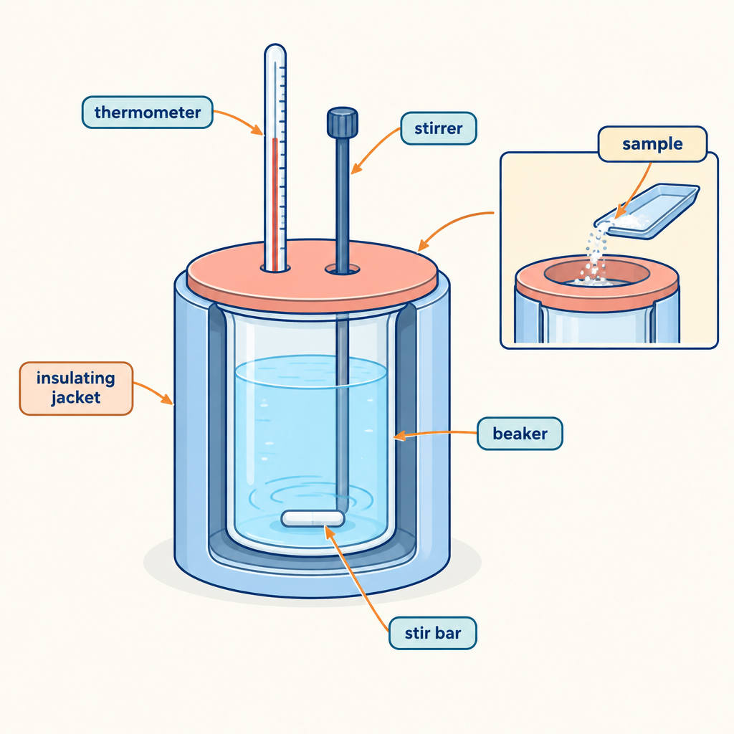
This brain teaser applies the relationship Q = mcΔt to the analysis of heat transfer (Outcome, Outcome) and asks you to connect a calorimetry measurement to a molar enthalpy change (Outcome, Outcome). Understanding enthalpy and molar enthalpy for chemical reactions (Outcome) and using ΔH notation correctly (Outcome) are both required knowledge for Unit A: Thermochemical Changes, where the general outcome is to determine and interpret energy changes in chemical reactions (Topic). The scenario below mirrors the kind of coffee-cup calorimeter investigation described in Resource, where students build a simple calorimeter and use repeated trials to calculate an experimental result.

The puzzle
A student runs a coffee-cup calorimetry experiment to find the molar enthalpy of dissolution for a solid ionic compound, X.
She places 100.0 g of water (specific heat capacity c = 4.18 J/g°C) into a polystyrene-cup calorimeter, assumed to lose no heat to its surroundings. The initial temperature of the water is 21.5°C.
She adds 4.00 g of solid X (molar mass = 80.0 g/mol) to the water and stirs until it fully dissolves. The final temperature of the solution settles at 26.3°C.
Using only these measurements, determine the molar enthalpy of dissolution of X, in kJ/mol, and state whether the dissolution is exothermic or endothermic.
Give your answer to three significant figures, and include the correct sign on ΔH.

Hints
Hint 1: Start with Q = mcΔt to find the heat absorbed by the water. Decide what mass to use in this step: the mass of the water, not the mass of the solid.
Hint 2: The heat gained by the water equals the heat released by the dissolving solid, but with the opposite sign. This is the link between the calorimetry data and the enthalpy change of the reaction (Outcome).
Hint 3: Convert the 4.00 g sample of X into moles using its molar mass, then divide the heat released (in kJ, with its correct sign) by the number of moles to get the molar enthalpy in kJ/mol.

Answer key
Step 1: Calculate the heat gained by the water.
Q = mcΔt
Q = (100.0 g)(4.18 J/g°C)(26.3°C − 21.5°C)
Q = (100.0 g)(4.18 J/g°C)(4.8°C)
Q = 2006.4 J, which rounds to 2.01 × 10^3 J, or 2.01 kJ
Step 2: Apply conservation of energy.
The water gained 2.01 kJ of heat, so the dissolving solid released 2.01 kJ. Since the reaction releases heat, ΔH for the dissolution is negative: ΔH = −2.01 kJ for the 4.00 g sample that dissolved.
Step 3: Convert the mass of X to moles.
n = mass ÷ molar mass
n = 4.00 g ÷ 80.0 g/mol
n = 0.0500 mol
Step 4: Calculate the molar enthalpy of dissolution.
ΔH(molar) = ΔH ÷ n
ΔH(molar) = −2.01 kJ ÷ 0.0500 mol
ΔH(molar) = −40.2 kJ/mol
The molar enthalpy of dissolution of X is −40.2 kJ/mol. The negative sign shows that the temperature of the water rose as X dissolved, so the process released heat to the surroundings and is exothermic.

AILI game · en · claude-sonnet-5 · 2026-09-17

