Cells and Systems: The Basic Unit of Life
Students compare plant and animal cells and explain why the cell is called the basic unit of life.
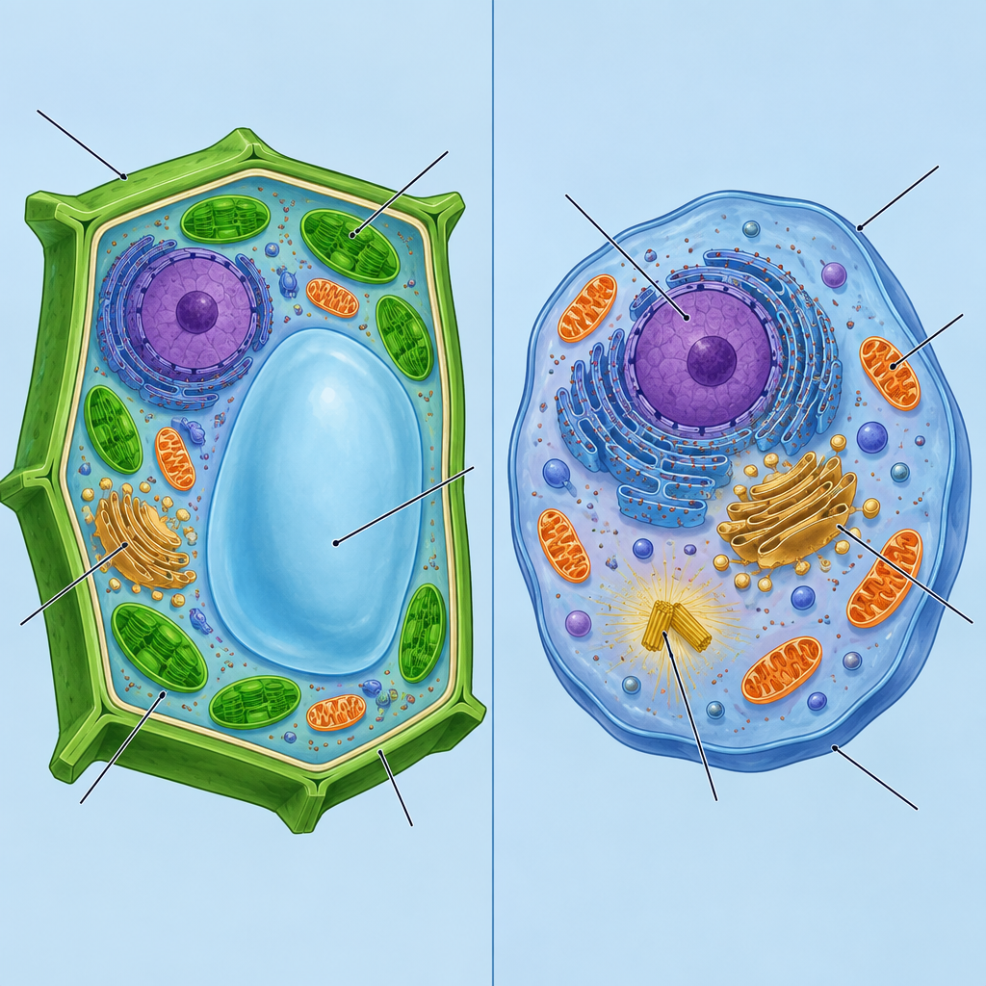

Learning intentions
We are learning to:
- Explain why the cell is the basic unit of life.
- Compare single-celled and multicelled organisms.
- Distinguish between plant and animal cells based on structure.

Success criteria
I can:
- State why all living things are made of cells.
- Give one similarity and one difference between a single-celled organism and a multicelled organism.
- Identify at least two structures that appear in plant cells but not animal cells, and explain what those structures do.

Curriculum alignment
- Describes the role of cells as the basic unit of life (Outcome).
- Analyzes similarities and differences between single-celled and multicelled organisms (Outcome).
- Distinguishes between plant and animal cells (Outcome, Outcome).
- Applies the concept of system in describing organisms (Outcome).
- Connects to the unit's key concepts of organisms, cells and structure and function (Topic).

Materials
- Microscopes and prepared slides of onion cells (plant) and cheek cells (animal), one set per pair of students
- Alternative if microscopes are unavailable: labelled diagram handouts of a plant cell and an animal cell
- Whiteboard or projector
- Venn diagram worksheet (plant cell vs. animal cell), one per student
- Sticky notes, two colours, enough for one of each per student
- Exit ticket slips

Lesson sequence
1. Hook (5 minutes)
Write this question on the board: "Is a single amoeba alive in the same way a grizzly bear is alive?"
Ask students to turn to a partner and answer in one sentence each. Take two or three answers cold-call style. Then say: "Both are made of the same basic building block. Today we find out what that building block is and how it's organized differently in each of them."
2. Direct instruction (10 minutes)
Explain: "Every living thing, from a single amoeba to a poplar tree to you, is built from cells. The cell is the basic unit of life. That means it's the smallest unit that can carry out all the processes of being alive: taking in materials, releasing waste, and reproducing."
Draw two columns on the board: "Single-celled" and "Multicelled." Give examples: an amoeba and a bacterium are single-celled organisms, they carry out every life function inside that one cell. A grizzly bear, a poplar tree and a human are multicelled, made of trillions of cells that specialize and work together.
Ask: "If a single-celled organism has to do everything itself, what does that tell you about how simple or complex its one cell might be?" Expect answers like "it has to be able to do a lot" or "it's more independent." Confirm: single cells in a multicelled body can specialize, like a nerve cell or a skin cell, because other cells handle other jobs. This is the concept of system: parts working together (Outcome).
Show or draw a plant cell and an animal cell side by side. Point out the cell membrane in both. Then point out the cell wall, chloroplasts and large vacuole in the plant cell only. Ask: "Why might a plant cell need a rigid wall around it, but an animal cell doesn't?" Take one or two guesses, then explain: plants don't move to find shelter, so a wall gives their cells shape and support (Outcome).
3. Guided practice (10 minutes)
Hand out the Venn diagram worksheet (plant cell circle, animal cell circle, overlap in the middle). Have pairs use microscopes to examine the onion cell slide and the cheek cell slide, or the diagram handouts if no microscopes are available.
Direct question for pairs to answer together: "Look at your onion cell. Can you see a straight-edged boundary around each cell? That's the cell wall. Now look at the cheek cell. Does it have that same straight edge, or is the edge more rounded and flexible?"
Circulate and ask individual pairs: "Name one thing your two cells have in common." "Name one thing that's different." Fill in one shared item (cell membrane, nucleus) and one different item (cell wall) on the board as a class model before releasing students to finish the worksheet independently.
4. Independent practice (10 minutes)
Students complete the Venn diagram individually, filling in at least three items in each section: plant-only, animal-only, and shared.
Then, on a sticky note, students write one sentence answering: "A single-celled organism like an amoeba and a multicelled organism like a grizzly bear are similar because ___, but different because ___."
Students post their sticky note on the board under a "Similar/Different" heading as they finish.
5. Consolidation (5 minutes)
Read aloud three or four of the posted sticky notes without naming authors. Ask the class: "Does everyone agree with this comparison? What would you add?"
Close with the exit ticket: "Name two structures found in a plant cell but not an animal cell, and explain what each one does." Collect on the way out.

Differentiation
Extension: Ask early finishers to research one specific single-celled organism (e.g., paramecium, euglena) and add a fourth column to their notes describing one structure that lets it survive without help from other cells, such as a contractile vacuole or flagellum. Connect this to Outcome's idea that different organisms meet the same function in different ways.
Support: Provide a partially completed Venn diagram with the shared section already filled in (cell membrane, nucleus, cytoplasm), so students only need to sort the plant-only and animal-only structures from a provided word bank (cell wall, chloroplast, large vacuole). Pair support students with a peer during the microscope activity and allow them to describe structures verbally rather than write full sentences on the exit ticket.

Assessment
Formative check: collect the exit tickets and scan for two things. First, whether students correctly name structures unique to plant cells (cell wall, chloroplast, and/or large vacuole) rather than confusing them with structures found in both cell types. Second, whether their explanation of function is accurate, for example connecting the cell wall to support and shape rather than leaving the explanation blank or generic. Students who list correct structures but cannot explain function need a quick follow-up mini-lesson before moving to organs and tissues in the next class.

AILI rapid lesson · en · claude-sonnet-5 · 2026-09-17

